Candidate Name: Finlay Wall Candidate Number: 1291

OCR GCE A

COMPUTERSCIENCE

PROJECT

H446-03

Name: Finlay Wall

Candidate Number: 1291

Archway School: South Bromsgrove Sixth Form

Title of Project: Phantom Dungeon

# Contents

Contents 2

The Idea / The Problem 8

Computational Methods: 8

Abstraction 8

Decomposition 8

Object Orientated Programming (Including Inheritance) 8

Problem Recognition 9

Stakeholders 9

Hardware and Software Requirements 10

Hardware 10

Software 10

Limitations of My Project: 11

Similar Games Research 12

1) Crawl 12

2) Hades 13

3) Enter the Gungeon 14

4) Slay the Spire 15

5) Risk of Rain 2 16

Essential Features: 17

Non-essential Features: 18

Success Criteria 19

GUI / 2D Environment 19

Gameplay 19

**Feedback from Stakeholders** 22

1) What is the most important feature of a 2D game? 22

2) What difficulty do you play games at? 22

3) Do you prefer a rich HUD or a simple HUD? 22

4) Do you prefer background music in a game? 23

**Conclusions** 23

**Design** 23

**Classes and Justification of Structured Solution** 25

**Start Screen** 25

**Music** 26

**Player** 27

Player Movement 27

Player Stats 29

Player Collisions 31

Attack 31

**Entities** 33

Health 33

Pathfinding 34

Enemy Collisions 37

Enemy Types 38

**Map** 38

Tile Map 38

Wall Collisions 38

Area Difficulty 38

**Menu** 38

**Items** 40

Weapons 41

Armour 42

Consumables 42

Gold / Currency 43

**Loop** 44

**Usability Features** 45

Description and sJustification of the design of the User Interface 45

Main Menu 46

Options Menu 47

Main Game HUD 47

Pause Menu 48

**Class Diagram Summary** 48

50

**Identifying key variables / data structures / classes** 50

MainMenu 51

SettingsMenu 51

Music 51

PlayerMovement 52

PlayerStats 52

StandardAttack 53

Enemy 53

EnemyMovement 53

Menu 54

PickUp 54

Player 55

GameManager 55

**Test Data for Development** 56

Test Data for Beta Testing 59

Post Development Tests 59

**Developed Coded Solution** 63

**Phase 1 - Main Menu** 63

Main Menu Tests 66

Phase 1 Review 66

**Phase 2 – Tile Map / Background Layers** 67

Phase 2 Review 69

**Phase 3 – Player Character** 69

Player Sprite Creation 69

Player Movement 69

Player Movement – Animation 70

Player Movement Tests 72

Player Collisions + Map Collisions 73

Player + Wall Collisions Tests 74

Phase 3 Review 74

**Phase 4 – Enemy Creation** 75

Enemy Sprite Creation 75

Enemy Path Finding – A* Algorithm 75

Phase 4 Review 87

**Phase 5 – Stats and Combat** 87

Enemy Attack + Health stats 87

Player Attack 92

Phase 5 Review 93

**Phase 6 - Items** 93

Armour Items 94

Potions 94

Gold 97

Phase 6 Review 100

**Phase 7 – Death Loop** 100

Phase 7 Review 102

**Phase 8 – Enemy Levels + Win Condition** 102

Enemy Levels 102

Win Condition 103

Phase 8 Review 105

**Phase 9 (Final Phase) – Combat Improvements (Dodge and Battle Music)** 105

Dodge Mechanic 105

Battle Music 106

Phase 9 Review 108

**Evaluation** 108

**Summary of Progress** 108

**Tests Description** 108

**Post Development Tests for function and robustness** 109

Player Movement 110

Collisions (Player, world, enemies,items) 110

Enemy Death 110

Enemy Movement 110

Player Death 110

Item Pickup 111

Player Attack 111

Music 111

Main Menu 112

Pause Menu 112

**Essential Features Tests** 112

Player Movement 113

Combat System 113

HUD 113

Stats (Player and enemy stats) 113

Replayable/Cyclical Structure 114

Enemy AI 114

Weapons 114

**Success Criteria Tests** 114

Sprites 115

Tile Map 115

HUD 115

Player Movement 116

Player Stats 116

Player Combat 117

Enemy Combat 117

Enemies 117

Enemy Collisions 118

Enemy Stats 118

Area Difficulty 118

Loot (Weapons and items) 119

Pause Menu 119

**Usability Features Testing** 119

Main Menu 119

Options Menu 120

Main Game HUD 120

Pause Menu 120

**Maintenance issues and Limitations of the solution** 121

Time 122

Experience 122

Scale (Manpower required) 122

Expectations 123

# The Idea / The Problem

My project will be a rogue-like dungeon crawler, made in a 2D environment, with all the classic retro elements to a 2D top-down RPG, that will be developed in Unity using C# for scripts. You will control a player that can move, attack and dodge, with a rich variety of weapons, abilities and items, as well as attempting epic boss battles and exploring challenging rooms. I hope to also include a basis of a story, so that there is an end goal to achieve also. This game will be similar to other rogue-likes such as “Hades”, and “Crawl”.

An overview of the features are: A HUD to display stats, ability cooldowns, damage displayed; a player with player movement, attack and dodge; battle mechanics (PVE); player abilities; boss battles; items and “loot” to collect; general story.

# Computational Methods:

## Abstraction

During the development of my game I will be using the basis of abstraction to help remove unnecessary information and to extract the core components of my game. For example, player movement will be abstracted to ensure that the player can move in the basic 4 directions at least – this will ensure that the player will be able to move, without any extra complex layers such a multi directional, or any dodges that may be implemented. Furthermore, the abstraction of the players movement is removing the appearance of the player as it is irrelevant at this layer of development; the time saved on not focusing on player aesthetics can be better suited to the development of another feature of the game.

## Decomposition

My game is large scale, complex problem that needs to be broken down into multiple simpler problems, hence decomposition will be vital for the development of this game. Decomposition will help me see problems as modular, meaning each component/feature of the game can be developed on separately, to ensure that they don’t conflict during the development and then they can all be brought together in stages – to minimise conflicts. For example, creating the player and creating an enemy are two very different problems that are components of the main problem – which can both be separately developed; moreover these problems can be further broken down, e.g. player can be broken down into: Health, armour, mana, movement, collisions etc. Overall, decomposition will be an important computational method to help simplify and section the main problem of my project.

## Object Orientated Programming (Including Inheritance)

OOP involves seeing everything as objects within a problem, and then those objects have attributes (describing the details of the object) and methods (to access and utilise their attributes). I will be using it in my project as it is a very efficient and logical computational method, and C# is an OOP language that is very suited to Unity as you can create different packages (Scripts) that run through a fixed update method in the program class. The way I will implement OOP is seeing all of the sprites as objects, which I will attached scripts to containing OOP coding constructs.

Furthermore, for example, for enemies I can instantiate multiple instances of enemies to create a variation of enemies that all have similar stats and methods but slightly different. Developing on this, I can create different difficulty levels of enemies by creating child classes from the enemy parent class – their stats and methods can be different from the parents class whilst also maintaining all the core attributes and methods. Therefore, OOP will not only save me time but will add complexity within reason.

## Problem Recognition

Problem recognition will be utilised throughout my project development as problems arise throughout - no matter how much I decompose each problem down, there will still be new problems that arise. Fortunately, a way to implement/employ project recognition will be via debugging tools in Visual Studio’s IDE (for editing scripts individually), and also Unity’s IDE (for compiling all the scripts together, and also to check that the GUI matches what is expected to appear on screen).

# Stakeholders

My game will be focused on a simulation, retro style that will not be representative of real life, and will also contain some gore/violence; for this reason it will be targeted at people of age 13+ who enjoy RPG/Dungeon crawler games. Furthermore, I will use a stakeholder to receive feedback throughout the development process to ensure that I am staying on course and hitting all the points needed for the marks – and to meet my own set objectives.

For my stakeholders I will have:

Stakeholder X: A 17-year-old who enjoys all types of games, and has played similar games to my project game such as Hades (which is looked at later), which is a main reason I chose this stakeholder, as they should have a liking towards the genre of my game.

Stakeholder Y: A 16-year-old who enjoys action/combat games and who plays games all the time. The reason I chose this stakeholder is because they are of a similar age and they like similar games, which is my exact target audience, meaning feedback from this stakeholder will be very constructive.

Stakeholder Z: A 23-year-old who does some gaming in their spare time, and is looking to get back into games properly. I chose this stakeholder as they are much more of a casual gamer, and I want to review whether my game will appeal to casual gamers.

During the development process I will be utilising the Agile Development Model which produces multiple prototypes of the game, that will be distributed to certain stakeholders at certain points of the process to contribute towards beta testing the project as it is built upon. This will be combined with my in-house testing and then a review can be created from that at different stages, to ensure I stay on task with my objectives and within my time scales.

# Hardware and Software Requirements

# Hardware

For the hardware requirements I will use a similar game “Crawl” (later referenced) as a reference point, as well as the requirements for running the Unity engine as my game will be utilising this engine; “Crawl” will have similar requirements due to the 2D, low resolution nature of the game.

* CPU: Any x64 Intel or AMD CPU that is more recent than 2006, has to be at least dual core
* RAM: 4 GB (Recommended 8 GB)
* GPU: Integrated graphics later than Intel HD 4000 / Radeon HD 2000
* Disk Space: 400 MB – for all of the assets and scripts
* OS: Windows 10 or later – as It will be developed in Windows 11, but there is little to no conflict between running Unity in Windows 10 or 11, as long as it is the same version of Unity.

# Software

Firstly you will need the Unity Engine, and specifically the Engine Version 2021.3.22f1, as this is the exact version the game will be developed in, to ensure no conflicts between versions. Also necessary is Visual Studio 2022 ( to run the scripts ), and C# downloaded within Visual Studio 2022 – which is labelled as “.NET desktop development”.

|  |  |
| --- | --- |
| **Limitation** | **Explanation** |
| Time Constraints | My project has a roughly 9-10 month limit, which will be interrupted by many factors (schoolwork, exams, social life, events, etc.) which will greatly limit the scale on which I can make this project; I will acknowledge these constraints and plan around them. Due to this it may mean my game is less fleshed out as it could be if I had longer. My time will need to be divided into documentation, learning coding constructs that are necessary to build my game, and then actually coding the game, as well as other elements such as testing and communication with stakeholders. |
| Visuals | I don’t have the time or the skill to create super detailed sprites in comparison to other fully developed games due to me being only one person creating the whole game, therefore for my project I will be using free-to-use sprites from online, which will all be credited to the source. In spite of this, I would still like my game to look appealing as it’ll contribute towards an enjoyable gaming experience. |
| Complexity of the Game | I am only one person developing this game; this means I will only be able to add so many layers of complexity to the game, with only so many features – due to time and skill constraints that come with it being a solo development. However, I will still develop my game using complex structures such as OOP, and there will be enough features to make the game interesting. |

# Limitations of My Project:

# Similar Games Research

## Crawl

Crawl is a brawler indie game by Australian developer Powerhoof. Up to four players and bots in local multiplayer advance through randomly generated dungeons with one player as the hero and the others as spirits who possess traps and monsters in the environment to kill and thus replace the hero.

Pros:

* Wide variety of items and abilities
* Loads of fun, different enemies
* The art style is very retro and fun to watch
* Up to 4 players can play, you can even replace players with bots

Cons:

* Some of the rooms are repetitive
* There should be a difficulty scaler to account for players of all levels of gaming skill.

Implementations to take from this:

* Having a large quantity of varied and interesting weapons, spells and abilities.
* The pixelated art form
* The feature of being able to respawn
* The shop within the game to buy items, that also refreshes each level

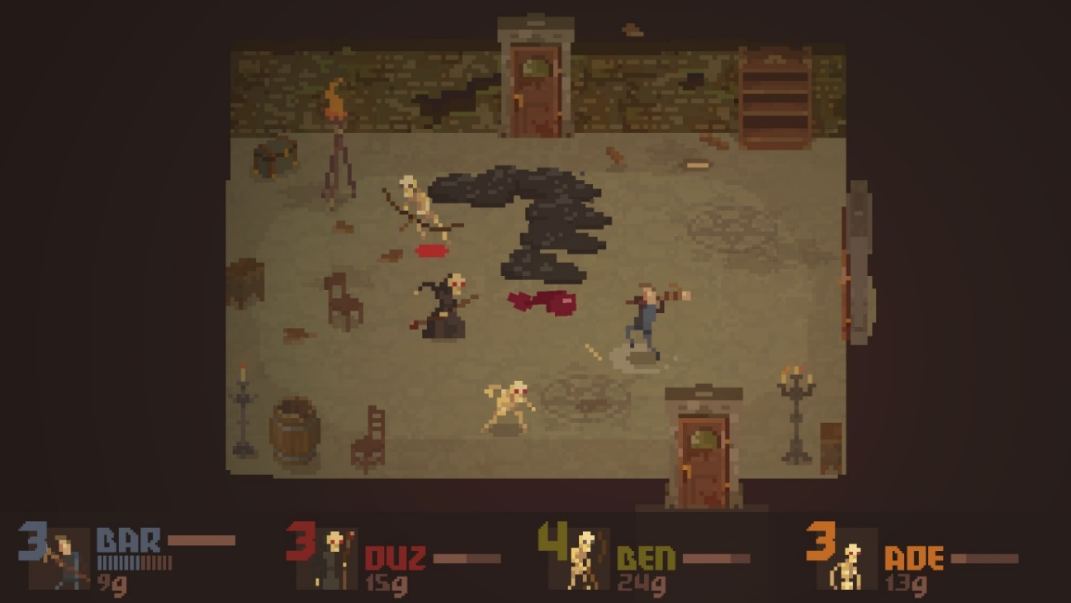

## Hades

Hades is a roguelike video game developed and published by Supergiant Games. It involves battling through rooms to escape from the Underworld to reach Mount Olympus, using a combination of a standard, special and ability attack, also with a dash to doge attacks. It has amazing replay ability as every time you play it you restart at the very start of the Underworld; you collect new weapons and ability improvements throughout different rooms to improve your characters damage, health and abilities.

Pros:

* Large number of weapons and abilities
* Boss battles are very fun and unique
* Impeccable, cartoonish art style
* Balanced weapon/ability damage and enemies
* Interesting plotline with dialogue and a fleshed-out story
* Has a difficulty setting

Cons:

* Slightly repetitive
* Could be classed as too quick action

Implementations to take from this:

* Ability combinations – along with an expansive set of abilities to learn and unlock
* Challenging bosses that really test the players skills
* Health bars for all enemies
* 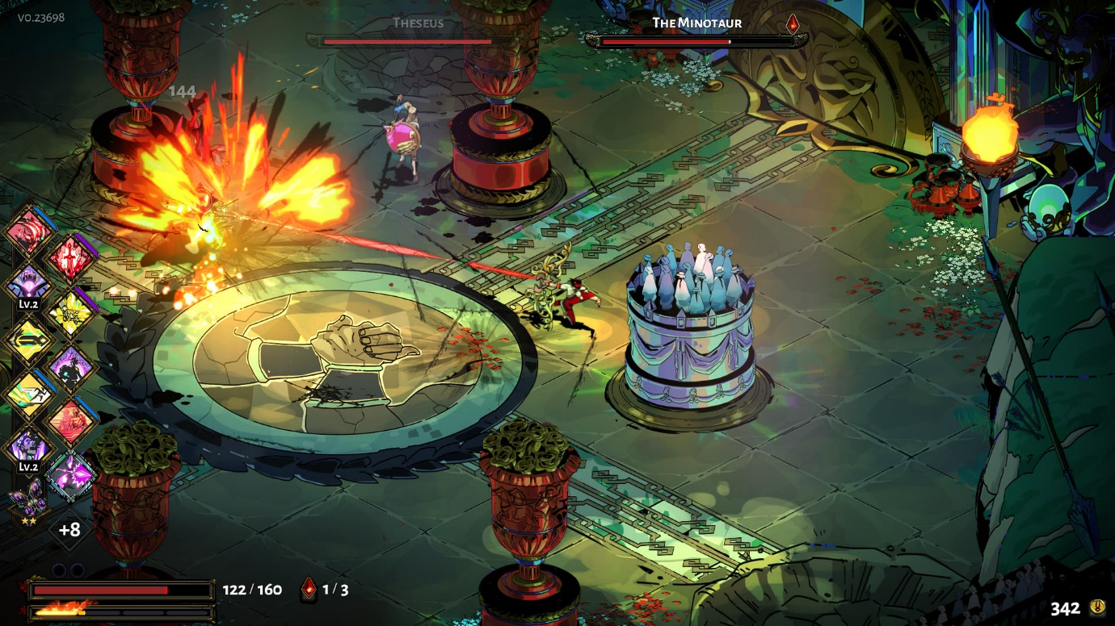Detailed story

## Enter the Gungeon

Enter The Gungeon throws players into a bullet hell roguelike. In this game, players take the role of a protagonist seeking a mystical gun that can kill the past. However, to obtain this mysterious gun, you’ll have to find it within the Gungeon. A constantly changing dungeon that is flooded with enemies that are willing to blast you away. Scattered about the dungeon are rooms and new weapons to use. However, if you are ever killed, the protagonist is forced to start back with a newly generated dungeon. In essence, it’s all about finding new, more powerful guns and blasting your way through a “Gungeon”.

Pros:

* Cool, fun pixelated art style with amazing sprites
* Dodge is an impressive, vital tool that can be used in many situations
* Fun, difficult boss fights with excessive and unique abilities
* Such an extensive array of guns to chose from – including “gag” guns like the pitchfork launcher
* Items to increase damage and health
* The movement controls are exceedingly fluid and natural

Cons:

* Can be quite overwhelming with how much is going on at once – too many enemies and projectiles at times
* The story isn’t very in depth

Implementations to take from this:

* Possibly add guns
* Use a similar movement system, as well as a fluid camera shake and camera panning
* Chaotic rooms
* 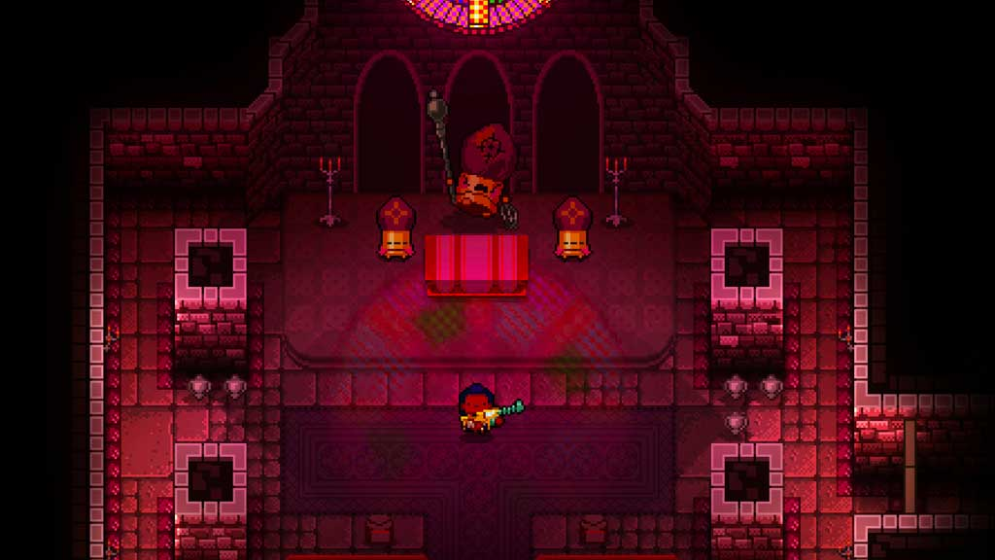Add funny/”gag” weapons and also bosses to add a comedic, light element to the game

## Slay the Spire

Slay the Spire is a roguelike deck-building video game developed by American studio Mega Crit and published by Humble Bundle. I’m using this example as it is an odd but interesting mix of a deckbuilding, dungeon crawler and rogue-like game all in one – which hands itself to being a thrilling combination of combat based around cards that can be acquired, built upon and combined to unleash devastating or crazy attacks. From a development point of view, they created a perfect mix.

Pros:

* The deck-building aspect is extremely varied – not just with the sheer amount of cards but also the purely ludicrous amount of combinations of cards possible
* Rich HUD - Stats including health, money, potions etc. are always displayed for the player
* Relics that you can collect have debuffs as well as buffs, allowing for effective balancing
* There is a wide variety of monsters, with their own unique attacks and also appearances

Cons:

* Quite slow paced due to “turn based” battles
* New players might find it difficult to understand all the cards – slightly steep learning curve

Implementations to take from this:

* A rich HUD – but not too excessive as it will become intrusive to the gameplay
* Balancing of items – include both buffs and debuffs
* 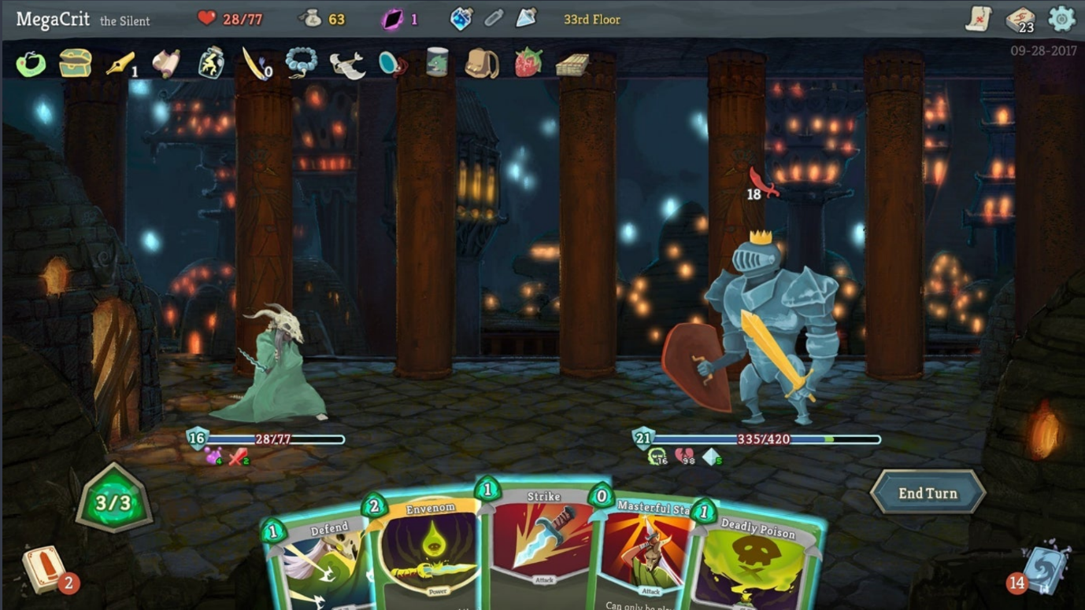A shop that sells items – also includes deals

## Risk of Rain 2

Risk of Rain 2 is a roguelike third-person shooter developed by Hopoo Games and published by Gearbox Publishing. This example is a perfect example of an incredible and vast implementation of items and weapons – there are hundreds of them. Furthermore, it has a multitude of enemies of varying types that all pose challenging battles. It has many stages of increasingly difficult levels, throwing stronger enemies at the player each time, but it also has an ending with a final boss.

Pros:

* Hundreds of interesting and complex items that provide the player with a multitude of buffs and abilities
* Fluid movement with a reactive camera movement system
* Fast paced battles
* Various enemies and captivating, challenging boss fights
* A final boss and a goal to work towards

Cons:

* The item system can be overwhelming at first
* The HUD can be slightly intrusive during large, complex battles

Implementations to take from this:

* Display hit points on enemies and the character, as well as health bars also displayed
* Wide choice of items with numerous buffs and abilities
* Intuitive controls and camera system

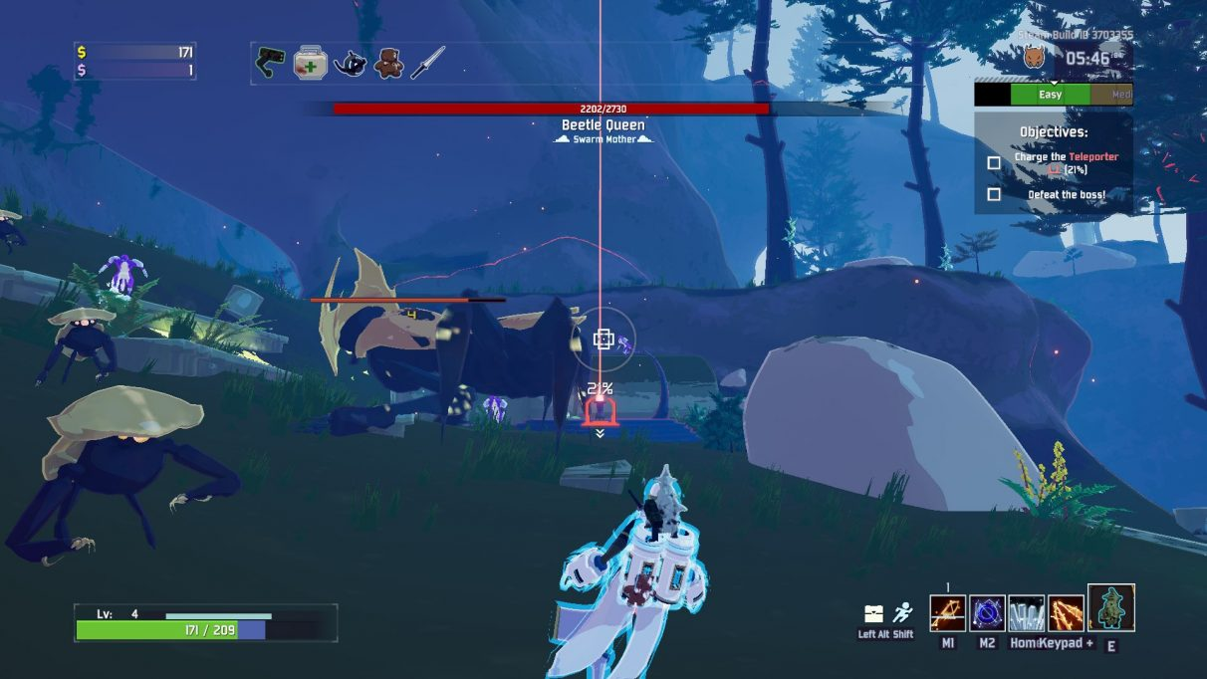

# Essential Features:

|  |  |
| --- | --- |
| **Feature** | **Explanation** |
| Player Movement | Player movement is vital for the person controlling the game to have a character that can move around and interact with the environment. |
| Combat System (PVE) | The nature of a dungeon crawler needs combat in which you fight enemies to ensure that the environment is more challenging and engaging. |
| HUD | Your stats (such as health and mana) need to be displayed at all times so the player can approach battles, take potions, use specific items etc. in relation to the condition of their stats. |
| Stats (Player and Enemy Stats) | The player and enemies need to be able to die, that is a core construct of the game. Not only this, but the player will have magical abilities that require mana, so mana is vital to control how often they can use those abilities. |
| Replayable/Cyclical Structure | As it is a rogue-like game, it is based on a constant repetition of similar levels that are revisited if you die, so the game needs to be similar but diverse each time it is played. |
| Enemy AI | The game needs enemy AI, that is intelligent enough to track and attack the player within a certain vicinity, while also having realistic cooldowns. Furthermore, the actual amount of enemies needs to be regulated to make the game challenging enough but also fair to the player. |
| Weapons | The game needs to have at least a weapon for the player and the enemy to use, which has its own collisions, damage and correct reactions within its environment – so it cannot phase through walls or sprites. |

# Non-essential Features:

|  |  |  |
| --- | --- | --- |
| **Feature** | **Explanation** | **Inspiration** |
| Item Shop | For my game, I could implement a small item shop into my game that could be accessed by the player – to purchase weapons and items. This could further be contributed to via a coin gathering system, where coins are stored in chests and dropped from enemies, and then those could be spent in the shop. | I’ve pulled this idea from the game “Crawl” above, which has an item shop that refreshes throughout the game, and can be accessed on multiple levels. |
| Boss Health Bars | This could be during the boss battles in which I plan to create – the health bars could be displayed at the top of the screen, with a specific name for each boss to make it more interactive and engaging. | This idea is from multiple of the games, as multiple contain this specific feature, but I like the implementation from Hades mostly. |
| Objectives | Objectives could be implemented within my game to reward the player with special weapons, or gold (to be spent in the shop), e.g. kill 5 enemies for 30 gold. | I’ve taken this directly from Risk of Rain 2, as in the game you have objectives that can reward you with weapons or abilities. |

# Success Criteria

I am creating a success criteria as a measure of my progress and also for testing purposes, to ensure that I am meeting all of my initial expectations as well as objectives. This will ensure that the main idea of the game is executed true to form, and then any later changes can be added to the initial idea.

|  |  |  |  |
| --- | --- | --- | --- |
| **Feature** | | **Explanation** | **Testing Criteria** |
| GUI / 2D Environment | | A GUI is fundamental for the game to be able to display the assets, sprites and combat that is happening while the game is running. |  |
| 1 | **Sprites** | Sprites will be representatives of the player, enemies and any interactable objects – which the player needs to be able to see at all times as it will construct the design of the game. | * All objects/characters have a sprite that is visible on screen * Each sprite has collisions, so you can’t phase through other sprites visually |
| 2 | **Tile Map** | The tile map will be the “background” on which the player will walk on, and where the walls are displayed, as well as doors etc. It will need to be a diverse palate of different floors, walls, doors and scenery. | * Walls have collisions with player and enemies * No visible sections of the map with no painted tile * “Layers” need to be implemented, meaning different objects have higher priority on screen e.g. the player is on top of the background. |
| 3 | **HUD** | The HUD is important for displaying stats to the player, such as health, mana and armour – as well as displaying helpful tips or controls, such as ability controls. | * Player health, mana and armour displayed at ALL times * Ability controls displayed * Enemy health displayed above their heads * Bosses health displayed at the top of the screen once a boss battle commences |
| Gameplay | | Gameplay features are the very crux of the game, and ensure the game functions as per the requirements. |  |
| **1** | **Player Movement** | The player needs to be able to traverse the map using logical controls (WASD) to do so. | * WASD controls the player sprite (Up, left, down, right – respectively) * Speed of player is reasonable |
| **2** | **Player Stats** | The player requires health, mana and armour stats, that interact with anything that could affect those e.g. enemy damaging a player should reduce their armour first (if they have any) and then their health. | * Health stat – if drops to zero then player dies and game over * Mana stat – abilities use mana * Armour stat – Functions as a second health bar essentially * Stats need to be correctly effected by items, potions, enemies |
| **3** | **Combat System** | The combat system in my game at the basic should have combat between the player and enemies – but this can be expanded with different abilities and weapons. This will add an element of action and skill to the game. | * Player can attack enemies * Enemies can attack player |
| **3.1** | **Player Combat** | The player themselves needs to be able to attack enemies, this is a fundamental mechanic of an RPG/action game. | * Player has standard attack and an ability attack at least * Player has a hit box * Player has a dodge/roll to avoid an attack from an enemy |
| **3.2** | **Enemy Combat** | The enemy needs to be able to damage the player, which adds an element of challenge to the game. | * Enemy has an attack that damages the player * Enemy has a hit box that is to scale of their body |
| **4** | **Enemies** | Enemies are a vital component to my game and will track the player down once the player is in range, and will try to kill the player. | * Every enemy has an area of detection, where it detects and hunts the player down |
| **4.1** | **Enemy Collisions** | Collisions are vital for the visual and technical aspects of enemies; they need to collide with the walls, player, weapons and any other immovable objects. | * Enemy will collide with walls and other immovable objects – check they don’t phase through anything they shouldn’t |
| **4.2** | **Enemy Stats** | Enemies have to have health, this is to ensure the game knows when the enemy is dead and needs to be deleted – it also decides when loot is dropped from them being dead. | * Each enemy has health, which will vary in extend depending on it’s difficulty * Enemy health is displayed above their head when player is in range |
| **5** | **Area Difficulty** | Certain areas will have scaled difficulty of enemies, to add variety and challenge to the game. These areas will have specific “types” of enemies that will pose their own specific challenges for the player. | * Inheritance is used to create different “types” of enemies in different areas of difficulty * These different areas are logically spaced out * Specifically have areas graded from 1-5 in their difficulty, 1 being the weakest enemies, and 5 being the strongest enemies. * Each difficulty area will have a class relating to it’s difficulty grading (grade 1 will have class 1 of enemies…etc.) * These areas will spawn a certain amount of enemies once the player comes within a certain distance of the areas, to save processing resources * Once they are spawned, they will stay in the game * The enemy objects will only be deleted once they are dead |
| **6** | **Loot (Weapons and items)** | Loot will be scattered throughout the map, e.g. in chests, secret rooms, dropped from enemies upon death. Weapons will be varied and there will be lots of items with effects on the player and their abilities or weapons, which will enhance and enrich the players’ experience. | * Diverse weapons with different damages and cooldowns * Potions that effect player stats * Certain items that have both buffs and debuffs |
| **7** | **Pause Menu** | The player needs to be able to pause the game in case of an interruption that requires them to stop the game momentarily. | * A function/key that pauses the running of the game, that can then be resumed |

# **Feedback from Stakeholders**

To gain useful feedback from my stakeholders relating to the creation and development of my game I used a questionnaire, for each of them to answer. I used google forms as it was the easiest way to view and extract conclusions from the data. Here are the questions and the results:

## What is the most important feature of a 2D game?

* Movement
* Attacks
* Items
* Enemies
* Animation

Stakeholder X: Attacks

Stakeholder Y: Movement

Stakeholder Z: Attacks

## What difficulty do you play games at?

* Easy
* Normal
* Hard

Stakeholder X: Hard

Stakeholder Y: Normal

Stakeholder Z: Normal

## Do you prefer a rich HUD or a simple HUD?

* Rich HUD
* Simple HUD

Stakeholder X: Rich HUD

Stakeholder Y: Simple HUD

Stakeholder Z: Rich HUD

## Do you prefer background music in a game?

* Yes
* No

Stakeholder X: Yes

Stakeholder Y: Yes

Stakeholder Z: Yes

# **Conclusions**

I can deduce from the data that: the movement and attack mechanics in my game must be thoroughly developed to ensure they are perfect; the game difficulty should accommodate for the average gamer; the HUD should always be a good balance between enough information and not too much information on the screen; definitely add background music to make a more immersive, fun experience. I will continue to get feedback from stakeholders once I start developing the coded solution, where I can provide stakeholders with beta versions to test.

# **Design**

To break down the different components of my game, I will use a hierarchy chart that will detail the different classes within the internal structure of the game. This will allow for the modularity development of my game to be successful, as each class/module can be treated individually and separately. Not only this, but it will help me identify where my variables (including where the inputs and outputs for these variables) will be needed – “thinking ahead”.

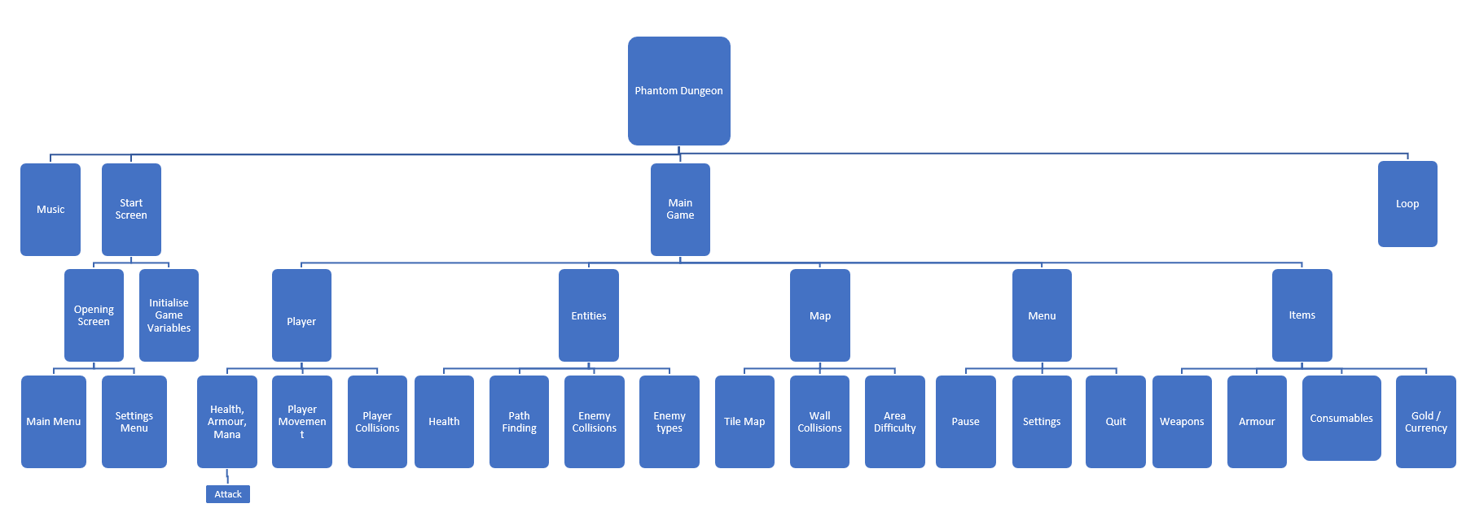

# **Classes and Justification of Structured Solution**

# **Start Screen**

The start screen will just be a screen displaying the title; game controls, options and quit (all 3 as buttons). The start screen will be a scene, which will be broken down into 2 classes, the SettingMenu and MainMenu class. The MainMenu class will be displaying the games controls and all the buttons, whereas the SettingsMenu class will be displaying the volume slider to control the games Master Volume. These will enable the player to understand how to play the game, and giving them the choice of playing or quitting before they begin.

|  |
| --- |
| class **MainMenu** |
| Int: buildIndex |
| PlayGame()  QuitGame()  GetActiveScene() |

The algorithm behind it accesses the build order of the scenes in unity ( which I ordered, having the Main Menu in index 0 and then the Main Game in index 1 ), and once the play button is pressed it changes to the next scene. For quitting it uses a line of code to stop the game from running – I couldn’t use Application.Quit() function as the game is not built, this line of code instead stops the game from running. I chose this method as it is an industry standard within unity games for how to switch scenes, and also how to control game buttons.

public class MainMenu

{

new procedure PlayGame ()

{

LoadScene(buildindex+1) ;

}

new procedure QuitGame ()

{

UnityEditor.EditorApplication.isPlaying = false;

}

}

|  |
| --- |
| class **SettingsMenu** |
| public AudioMixer audioMixer |
| SetVolume(float volume) |

The SettingsMenu class uses this algorithm to simply change the Master Volume, as all audio sources are attached to the Master Volume, including the background music which is played at all times. The function SetVolume is attached to the slider on the settings menu, so the slider can adjust the volume. This class is public as its function needs to be accessed by the slider object. I chose to do this pseudocode as volume sliders are very simple for the user to use, and they aren’t too complex to code; especially when I only need it to perform one simple function.

public class SettingsMenu

{

public AudioMixer audioMixer;

new procedure SetVolume (float volume)

{

audioMixer.SetFloat("volume", volume);

}

}

# **Music**

The first iteration of the game will only have background music for ambiance, which in itself doesn’t have any script behind it, however it is effected by the algorithm involving the volume changing slider (as shown above). But, in later iterations I hope to add a Music class which will change the music depending on the circumstances that the player is in, so for example when the player is in a battle, then battle music will play and the normal background music will halt.

|  |
| --- |
| class **Music** |
| Int: EnemyDistanceX  Int: EnemyDistanceY |
| ActivateBattle() |

The algorithm for this will check how far an enemy is from the player, and if it’s within a certain vicinity then the battle music will start playing and the background music will halt; if there are no more enemies in the vicinity then the battle music will stop and the background music will return. I’ve written the pseudocode in this way as it is an effect way of calculating the players distance between enemies and it will ensure the game music is adjusted in real time in relation to that distance; it is a common game practice to have “battle” music that is engaged when the player is near an enemy.

public class Music

{

Public Int EnemyDistanceX = Player.posX – Enemy.posX

Public Int EnemyDistanceY = Player.posY – Enemy.posY

new procedure ActivateBattle()

{

If EnemyDistanceX =< 6 and EnemyDistanceY =<6

{

BattleMusic.SetVolume(-20)

BackgroundMusic.SetVolume(-80)

}

Else

{

BattleMusic.SetVolume(-80)

BackgroundMusic.SetVolume(-20)

}

}

# **Player**

## Player Movement

The player movement class will consist of WASD controls for moving across the 2D plane, or alternatively using the arrow keys. The reason this class is vital is so that the player can move around and explore different rooms, as well as engaging in combat etc. Not only this, but the player will also have a left dodge and a right dodge to avoid enemy attacks, which will have a cooldown.

|  |
| --- |
| class **PlayerMovement** |
| Float: speed  rigidbody2D: Rigidbody2D |
| Start()  Update()  Move(Vector2 direction) |

The algorithm works by getting the horizontal and vertical inputs (via either WASD or arrow keys) and finding the direction using the Vector2 class (which is inbuilt to unity) and then combing the direction and speed to create the velocity in which the player will move (as velocity is a vector). The move method is called to calculate the velocity. This pseudocode is vital to ensure the player can move, and it is a well-recognised method of controlling player movement based on user input, and means the player can move in any direction.

public class PlayerMovement

{

public float speed = 3f;

private Rigidbody2D rb;

new procedure Start()

{

rb = GetComponent<Rigidbody2D>();

}

new procedure Update()

{

float horizontalInput = Input.GetAxis("Horizontal");

float verticalInput = Input.GetAxis("Vertical");

Vector2 movementDirection = new Vector2(horizontalInput, verticalInput);

Move(movementDirection);

}

new procedure Move(Vector2 direction)

{

velocity = direction * speed;

}

}

## Player Stats

The player stats class will consist of attributes of Health, Mana and Armour, that can all be affected by different objects, such as health potions, armour pieces etc. These stats will determine when the player dies, when abilities can be used, and an indication of how to prepare before and during battles.

|  |
| --- |
| class **PlayerStats** |
| Int: Health  Int: Mana  Int: Armour |
| getHealth()  getMana()  getArmour()  ModifyHealth(Int: amount)  ModifyMana(Int: amount)  ModifyArmour(Int: amount) |

The algorithm for this sets all base stats to 100 by default, and then can be accessed via the Get… procedures – these can be used to display the player stats onscreen at all times via another class. The stats can also be altered via the public procedures via any other class/object. Furthermore, when stats are changed, it checks whether they go below zero and if they do then it sets them back to zero, as stats below zero could cause many issues. I wrote the pseudocode in this way to ensure that any other class/method can affect the stats via the methods within the class: items and enemies will be able to alter the players stats depending on the intended effect; it also means that the player stats cannot be accidentally effected by an external class, as they’re only accessible via the methods within the PlayerStats class.

public class PlayerStats

{

private int health = 100

private int mana = 100

private int armor = 100

new procedure GetHealth()

{

return health;

}

new procedure GetMana()

{

return mana;

}

new procedure GetArmor()

{

return armor;

}

new procedure ModifyHealth(int amount)

{

health += amount;

if (health < 0)

{

health = 0;

}

}

new procedure ModifyMana(int amount)

{

mana += amount;

if (mana < 0)

{

mana = 0;

}

}

new procedure ModifyArmor(int amount)

{

armor += amount;

if (armor < 0)

{

armor = 0;

}

}

}

## Player Collisions

Player collisions isn’t a class, as it is using the Box Collider 2D property – which allows for the player to interact and come in contact with other 2D objects. The objects that the player will collide with will be the walls of the map, the enemies, visual objects (e.g. weapons, potions). Despite this not being a class, it is vital to ensure to that the player cannot phase through walls, and to use in battles to determine hit boxes for the player and enemies.

## Attack

The player will have an attack that will use the weapon the player has, and it will damage enemies. This will allow for players to kill enemies. The different types of attack will be broken up into ability attack (utilising the player ability) and standard attack (utilising the player weapon) to add variety to the combat experience.

|  |
| --- |
| class **StandardAttack** |
| Int: attackDamage  swordCollider: Collider2D  int: WeaponDelay |
| Attack(int damage, Collider2D collider)  HandleCollision(collision: Collision2D)  DisableWeaponCollider()  Execute() |

The algorithm for the Standard Attack will firstly define the attack damage of the player – depending on the weapon they have; it will then initialise attack with its attack damage and the collider respectively. It will activate the weapon collider so it will collide during it swinging, and then it will be disabled for weapon delay. The OnCollision procedure will decide if they weapon collider collided with the enemy, and then damage the enemy if that is true. The ability attack will be very similar to this with just a minor adjustment to the way in which the attack works – it’ll be launched as a projectile as opposed to a swing from a sword. I wrote this pseudocode in this way to ensure that the weapon is disabled when not being swung, and that there is a delay so that the player cannot attack too quickly, and 2D collisions is a very good method of doing this as the weapon will have it’s own collider shaped around itself.

public class Attack

{

private int attackDamage;

private Collider2D weaponCollider;

public Attack(int damage, Collider2D collider)

{

attackDamage = damage;

weaponCollider = collider;

}

new procedure Execute()

{

weaponCollider.enabled = true;

DelayTheDisabller()

}

new procedure DisableWeaponCollider()

{

weaponCollider.enabled = false;

wait FOR time(WeaponDelay)

}

new procedure HandleCollision(Collision2D collision)

{

if (collisionwithenemy = True)

{

enemyHealth = collided.enemy.health()

if (enemyHealth > 0)

{

enemyHealth.TakeDamage(attackDamage);

}

}

}

}

# **Entities**

## Health

Enemies will need health to not only determine when they die, but also for the player to determine how difficult they will be to defeat. Enemy health will fall under the enemy class, as it is just one component of each enemy object.

|  |
| --- |
| class **Enemy** |
| Int: Health |
| getHealth()  ModifyHealth(Int: amount) |

The health within the Enemy class will be a private variable that other classes can access via the GetHealth function and modify via the ModifyHealth() method, and it is vital for the game to be able to decide when an enemy is dead, and for the player to be able to see how “low health” an enemy is.

public class Enemy

{

private int health = 100

new procedure GetHealth()

{

return health;

}

new procedure ModifyHealth(int amount)

{

health += amount;

if (health < 0)

{

health = 0;

}

}

}

## Pathfinding

For the enemies to “find” and approach the player to attack, it must have an algorithm in which the enemy can identify where the player is, and the best way to approach them; for this I will use the well known A* algorithm, in which heuristics are utilised to calculate an estimated distance from the start node to end node, and then calculate a best path based on the weight of each heuristic. This will fall under the Enemy class also, but for demonstrating purposes I will abstract the class and only show the Pathfinding parts. The algorithm will use the well recognised code for A*, as it is difficult to alter the code for it, however I will use another piece of code to implement it into my game for enemy movement. The main I reason I chose the A* algorithm is due to the efficiency and effectiveness of the pathfinding algorithm, as it is very fast at calculating an optimum path; it can also be edited and utilised in a multitude of ways, which is vital for game development as the game is always changing.

Here is the pseudocode behind the A* algorithm, that I will utilise within my game.

Public function Pathfinding

{

Visited_List

Unvisited_List

append start_cell to Visited_List

LOOP

{

current_cell = cell in Visited_List with the lowest F_COST

remove current_cell from Visited_List

append current_cell to UnVisited_List

if (current_cell = finish_cell)

{

return

}

foreach adjacent_cell to current_cell

{

if (adjacent_cell is unwalkable or adjacent_cell is in Unvisited_List)

{

next adjacent_cell

}

}

if (new_path to adjacent_cell is shorter or adjacent_cell is not in Visited_List)

{

SET F_COST of adjacent_cell

parent of adjacent_cell = current_cell

if (adjacent_cell not in Visited_List)

{

append adjacent_cell to Visited_List

}

}

}

}

To utilise the code for the A* algorithm, I will have a class called EnemyMovement that takes the shortest path found by the A* algorithm and makes the enemy follow that path towards the player. It works by iterating through each path, and then adding it to a reached path list so it is identified when each path has been explored – as long as movedone is not false, which confirms whether the whole movement between start and end node is completed.

It then calculates the lastDirection as a vector between the current position of the GameObject (transform.position) and the wt element's cell coordinates. It then rounds those values.

Based on the lastDirection, it sets the movement vector. If the lastDirection is up, it sets movement.y to 1; if down, it sets movement.y to -1; if left, it sets movement.x to -1; if right, it sets movement.x to 1. Movedone is then set to true to indicate that the enemy is moving.

It also checks, once MoveDone is true, whether the enemy is within a very small distance of the player, if it is then it will stop the enemy from moving.

public class Enemy_Movement

{

Vector3 lastDirection = Vector3.zero;

bool moveDone = false;

List<WorldTile> reachedPathTiles = new List<WorldTile>();

New procedure Start()

{

}

New procedure Update()

{

MovementPerformed();

}

void MovementPerformed()

{

}

New procedure SetMovementVector()

{

if (path exists)

{

if (paths > 0)

{

if (!moveDone)

{

for (int i = 0; i < path.Count; i++)

{

if (reachedPathTiles.Contains(path[i])) continue;

else reachedPathTiles.Add(path[i]); break;

}

WorldTile wt = reachedPathTiles[reachedPathTiles.Count - 1];

lastDirection = new Vector3(Round(wt.cellX - transform.position.x), Round(wt.cellY - transform.position.y), 0);

if (lastDirection.Equals(Vector3.up)) movement.y = 1;

if (lastDirection.Equals(Vector3.down)) movement.y = -1;

if (lastDirection.Equals(Vector3.left)) movement.x = -1;

if (lastDirection.Equals(Vector3.right)) movement.x = 1;

moveDone = true;

}

else

{

movement = Vector2.zero;

if (Vector3.Distance(transform.position, player.position) <= .001f)

moveDone = false;

}

}

}

}

}

|  |
| --- |
| class **EnemyMovement** |
| Vector3: lastDirection  bool: moveDone  List: reahedPathTiles |
| Start()  Update()  SetMovementVector() |

## Enemy Collisions

Once again Enemy collisions isn’t a class, as it is using the Box Collider 2D property – which ensures that enemies will collide with their surroundings, including the walls, player and items. This will also serve as the enemies hitbox – where player weapons will collide with the enemy and cause damage. The 2D Box Collider will be attached to each enemy object, and will utilise the inbuilt 2D physics.

## Enemy Types

Enemy types will be 5 different types of enemies, that all inherit the enemy class, but will just have different stats – health and damage will be different. This will allow for variety for when the player faces battles, to make the game more challenging and diverse. These 5 different types of enemies will be split into “Grades”, from 1-5, 1 being the lowest and weakest grade.

|  |
| --- |
| class **Grade1 (inherits Enemy)** |
| Int: Speed |
| ModifySpeed(Int: amount) |

|  |
| --- |
| class **Grade2 (inherits Enemy)** |
| Int: Speed |
| ModifySpeed(Int: amount) |

|  |
| --- |
| class **Grade3 (inherits Enemy)** |
| Int: Speed |
| ModifySpeed(Int: amount) |

|  |
| --- |
| class **Grade4 (inherits Enemy)** |
| Int: Speed |
| ModifySpeed(Int: amount) |

|  |
| --- |
| class **Grade5 (inherits Enemy)** |
| Int: Speed |
| ModifySpeed(Int: amount) |

They will each having increasingly better stats as the grades increase, making them quicker, with more damage and more health.

# **Map**

## Tile Map

The tile map is essentially the background for the game, it has multiple layers to ensure that objects on the screen are displayed in the correct order, e.g. the player is above all layers as it has to walk over the terrain. The tile map is made up of the floor, the walls, objects, enemies, weapon and players, in that order exactly – with player being top layer. The tile map is vital for the visuals of the game, as it is also where sprites are displayed and it is used to decide where Box Colliders are supposed to be for the walls, objects, player and enemies. The Grid is what the tile map is broken up into, with each cell making up the entire grid; the grid has 3 objects, ground, path and wall.

## Wall Collisions

Wall collisions will just consist of static box colliders that are attached to tiles on the tilemap at the “Walls” layer, so they will dynamically fit around each wall – or anything else on that layer, to ensure that the player cannot walk through walls.

## Area Difficulty

Area difficulty links into the enemy types, as certain areas will have 1 type of grade enemies, so certain rooms will be more difficult due to it being a more difficult area. I will create each room individually, deciding logically where to put harder or easier difficulties.

# **Menu**

The pause menu will be very similar to the start menu, however instead of having a “START” button it will have a “RESUME” button. The functioning of the pause menu will require the game to be completely halted, and to open a new scene with the menu screen on it. This is necessary for if the player needs to take a break, change the settings, or even quit the game – for whatever reason. The pause menu will be accessible by pressing escape. Also for good practice, and to avoid conflicts, I will stop every movement action from being performed while pause is active, so this will require a check in each script involving movement to have a method to check whether pause is active or not; this is due to the fact that the way the game is being paused is by setting the game speed to zero, so everything involving time calculations (so movement etc.) will be stopped, but animations may still be affected, so to avoid any conflicts this is a necessary step.

|  |
| --- |
| class **PauseMenu** |
| Bool: gameIsPaused |
| Update()  PauseGame() |

The algorithm for this works by checking whether escape has been pressed, if it has then the pause method will be invoked, and the game will be paused. The “gameIsPaused” variable is used in other classes to check whether the inputs for movement should be ignored while the pause menu is open. It also activates the pause menu scene and deactivates the main menu scene. I chose to write this algorithm this way I wanted the input for the player to be simple so that the pause menu is easily accessible throughout the game; it is quite difficult to “pause” a game fully, so the best method (after doing research) was to freeze the games timer, as almost every method runs off a timed variable.

public class PauseMenu

{

public static bool gameIsPaused;

new procedure Update()

{

if (Input (Escape))

{

gameIsPaused = !gameIsPaused;

PauseGame();

}

}

new procedure PauseGame ()

{

if(gameIsPaused)

{

GameSpeed = 0;

PauseMenu.SetActive(True)

MainGame.SetActive(False)

}

else

{

GameSpeed = 1;

PauseMenu.SetActive(False)

MainGame.SetActive(True)

}

}

}

# **Items**

All items in game will be able to be picked up, to do this I will use a PickUp class that will have multiple child classes that have different effects once picked up.

|  |
| --- |
| class **PickUp** |
| Collider2D: collision |
| OnCollision() |

I chose to write the algorithm in this way as it destroys the object in the game, so it cannot be picked up or interacted with again, this ensures no errors will collisions or effects can take place.

public class PickUp

{

Override new procedure OnCollisions(Collider2D collision)

{

if (collision.tag == “Player”)

{

Destroy(GameObject)

}

}

}

## Weapons

Weapons are an integral part of the combat system, and they will need to be able to be “picked up” in the game; the player will only use/own one weapon at a time. Their weapon will be used as one of their forms of attack (the other being ability attack). The main focus of this point is the algorithm behind picking up and equipping a new weapon, as the battle mechanics have already been described with evidence.

|  |
| --- |
| class **WeaponPickup inherits PickUp** |
| Collider2D: collision |
| OnCollision() |

The algorithm for this will simply detect if the hitbox of the weapon is colliding with the hitbox of the player; if this is true then it will delete the object so the player picks it up. Depending on the weapon, the algorithm will be very slightly different – it will change the player equipped weapon to the name of the weapon they picked up, with its respective stats.

public class WeaponPickup

{

Override new procedure OnCollisions(Collider2D collision)

{

if (collision.tag == “Player”)

{

Destroy(GameObject)

Player.EquipWeapon(WeaponName)

}

}

}

## Armour

The player will have an armour stat, that will essentially function as a second health bar, and can be increased by finding pieces of armour around the map. The armour will share the same script as the WeaponPickup class, with minor adjustments.

|  |
| --- |
| class **ArmourPickup inherits Pickup** |
| Collider2D: collision |
| OnCollision()  ModifyArmour(int amount) |

The algorithm for the Armour will allow for armour to be picked up once the player collides with the armour, and then depending on the stats of the armour, it will correspondingly increase the armour of the player.

public class ArmourPickup

{

Override new procedure OnCollisions(Collider2D collision)

{

if (collision.tag == “Player”)

{

Destroy(GameObject)

Player.ModifyArmour(int amount)

}

}

}

## Consumables

Consumables will be potions in the game, which will apply special effects that will alter the stats of the player, such as a 20% increase in health, or 100 armour. These consumables will allow for the player to find useful boosts during the game to help fight enemies and defend themselves.

|  |
| --- |
| class **ItemPickup inherits PickUp** |
| String: Potion  Int: HealthEffect |
| Player.ModifyHealth(int HealthEffect) |

The algorithm for this will override the method in the PickUp class to alter it so that the players health will be modified. It will destroy the object when it is picked up so that the player cannot pick it up infinitely, and upon pickup it will alter the players health (or other stats, will depend on the specific item, and the code will be altered accordingly for each item).

public class ItemPickup inherits PickUp

{

Override new procedure OnCollisions(Collider2D collision)

{

if (collision.tag == “Player”)

{

Destroy(GameObject)

Player.ModifyHealth(int HealthEffect)

}

}

}

## Gold / Currency

Gold in this game will be used as a method of purchasing items, but also as a track of progress, as when you play more you will collect more gold naturally. As the item shop is not one of the essential features, I will mainly focus on displaying the amount of gold the player holds, and then display it on screen at all times. For this to work, the player class will need a gold variable added to it to keep count, as shown here:

|  |
| --- |
| class **Player** |
| Int: Gold |
| ModifyGold(int amount) |

|  |
| --- |
| class **GoldPickup inherits PickUp** |
| Int: amount |
| Player.ModifyGold(int amount) |

public class GoldPickup inherits PickUp

{

Override new procedure OnCollisions(Collider2D collision)

{

if (collision.tag == “Player”)

{

Destroy(GameObject)

Player.ModifyGold(int amount)

}

}

}

# **Loop**

The core mechanic of a rogue-like game is the fact that the game loops when you die, so you keep going until you “beat” the game – that is if there is an ending. In my game, there will be an ending which can be achieved, which will be when you kill the final enemy, so the algorithms for this will be 2 different things, firstly a loop where upon death the game resets and you play again; when the final enemy is killed the game ends and you get a win screen.

|  |
| --- |
| class **GameManager** |
| player: Player  enemies: Enemy[]  items: Item[]  InitialPlayerData: PlayerData  InitialEnemyData: EnemyData[]  InitialItemData: ItemData[] |
| Start()  ResetGame() |

The algorithm for this will work by saving the data of the player, every enemy and each item so that the initial state of each object can be reset upon the death of the player. The ResetGame function will be called upon the players death, within the update function in the player class. The reason I chose to the algorithm this way is because it negates any changes that happen during the game, as all the initial states of every object are stored at the very start, and then later returned to those states once the game resets upon player death – so it is an effective method of looping the game.

Public class GameManager

{

Private Player player

Private Enemy[] enemies

Private Item[] items

Private PlayerData initialPlayerData

Private EnemyData[] initialEnemyData

Private ItemData[] initialItemData

new procedure Start()

{

initialPlayerData = CreatePlayerData(player)

initialEnemyData = CreateEnemyDataArray(enemies)

initialItemData = CreateItemDataArray(items)

}

new procedure ResetGame()

{

player.ResetToState(initialPlayerData)

for each enemy in enemies:

{

enemy.ResetToState(initialEnemyData[enemy])

}

for each item in items:

{

item.ResetToState(initialItemData[item])

}

}

}

# **Usability Features**

## Description and sJustification of the design of the User Interface

For this section I will explain how the different menus will look and why I chose them to look and function that way. I will also provide previews of what the menu screens will look like, to help explain and justify my points.

## Main Menu

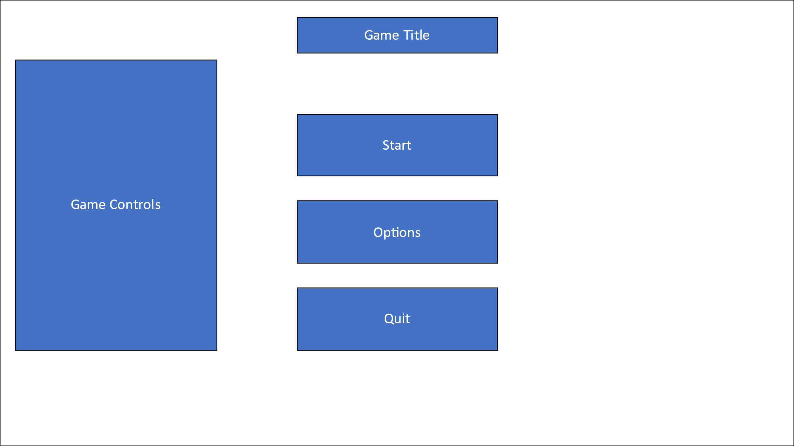











The main menu is vital as it is the first thing the player will see when loading my game, and it needs to be easy to use so that the player has a seamless experience. Firstly, the game title (5) will stand out in a bold font and a classy design, to ensure that the player knows what game they are playing. Then the interactable buttons are the “START” button (1), which will launch the player into the game; the “OPTIONS” button (2) which will take the player to the options screen to customize their gaming experience as an addition; the “QUIT” button (3) which will allow the player to exit the game if they do not wish to continue playing.

Not only this, but there are also all the game controls (4) on the left hand side of the screen to allow for the player to become familiar with the controls of the game before they even play, which is a very useful feature ( game controls will also be displayed in the pause menu in case players forget any controls during gameplay ).

I chose to have a main menu as it is standard among almost all video games, as it provides the player with an intro to the game as it establishes a mainframe to interact with the different elements of the game before it is actually played, hence I declared it as a vital feature, and not optional.

## Options Menu

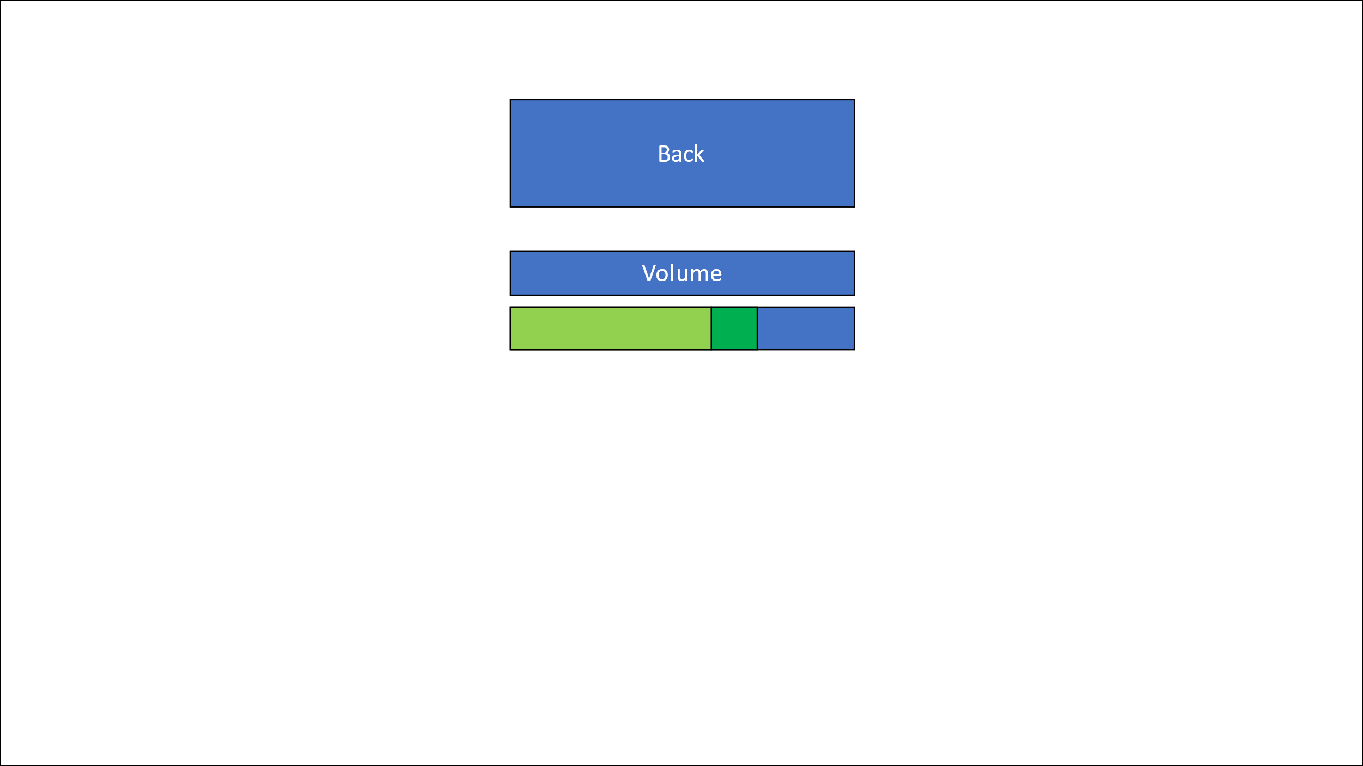

The options menu is an extra usability feature as it is not necessary, but I will implement it as it allows for an element of personal customization for the player. I initially only plan to add a volume slider (1) so the player can control the overall game volume to their liking, and other options (such as resolution change) can be added if time constraints allow for it.

It consists of a “BACK” button (2) which will take you back to the main menu, and a volume slider, so the player can manually change the volume of the game (this includes any music or sound effects).

## Main Game HUD

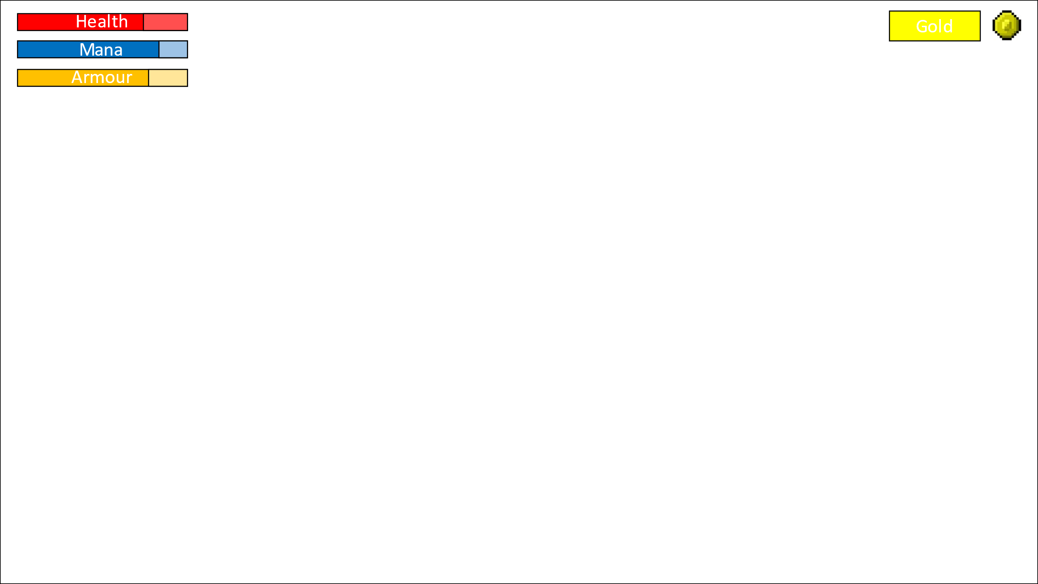

The main game HUD is important for displaying information to the player at all times, and it will displayed constantly over the main game. The information being displayed is: the player’s health (1), mana (2) and armour (3), as well as the amount of gold (4) the player has. Health is vital to how the player will make decisions – e.g. if the player has low health then they may try not to enter combat and instead try and find a health potion. The amount of mana the player has will determine whether they can use their ability or not, so this needs to be shown to the player at all times. Armour acts as essentially a second health bar, so is a good indication of how “strong” the player is at the current moment, and therefore is also important to show. The displaying of gold is more of an indication of how far along the player is in the game (as you collect more gold as you play more of the game) but it will also be used to spent in the shop (if the shop is created) so they will need to know how much gold they have to spend.

## Pause Menu

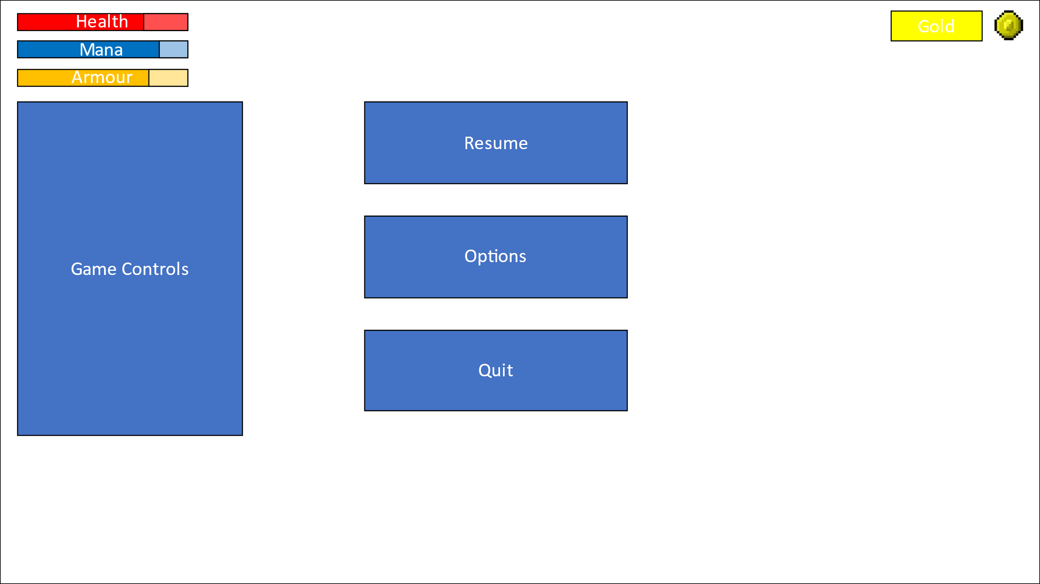

The pause menu is vital to be able to halt the game for a multitude of reasons, but it provides an interface for the player to either: “RESUME” (1), where the game will unpause and continue as normal; “OPTIONS” (2), where the player can access the volume slider again to change the volume during the game; “QUIT” (3), where the player can quit during the game. It will also display the game controls in case the player needs a reminder of the controls. The game HUD will still be displayed also as the player may want to see their stats, even when paused.

# **Class Diagram Summary**

|  |
| --- |
| class **MainMenu** |
| Int: buildIndex |
| PlayGame()  QuitGame()  GetActiveScene() |

|  |
| --- |
| class **SettingsMenu** |
| public AudioMixer audioMixer |
| SetVolume(float volume) |

|  |
| --- |
| class **PauseMenu** |
| Bool: gameIsPaused |
| Update()  PauseGame() |

|  |
| --- |
| class **PlayerMovement** |
| Float: speed  rigidbody2D: Rigidbody2D |
| Start()  Update()  Move(Vector2 direction) |

|  |
| --- |
| class **PlayerStats** |
| Int: Health  Int: Mana  Int: Armour |
| getHealth()  getMana()  getArmour()  ModifyHealth(Int: amount)  ModifyMana(Int: amount)  ModifyArmour(Int: amount) |

|  |
| --- |
| class **Player** |
| Int: Gold |
| ModifyGold(int amount) |

|  |
| --- |
| class **Music** |
| Int: EnemyDistanceX  Int: EnemyDistanceY |
| ActivateBattle() |

|  |
| --- |
| class **EnemyMovement** |
| Vector3: lastDirection  bool: moveDone  List: reahedPathTiles |
| Start()  Update()  SetMovementVector() |

|  |
| --- |
| class **Enemy** |
| Int: Health |
| getHealth()  ModifyHealth(Int: amount) |

|  |
| --- |
| class **Grade1** |
| Int: Speed |
| ModifySpeed(Int: amount) |

|  |
| --- |
| class **Grade2** |
| Int: Speed |
| ModifySpeed(Int: amount) |

|  |
| --- |
| class **Grade3** |
| Int: Speed |
| ModifySpeed(Int: amount) |

|  |
| --- |
| class **Grade5** |
| Int: Speed |
| ModifySpeed(Int: amount) |

|  |
| --- |
| class **Grade4** |
| Int: Speed |
| ModifySpeed(Int: amount) |

|  |
| --- |
| class **StandardAttack** |
| Int: attackDamage  swordCollider: Collider2D  int: WeaponDelay |
| Attack(int damage, Collider2D collider)  HandleCollision(collision: Collision2D)  DisableWeaponCollider()  Execute() |

|  |
| --- |
| class **GameManager** |
| player: Player  enemies: Enemy[]  items: Item[]  InitialPlayerData: PlayerData  InitialEnemyData: EnemyData[]  InitialItemData: ItemData[] |
| Start()  ResetGame() |

|  |
| --- |
| class **PickUp** |
| Collider2D: collision |
| OnCollision() |

|  |
| --- |
| class **ItemPickup** |
| String: Potion  Int: HealthEffect |
| Player.ModifyHealth(int HealthEffect) |

|  |
| --- |
| class **WeaponPickup** |
| Collider2D: collision |
| OnCollision() |

|  |
| --- |
| class **ArmourPickup** |
| Collider2D: collision |
| OnCollision()  ModifyArmour(int amount) |

|  |
| --- |
| class **GoldPickup** |
| Int: amount |
| Player.ModifyGold(int amount) |

# **Identifying key variables / data structures / classes**

I will use a table that shows all of my key variables within Phantom Dungeon, with a justification of each variable and their respective class.

|  |  |  |  |  |
| --- | --- | --- | --- | --- |
| **Class** | **Variable** | **Data Type** | **Explanation / Justification** | **Example** |
| MainMenu | buildIndex | int | This variable will be utilised to control which scene is being displayed at what point, and I’ve used it as it is an effective method at knowing which scene is being loaded; in the correct order . | LoadScene(buildindex+1) ; |
| SettingsMenu | audioMixer | AudioMixer | This variable accesses the volume of the whole game – the master volume. It is vital as it allows for the player to customise the volume of the sounds of the game to their liking via a volume slider. | audioMixer.SetFloat("volume", volume); |
|  | volume | float | The volume variable is used to input into a function under the audioMixer library to change the volume of the game – I named the parameter “volume” as it is controlling the volume, so makes logical sense. | audioMixer.SetFloat("volume", volume); |
| Music | EnemyDistanceX | Int | The X distance calculates how far the enemy is in relation to the player in the X-axis, and is then used to decide when the battle music starts palying | If EnemyDistanceX =< 6 and EnemyDistanceY =<6 |
|  | EnemyDistanceY | Int | Similarly, the Y distance calculates how far the enemy is in relation to the player in the Y-axis, and both the X and Y distances are used in combination to determine when the enemy is in range. | If EnemyDistanceX =< 6 and EnemyDistanceY =<6 |
| PlayerMovement | speed | Float | The speed variable controls the speed of the player, in combination with the direction to give the velocity (a vector) and it is vital for correct and balanced player movement. | velocity = direction * speed; |
|  | RigidBody2D | rigidbody2D | This variable is used to identify the “body” of the player and attach all of the movement functions to it, so it actually moves the player – so it is essential for player movement. | rb = GetComponent<Rigidbody2D>(); |
| PlayerStats | health | int | The player health will decide when the player is dead or not, and will be displayed at all times to determine how “damaged” the player is, and is a core mechanic of every game that involves battles. | health += amount; |
|  | mana | Int | The player mana will be used to determine whether the player can use an ability attack, and can be regenerated overtime or with potions; it balances out abilities so they can’t be used repetitively. | mana += amount; |
|  | armour | Int | The player armour will effectively act as a second health bar, and is useful as a good preparation for a battle that the player is about to enter. | armour += amount; |
| StandardAttack | attackDamage | int | The attack damage will determine the damage the player will inflict on enemies via their weapon – so it will depend on the strength of their weapon; it creates an incentive to find better weapons during the game. | enemyHealth.TakeDamage(attackDamage); |
|  | weaponCollider | Collider2D | The weapon collider is used to determine when the weapon collides with an enemy collider, so that the player can be damaged, and is a fundamental of a battle system. | weaponCollider.enabled = false; |
| Enemy | Health | Int | Enemy health will determine when they are dead, and as an indication as to how strong an enemy is to the player. | return health; |
| EnemyMovement | lastDirection | Vector3 | This variable is vital for ensuring the enemy moves in the correct direction, as it is used to calculate the last direction the enemy was moving in. | lastDirection = new Vector3(Mathf.Ceil(wt.cellX - transform.position.x) |
|  | moveDone | bool | moveDone is crucial for controlling when movement is completed; it acts as a flag to signal whether the enemy is currently moving or not. | if (!moveDone) |
|  | reachedPathTiles | List | reachedPathTiles maintains a list of tiles that have been reached during movement. It helps keep track of progress along a predefined path. This variable is important for pathfinding and ensures that the enemy follows the correct route, avoiding revisiting the same tiles. | reachedPathTiles.Add(path[i]); |
| Menu | gameIsPaused | Bool | This variable is used to show when the game is paused or not, and then effects the game accordingly – it will freeze the main game and activate the pause menu. | if(gameIsPaused) |
| PickUp | collisions | Collider2D | This variable is used to check what object the player has collided with, utilising the inbuilt collision physics; then the object is destroyed and the player acquires the object. | Override new procedure OnCollisions(Collider2D collision) |
| Player | Gold | Int | The gold variable will keep track of the amount of money the player has, in which they can spend in the shop and I chose it as a good measure of the players progress through the game. | Player.ModifyGold(int amount) |
| GameManager | player | Player | This variable will access all of the player object’s data and is vital to ensure that when the player dies, their data is erased and the game loops. | initialPlayerData = CreatePlayerData(player) |
|  | enemies | Enemy[] | Similarly, this accesses every enemies’ data so it can be wiped. | initialEnemyData = CreateEnemyDataArray(enemies) |
|  | items | Item[] | Similarly, this accesses every items’ data so it can be wiped. | initialItemData = CreateItemDataArray(items) |
|  | initialPlayerData | PlayerData | This variable is where the initial state of the player object is stored – when the game is first loaded, so that the player can be restored to that state upon death. | initialPlayerData = CreatePlayerData(player) |
|  | initialEnemyData | EnemyData[] | Correspondingly, this is used to store the initial state of all enemies so they can be restored to this state. | initialEnemyData = CreateEnemyDataArray(enemies) |
|  | initialItemData | ItemData[] | The same for all of the items in the game, so in total all objects are restored to their initial state and the game loop continues. | initialItemData = CreateItemDataArray(items) |

# **Test Data for Development**

To ensure that my game fully functions are expected in regards to visual output and the logic output (such as how stats are effected or damage effects), I will do iterative testing throughout the development of the coded solution.

This will be presented in the form of a table, in which there is: the condition being tested identified, the input for the condition being identified, and the expected outcome from the condition.

|  |  |  |  |
| --- | --- | --- | --- |
| **Test Item** | **Input** | **Expected Outcome** | **Justification** |
| Player Movement | WASD keys, or arrow keys | The player on screen should move up (W), left (A), down (S) and right (D) with the respective key press; if there is a wall in the way then the player shouldn’t be able to move into it also.  Also if player holds 2 keys down – e.g. W and D – then the player should move diagonally. | Player movement is a vital part of the game and must be tested to ensure all player inputs are translated on the screen as expected. |
| Collisions (Player, world, enemies,items) | Any collision that could take place – e.g. player walking into wall | * For the player walking into a wall scenario, the player must collide with the wall and not be able to phase through it. * Another example is that enemies should “bounce” off players and not phase through them also. Enemies should also collide with walls and not be able to go through them. | Enemy collisions are vital as it ensures a balanced, immersive experience as long as the collisions are functioning, hence they must be tested to check they are working as intended. |
| Enemy Death | Enemy health falls to 0 (via an attack from the player) | When an enemy is killed (when their health is 0) the enemy object must be deleted so the enemy doesn’t exist in the game anymore. | Enemies dying is vital, as players must be able to kill the enemies that approach them; a test is important as it needs to be checked that when enemies health falls to zero they die – which is quite a simple test. |
| Enemy Movement | Enemy is within a certain distance of the player | The enemy should “chase” the player when they are within range, they should be taking a path around obstacles, that is logical and also close enough to the “quickest route”. The enemy should not get stuck on any walls or objects. | The A* algorithm is quite a complex algorithm that must be tested thoroughly to ensure each part of it is working as intended; this will require multiple test runs to ensure enemies are following correct routes. |
| Enemy Types | When a player enters a certain area different types of enemies should be spawned | * There should be different rooms which spawn different level of enemies. * Each different level of enemy should have different stats. * Grade 1 are the weakest, grade 5 the strongest; their stats should reflect this. | The enemy types section is important for adding an extra layer of difficulty, and there’s many areas where it could go wrong, especially with spawning issues, so it requires a thorough testing. |
| Player Death | Player health falls to 0 | When the player dies a death screen must be displayed, and the game will be effectively reset after that. | The player death is a core mechanic of any game where the player has health, and it is vital that the player dies when their health falls to zero, so it will require constant monitoring and testing of player health to ensure they die when expected. |
| Item Pickup | Player collider collides with the item collider | Once the player makes contact with the item the item object should be deleted so that it is no longer in the game; the player will have acquired the item with its respective effects (so if a new weapon they will equip the new weapon, if it is a potion then the effects of the potion will be activated). | There is a large margin for error when the player picks up an item: the game object could not delete correctly; the player could not equip or use that item; the item may not visually be removed. Therefore it is vital each section of the item pickup algorithm is tested. |
| Player Attack | When the player presses left mouse button the player should use their standard attack | * When the player presses LMB the weapon the player has should be swung and then there should be a delay before they can swing again. * The weapon should have a collider that, if it hits an enemy, should damage them. * The attack should also knock back the enemy slightly. | As there is so many layers to the player attack it is important that each of those layers are tested individually and then all together as this is a major mechanic of the game – allowing for the player to kill enemies. |
| Music | When the player gets close to enemies it will change from background music to “battle” music | When the player comes into a certain vicinity of an enemy the music should switch from the standard background music to the battle music, it should also switch back after all enemies within that vicinity are dead, or if the player escapes that vicinity. | This test is important but also quite simple to perform and very effective, as the player only has to run towards an enemy then escape or kill that enemy; whilst listening to the change in the music. |
| Main Menu | * Player clicks START button * Player clicks OPTIONS button * Player clicks QUIT button * When game is run the controls should be displayed on the main menu | * When START button is clicked the main game should launch, and so the scene should switch from MainMenu to MainGame. * When OPTIONS button is clicked the options menu should be displayed. * When QUIT button is clicked the game should be exited and stop running. * The controls of the game should be displayed on the main menu. | The main menu is the firs thing the player sees so it is vital that it all functions correctly; each button on the main menu has very important functions that allow for the player to initialise the game, so testing each button is of upmost importance. |
| Options Menu | * Player clicks RESUME button * Player clicks OPTIONS button * Player clicks QUIT button * Game controls are displayed | * When RESUME button is clicked the game is unpaused and the resume menu is hidden. * When OPTIONS button is clicked the options menu should be displayed. * When QUIT button is clicked the game should be exited and stop running. * The controls of the game should be displayed while the pause menu is open. | The pause menu is important as it allows for players to halt the game; if the pause function does not work correctly then it could cause many conflicts within the game, so it is important that it is tested in depth. |

## Test Data for Beta Testing

Once all of the iterative tests have been completed, my game will enter a beta testing phase where I will produce a semi-finished product that users can test and give feedback on any flaws, bugs or also good points.

Beta testing is a vital part of game development as it very helpful to see if your game is meeting its initial goals and that it reaches its target audience’s expectations before full release. Here are some examples of games that underwent or are still in beta testing:

* Fortnite
* PayDay 3
* Escape from Tarkov
* Starfield

The way in which my beta testing will be achieved is by distributing a version of Phantom Dungeons to people I know around me – to ensure that I will receive quick and quality feedback that should be useful for the further development of my game. Normally beta tests are done over a very large scale (for large games such as COD or FIFA) but due to the scale of my game I will only be able to provide beta tests amongst my peers, not the whole world; my beta version of my game will also of course be free as it is not becoming a published game.

## Post Development Tests

Each of these tests are essential features that ensure the game actually functions as intended. Some of these tests have been pulled from the table above (and the justification is all the same), as they are the same tests that will done iteratively, as well as at the very end of the development to ensure that each module works together.

|  |  |  |  |
| --- | --- | --- | --- |
| **Test Item** | **Input** | **Expected Outcome** | **Justification** |
| Player Movement | WASD keys, or arrow keys | The player on screen should move up (W), left (A), down (S) and right (D) with the respective key press; if there is a wall in the way then the player shouldn’t be able to move into it also.  Also if player holds 2 keys down – e.g. W and D – then the player should move diagonally. | Player movement is a vital part of the game and must be tested to ensure all player inputs are translated on the screen as expected. |
| Collisions (Player, world, enemies,items) | Any collision that could take place – e.g. player walking into wall | Any game object has a collision, others objects cannot walk through them. | Enemy collisions are vital as it ensures a balanced, immersive experience as long as the collisions are functioning, hence they must be tested to check they are working as intended. |
| Enemy Death | Enemy health is 0 | When an enemy is killed (when their health is 0) the enemy object must be deleted so the enemy doesn’t exist in the game anymore. | Enemies dying is vital, as players must be able to kill the enemies that approach them; a test is important as it needs to be checked that when enemies health falls to zero they die – which is quite a simple test. |
| Enemy Movement | Enemy is within a certain distance of the player | Enemies should follow the player when within range. | The A* algorithm is quite a complex algorithm that must be tested thoroughly to ensure each part of it is working as intended; this will require multiple test runs to ensure enemies are following correct routes. |
| Player Death | Player health falls to 0 | When the player dies a death screen must be displayed, and the game will be effectively reset after that. | The player death is a core mechanic of any game where the player has health, and it is vital that the player dies when their health falls to zero, so it will require constant monitoring and testing of player health to ensure they die when expected. |
| Item Pickup | Player collider collides with the item collider | When player walks over an item they pick it up and equip (for weapons) or use it (for consumables). | There is a large margin for error when the player picks up an item: the game object could not delete correctly; the player could not equip or use that item; the item may not visually be removed. Therefore it is vital each section of the item pickup algorithm is tested. |
| Player Attack | When the player presses left mouse button the player should use their standard attack | Player presses LMB and swings their weapon, upon collision of the enemy it will damage and knock-back them. | As there is so many layers to the player attack it is important that each of those layers are tested individually and then all together as this is a major mechanic of the game – allowing for the player to kill enemies. |
| Music | When the player gets close to enemies it will change from background music to “battle” music | When the player comes into a certain vicinity of an enemy the music should switch from the standard background music to the battle music, it should also switch back after all enemies within that vicinity are dead, or if the player escapes that vicinity. | This test is important but also quite simple to perform and very effective, as the player only has to run towards an enemy then escape or kill that enemy; whilst listening to the change in the music. |
| Main Menu | * Player clicks START button * Player clicks OPTIONS button * Player clicks QUIT button * When game is run the controls should be displayed on the main menu | * When START button is clicked the main game should launch, and so the scene should switch from MainMenu to MainGame. * When OPTIONS button is clicked the options menu should be displayed. * When QUIT button is clicked the game should be exited and stop running. * The controls of the game should be displayed on the main menu. | The main menu is the firs thing the player sees so it is vital that it all functions correctly; each button on the main menu has very important functions that allow for the player to initialise the game, so testing each button is of upmost importance. |
| Options Menu | * Player clicks RESUME button * Player clicks OPTIONS button * Player clicks QUIT button * Game controls are displayed | * When RESUME button is clicked the game is unpaused and the resume menu is hidden. * When OPTIONS button is clicked the options menu should be displayed. * When QUIT button is clicked the game should be exited and stop running. * The controls of the game should be displayed while the pause menu is open. | The pause menu is important as it allows for players to halt the game; if the pause function does not work correctly then it could cause many conflicts within the game, so it is important that it is tested in depth. |

# **Developed Coded Solution**

## **Phase 1 - Main Menu**

To start off the creation of my game I will need my main menu, as it is the firs thing that the player will be presented with when they open the game. My main menu will consist of the title of the game (Phantom Dungeon), a start button to enter into the actual game, an option button to open the options menu, a quit button to exit the game, and finally the basic game controls on the side of the main menu so the player knows how to control their in game character before entering the game.

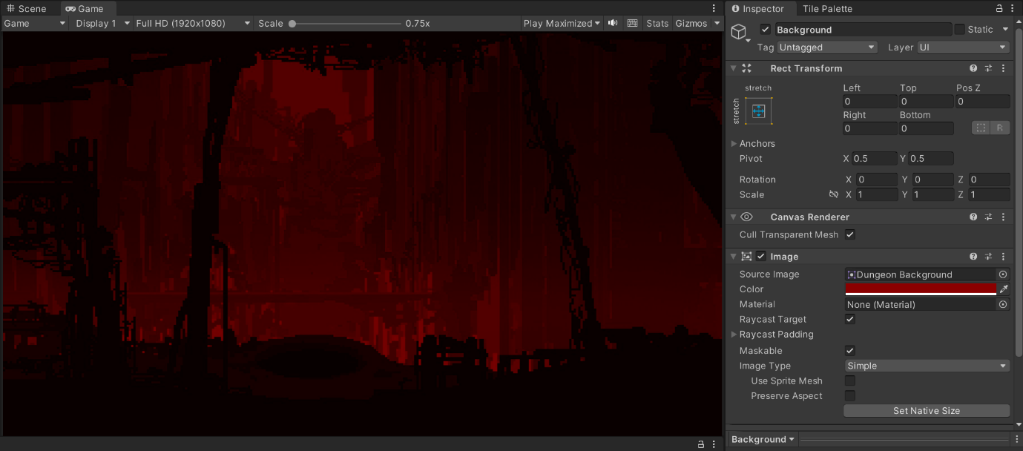Firstly, I have created a new scene, and then created a canvas so that I can add all of my buttons and my background to the main menu. I have then created a background object to make the main menu look appealing, as shown:

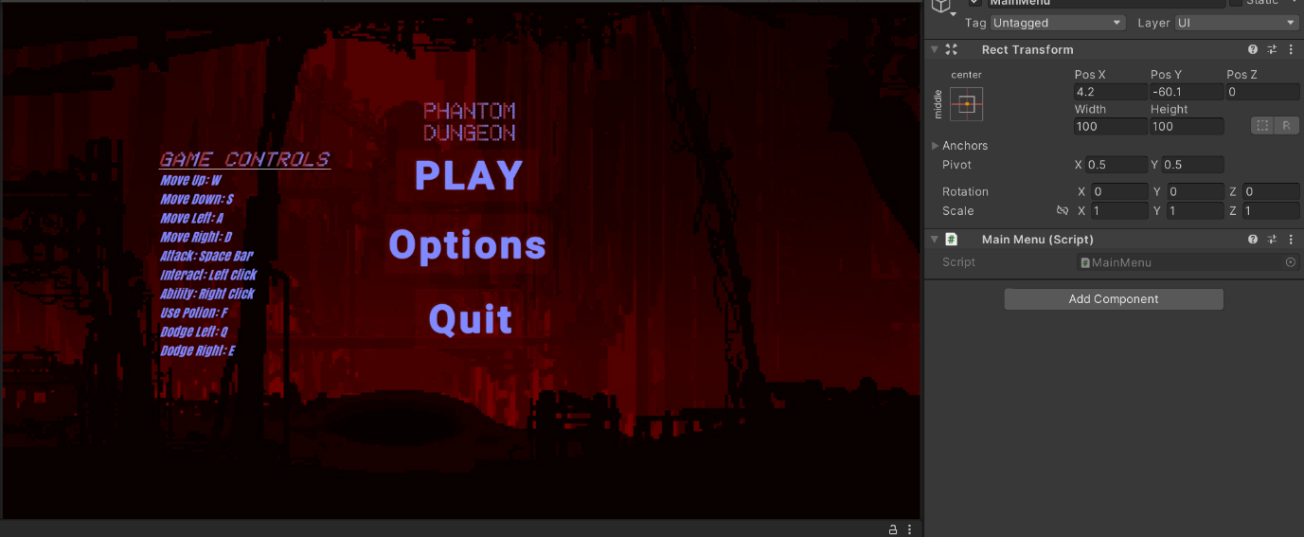The basis of all of the buttons and text on the screen will come from my main menu object, with button objects for all the interactable, and text objects for all the information needed.

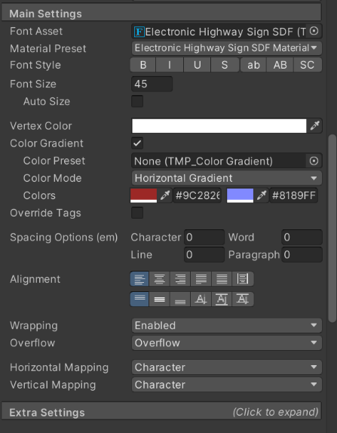I added a colour gradient to the text to add further to the appeal of the main menu.

Each button object has its own text object within it, as the button itself has no text – just an interactable button, so I used Text TMP to write the text; all the buttons and their text are named respectively to ensure that the naming is clear so I know which objects apply to each other, and how they should be interacting, as shown:

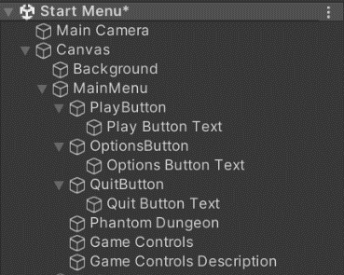

Next is the functionality of each object, to start with the Play button, I need it to switch to the main game scene upon being pressed, so I have created a script to do so and attached it to the PlayButton, and then instructed it to activate the script upon being pressed. To do this I have made a MainMenu script, that is also used to quit the game as well:

Upon pressing the PlayButton it access the PlayGame method, which loads the next scene in the build index of the scenes, and I have made it so the Main Menu scene is first, then the Main Game scene is second; this means the Main Game scene is opened upon button press.

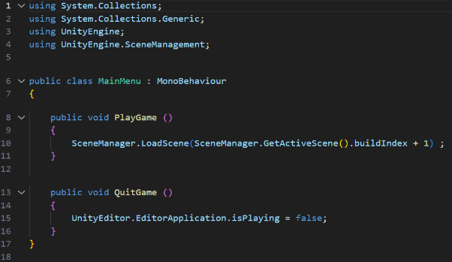

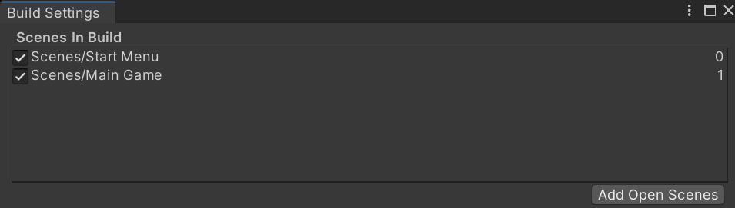

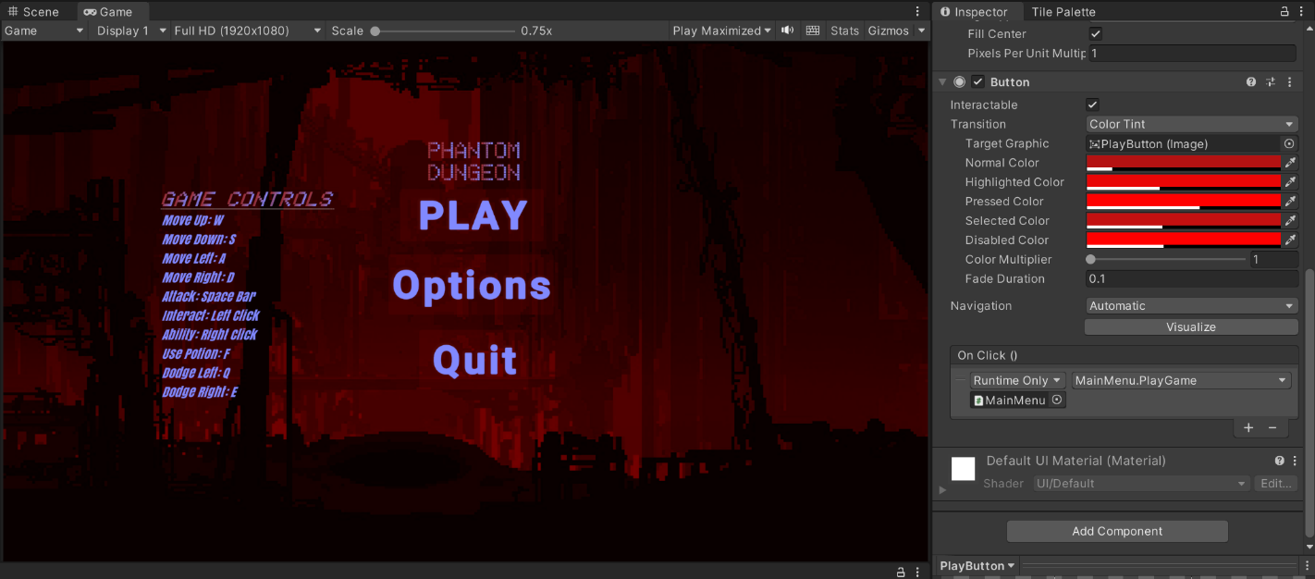

This functionality has been repeated for the QuitButton, upon being pressed it accesses the MainMenu script and uses the QuiteGame method to exit the game.

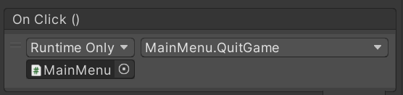

Next the options button needs to be added; the way I will achieve this is by hiding the whole of the MainMenu, so the functionality of all the objects within the MainMenu object will be deactivated (essentially hidden) and then the OptionsMenu object can be activated and displayed. This will be using the On Click() method provided by the unity editor as shown:

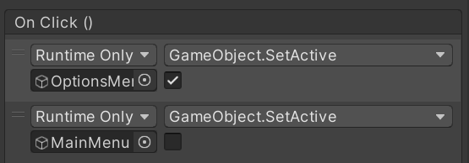

Finally, the options menu will complete the MainMenu scene, then I can test to ensure each component of the main menu works. This consists of 3 different objects: the title of “Options”, the volume slider (with a title) and a back button (to return to the Main Menu). The options menu is created with Text TMP again, and follows the same colour scheme as the other text on the main menu; the volume slider “volume” title follows the same format. The volume slider itself is a slider object built into the unity editor, which allows the user to move the slider to either fill or unfill the area within the slider; I have written a script that utilizes this slider to alter the volume of the overall game accordingly (more area on slider = louder volume).

This script is then attached to the volume slider object, so that the SetVolume method can be accessed by the slider – the audiomixer is the master volume of the whole game (MainMixer).

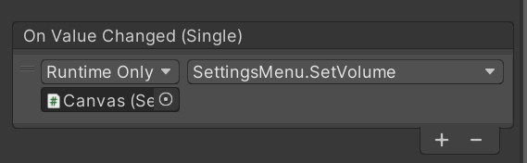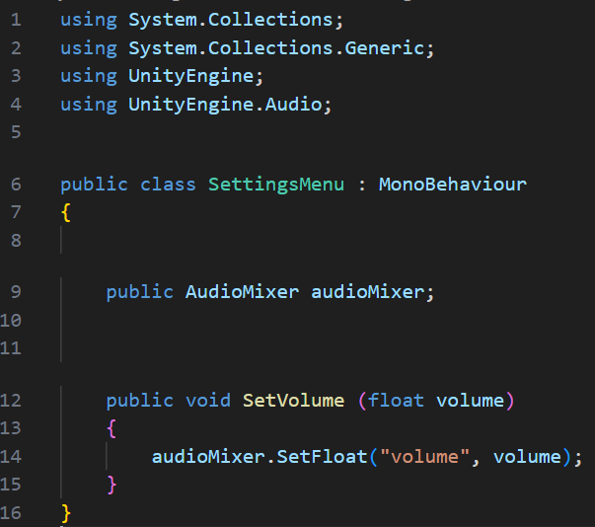

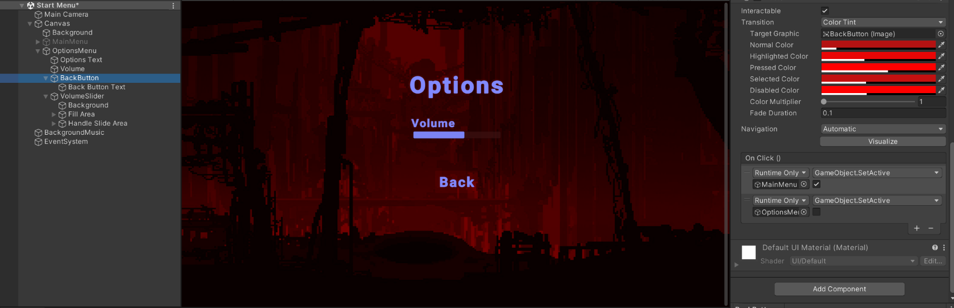Next, the Back Button needs to do the opposite of what the settings menu button did, so it will activate the MainMenu object so that all the text and buttons of the Main Menu appear, and deactivate the OptionsMenu object so that all of it is hidden.



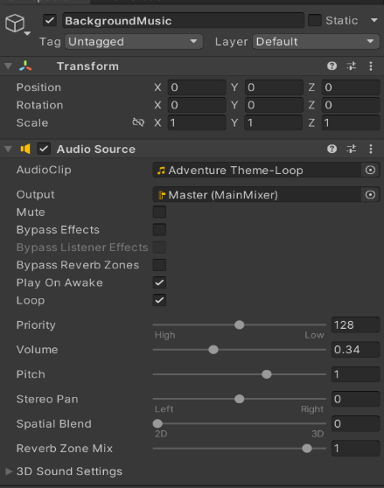One final touch is the background music that needs to be added, not only will this add some depth to the game but it will allow the volume slider to be tested as well (otherwise there’d be no way to test if the volume is actually being changed during the playing on the game). I have done this by adding an audio object to the MainMenu scene, which has an audio clip attached to it that I have imported into the game; this is then outputted via the MainMixer of the game, which is the master volume (so the volume slider will adjust the volume of the music).

### Main Menu Tests

|  |  |  |  |
| --- | --- | --- | --- |
| What is the test and why test it? | Expected Outcome | Successful? | Improvements |
| Start button takes you into the game – this is vital for the commencing of the game | Upon clicking the start button the scene switches to the main game | Yes | None |
| Quit button exits the game – necessary so the player can leave the game | Upon clicking the quit button the game exits completely | Yes | None |
| Options button takes you to the options menu – this is so the player can alter their settings | Upon clicking the options button the main menu is hidden and the options menu shown | Yes | None |
| Volume Slider adjusts the in game master volume – so the background volume and any other sounds can be adjusted | As you move the slider to the right it increases the volume, and vice versa | Yes (Used audio monitor to ensure that it does adjust master volume) | Could possibly split different sounds into different volume categories later |
| Back button to return to main menu – so you can go back to either starting or quitting the game | The options menu is hidden and the main menu is shown again | Yes | None |

### Phase 1 Review

In phase one I wanted to complete the main menu before the player enters the game, which has been successfully done. All the buttons and functions work exactly as they should, with only minor room for improvement; this will lead perfectly onto the rest of the development process, which will be working on the Main Game.

## **Phase 2 – Tile Map / Background Layers**

The Main Game will be built around the map, with the player exploring the different corners and dungeon rooms of the map, so it is important that it is wide, varied and appealing. The map is built off a grid, with a tile map upon it, placed in layers (the layers are important for collisions and visual effects).

To create the tile map I have imported multiple tile map visual resources that are all in a retro dungeon theme to fit the theme of “Phantom Dungeon”.

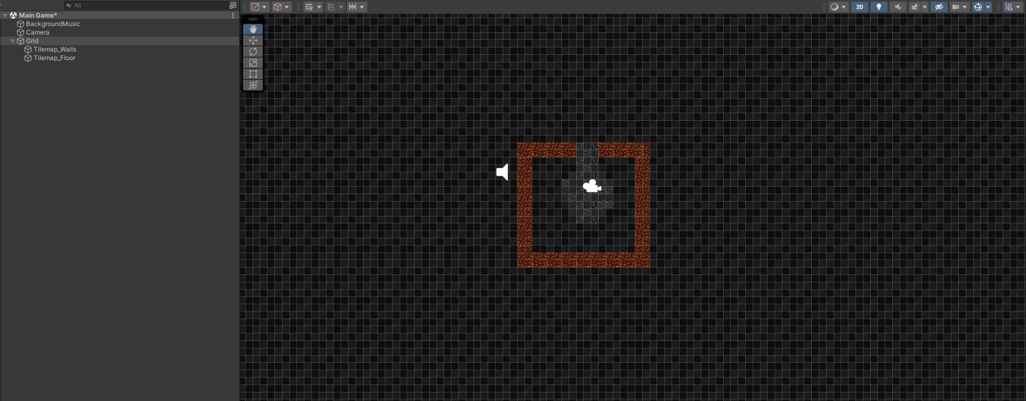To start with, I have painted a layer of a giant floor of tiles, to allow for the area that the player can explore, and then added another layer for the walls to be placed on; I have made a basic starting room to ensure that everything functions as expected.

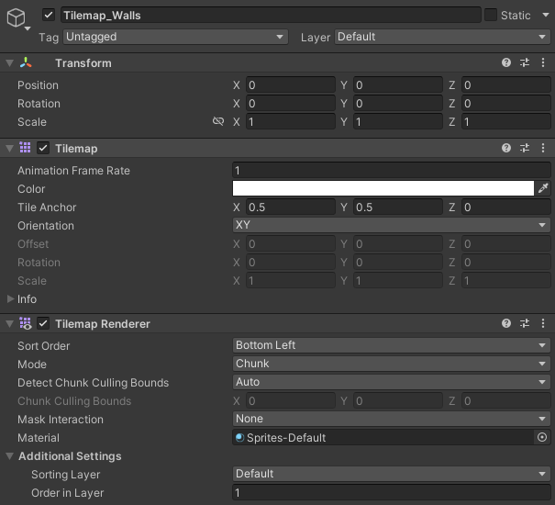The wall layer is placed higher in the order of layers than the floor layer, as the walls need to be ontop of the floor so they can be seen.

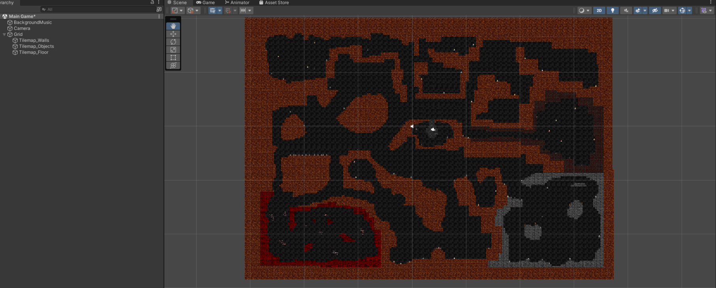Now that a basis of the map has been built, I will create the rest of the map, with all the rooms, and decorative objects so that the map is wide and varied for the player to explore. Furthermore, another layer for objects will be made and placed at the same layer as walls (so they are above the floor and can be seen).

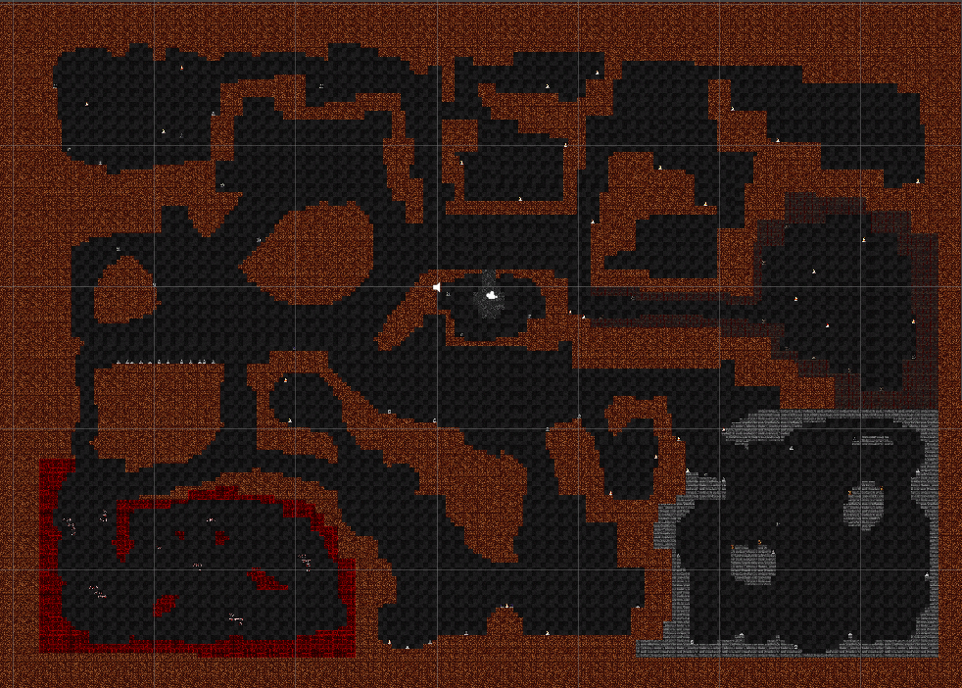This is the map I have created, it consists of a series of rooms, walkways and objects scattered throughout.

### Phase 2 Review

For this phase I set out to create the map upon which the game will be based in, and I have achieved that perfectly. The map is complex and detailed enough so that the player will have a fun experience exploring the different rooms and finding loot. I do need to add collisions to all the walls but that will be done after the player character has been created, as they will be used to test the wall collisions.

## **Phase 3 – Player Character**

The player character is arguably the most important component of the game, and it’s what the player controls to collect loot, kill monsters and win the game. The player object is a sprite within the game, that will have scripts that create all of the functions of the player (movement, collisions, attacks, pickup items). Not only this, but I will also add animation to the player movement so that the movement will look more natural and fluid.

## Player Sprite Creation

Firstly, I need to add the player sprite object, add a sprite (skin) to it and add a Rigid Body 2D to it to ensure that it can interact with objects, and it’s used for the movement as well. I have renamed the object to player so that it is easy to identify which object the player is; I have added its rigid body, turned the gravity scale to 0 so that it doesn’t fall to the bottom of the map and I’ve froze its Y rotation, so that the player doesn’t spin around.

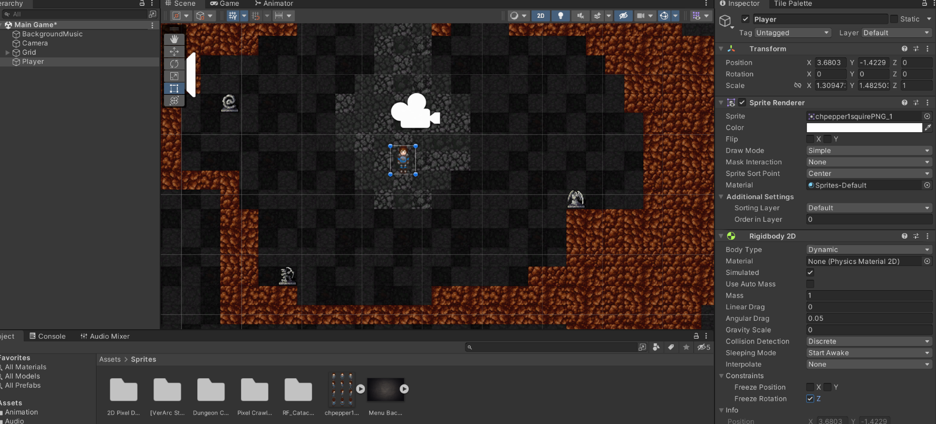

### Player Movement

Next I will implement a player movement script to allow for the player to control the player character within the game via using WASD or arrow keys (their preference). The player movement script will be attached to the player object as a component. The script works by getting the x and y input from the player (using the WASD / arrow keys), and then storing this in a vector variable (movement), which is then used within the fixed update function to calculate the position of the players rigid body in relation to the player input, movement speed, and time elapsed since the last input from the player.

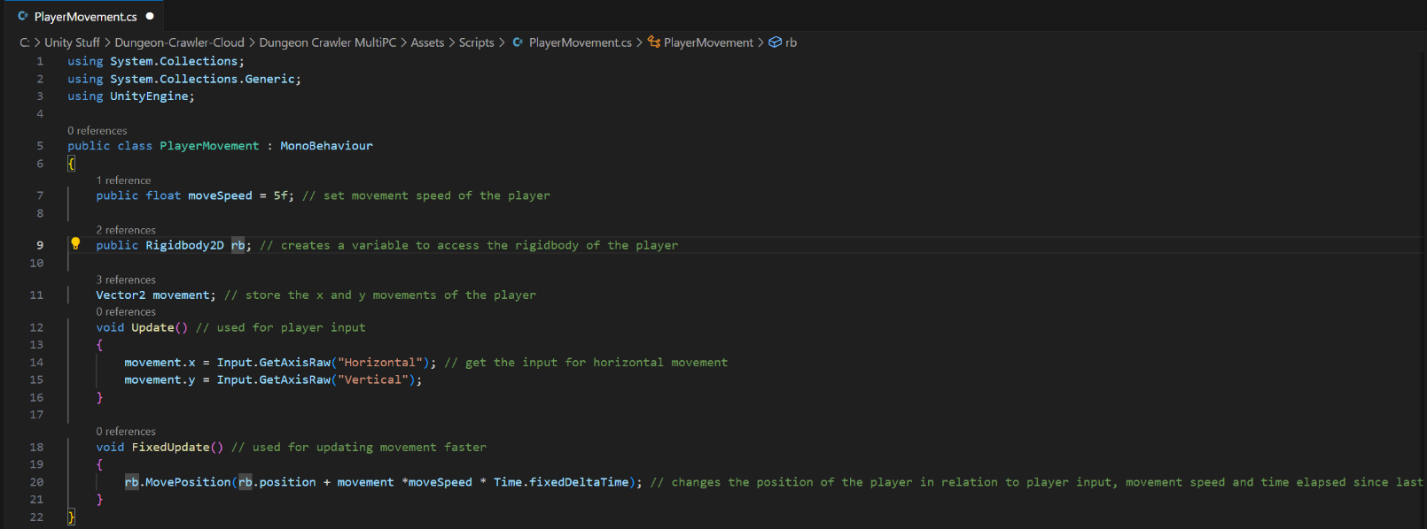

### Player Movement – Animation

Next I will add animation to the player movement, this will make the movement look more fluid rather than the "floating” appearance of the player at the moment. This works by splitting the player sprite up into different frames (the imported player sprite I have has these separate frames to work with) of which the player is: walking left, right, up, down and idle; I then need to make it so it determines what the player input is, and changes the frame of the player in accordance with it (e.g. when the player is moving left the player sprite on screen will be “walking” left).

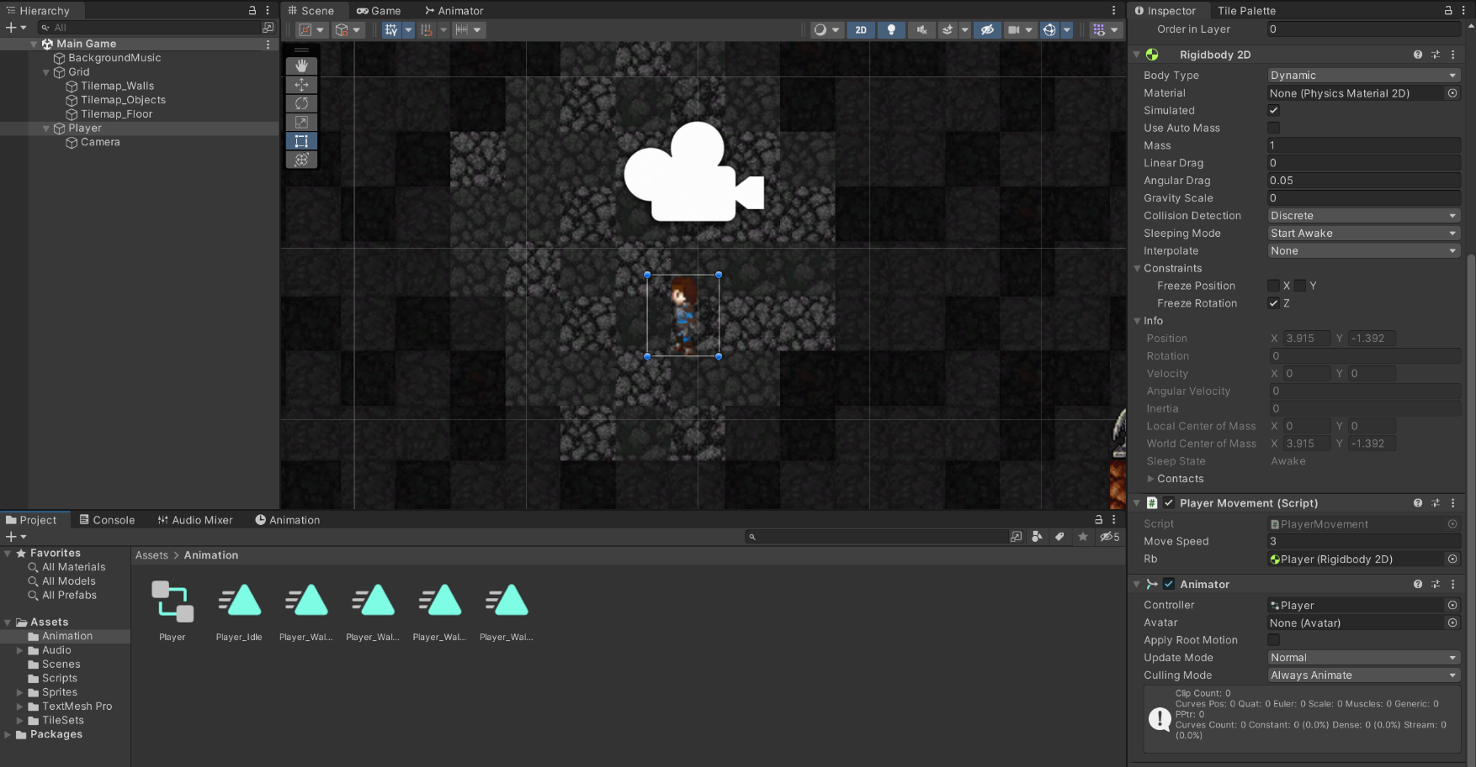To start this I have created an animation component on the player, in which I have created an animation for the 4 way directional movement – that being walking up, down, left, right and idle.

I have now created an animation blend tree to configure the horizontal and vertical input to affect the animation of the player character being shown on the screen. This works by using a 2D simple direction blend type, which takes the horizontal and vertical inputs from the player movement as parameters, and then shows the corresponding frames based on the value of those parameters as shown:

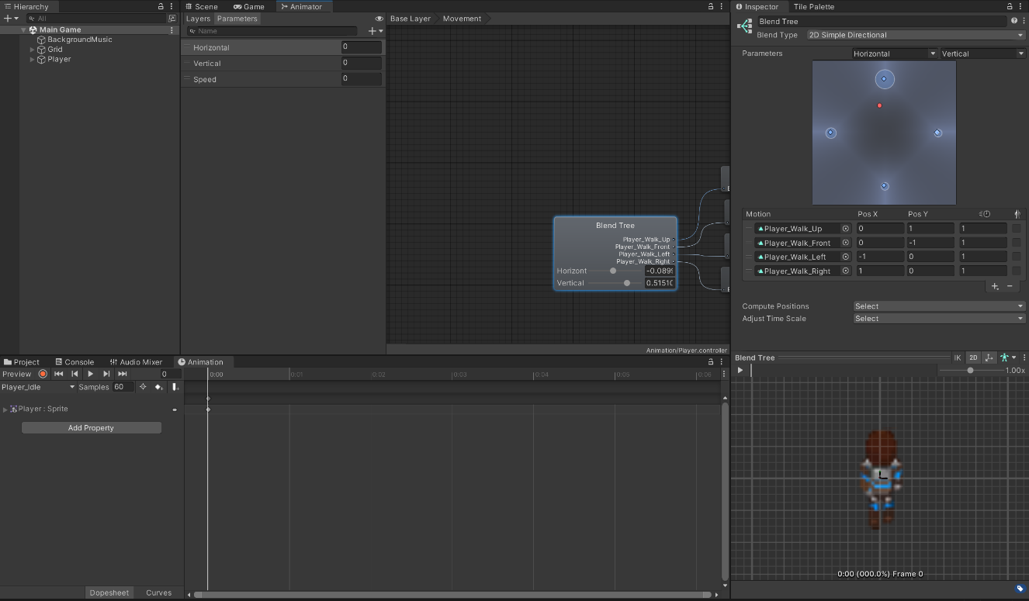

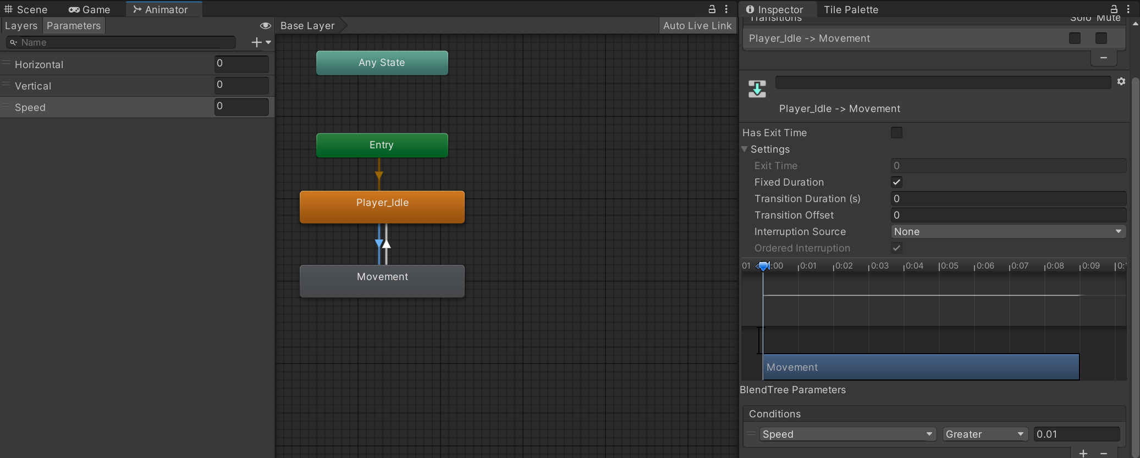I have then added transitions between idle animation and the movement animations, baring conditions of whether the new parameter – Speed – is above 0.01 (in which case the movement animations will play in accordance with direction) and if not then the idle animation will play.

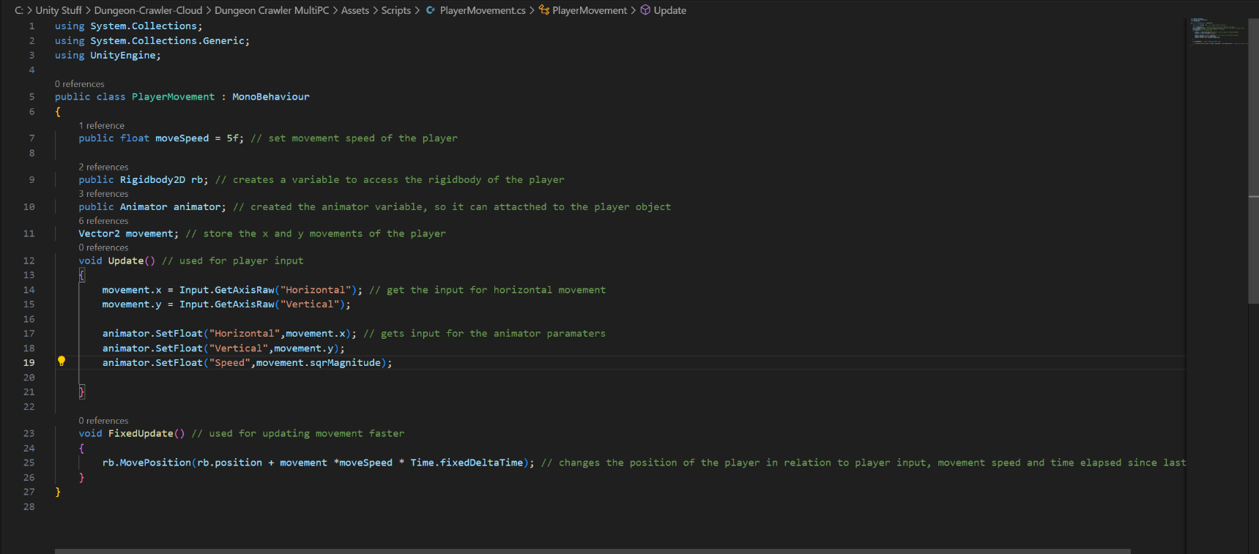Finally, to bring the animation all together, I have added to the player movement script so that it will get all the inputs for the animator parameters and make sure that the animator is attached to the player sprite.

### Player Movement Tests

|  |  |  |  |
| --- | --- | --- | --- |
| What is the test and why test it? | Expected Outcome | Successful? | Improvements |
| WASD/Arrow keys moves the player sprite on screen in the intended direction – this is vital that it works as the player needs to be able to traverse the map | E.g. player moves left when user input is “A” or “Left arrow”; also if the player holds 2 keys down it will move diagonally (e.g. W and D) | Yes | No – speed can be adjusted throughout the game to get a balanced, fluid feel |
| Player animation makes it appear as if the player is actually walking in that direction – makes movement look more fluid and natural | Player faces the direction in which it is moving | Yes | No |

**(Shows the animation of the player when it is moving in the 4 respective directions)**

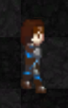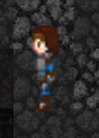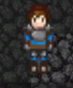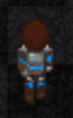

### Player Collisions + Map Collisions

The next important thing is to ensure that the player cannot walk through walls, as the map is designed in such a way that there are lots of rooms and secret pathways that can only be explored by going down certain ways; therefore the walls need static collisions and the player needs a collision box to collide with walls, enemies, items and any other objects with collisions.

Firstly I will create the tilemap collider, and assign it to the wall tilemap, so that the player will collide with walls specifically. It will be using a composite collider for more accurate collisions, therefore it has to be used by composite, as shown:

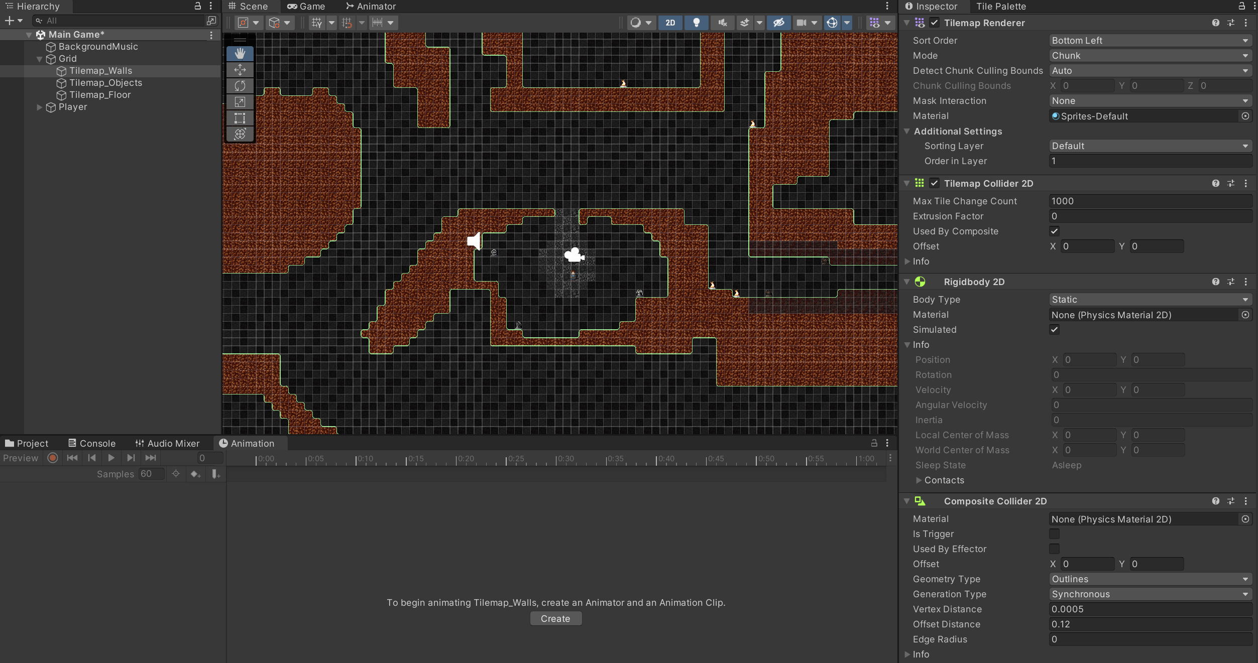

Next I need the player collider, so that the player will actually collide with these walls, because at the moment the player will still just walk through walls. This will be using a 2D box collider, that I have just shaped around the player, so that it is a sensible collider.

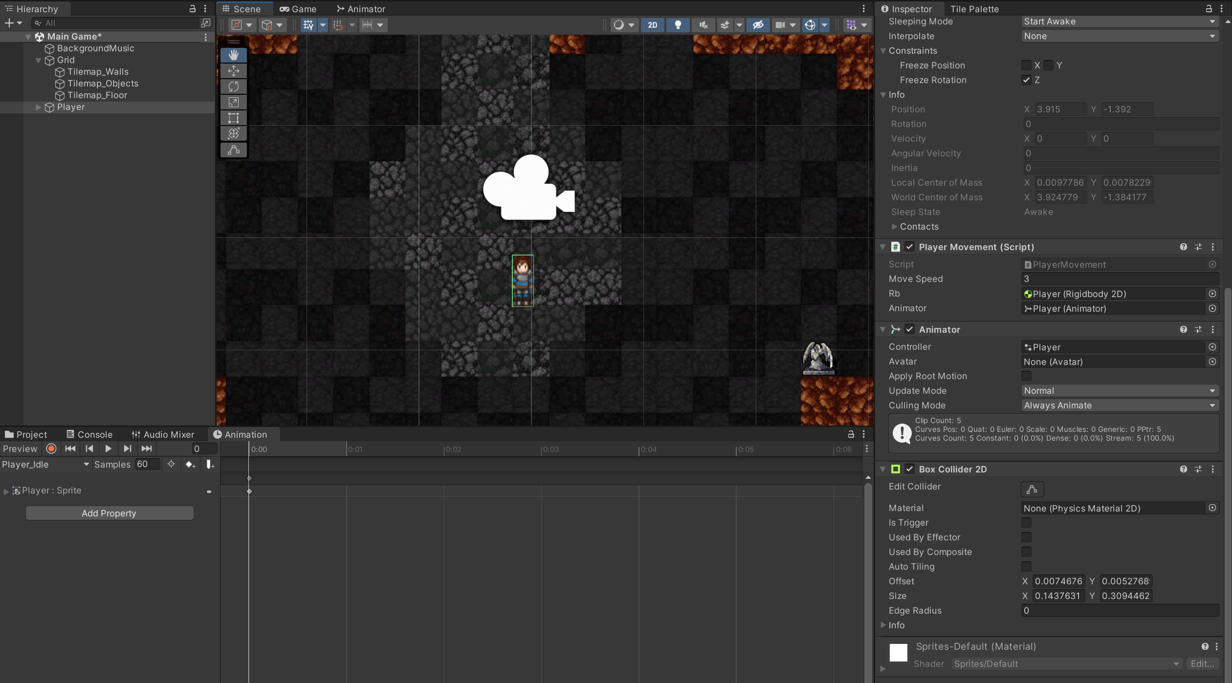

### Player + Wall Collisions Tests

|  |  |  |  |
| --- | --- | --- | --- |
| What is the test and why test it? | Expected Outcome | Successful? | Improvements |
| Player cant walk through walls; there is a physical collision between the colliders of the player and wall – this is so the map can be explored through the intended paths. | Player stops moving when in contact with a wall; can’t walk through it (no part of the player can walk through the wall) | Yes | No |

**(Shows that the player cannot walk through walls)**

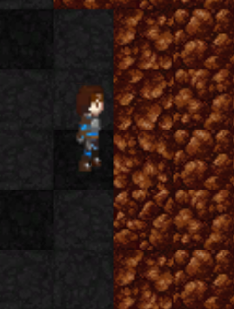

### Phase 3 Review

In this phase I set out to create the player and the base functions relating to the player, which includes: the sprite, the movement controls, the collisions and also the camera (this was added as an after thought, I attached the camera to the player so the camera follows the player throughout the game). All of the tests for this section have been successful and there have been no problems with any of the sections, as expected for the base layers of the game. Next I will move onto enemy creation, and how the enemy and player will interact with each other, upon which the player will also be developed further.

## **Phase 4 – Enemy Creation**

In this phase I need to create the enemy blueprint, this will then further be used to create the different difficulty of enemies, but for this phase I will create a base enemy to test all of its functions and interactions with the player and environment. It will also have a sprite, a path finding algorithm to track the player in close vicinity, an attack, collisions and all of its stats (health, damage etc).

### Enemy Sprite Creation

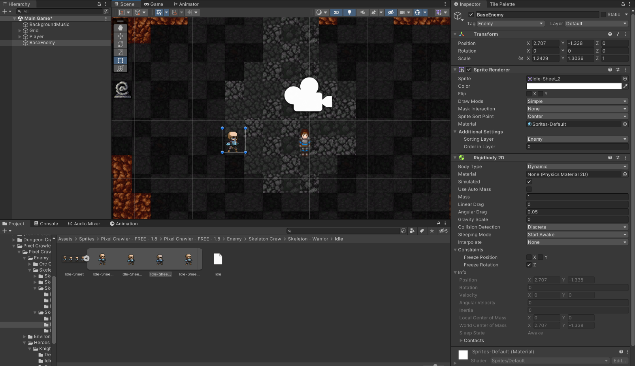To start off I will need to create an enemy sprite, which I have within the imported assets folder, so I will use one of those. It’ll also need a rigid body so that it can move around and interact with the environment (with gravity set to 0 so it doesn’t fall through the map).

### Enemy Path Finding – A* Algorithm

Next, before any stats or attacks are added to the enemy, I will need to implement the A* algorithm to the enemy so that it will find the player and go towards them.

The A* algorithm works by using a grid system, in which you can move in 8 directions from each node; you have a “G” cost, which is the walking cost from the start node; you have the “H” cost which is the heuristic cost to reach the end node (an estimate of the distance between that node to the end node); the “F” cost which is the G+H cost; the algorithm stops when the end goal is reached. It follows the path with the lowest “F” cost, and then once the final node is reached it retraces the path and then the path is outputted.

It will also need an “Open List” for the nodes queued up for searching, and a “Closed List” for the nodes that have already been searched, and we keep traversing nodes until either the Current Node = End Node, or the Open List is empty (no more nodes to search).

Grid System

So to start with I will make the grid system, as the whole map needs to be split into a grid with squares to measure the distance between nodes, and also collisions. For the first part of the grid, I have created the grid itself, with its height, width and cell size; then I’m using a test script along side it to test a grid to be displayed to make sure I am coding it correctly. The code is annotated to give direction to how each line or section is functioning. To assist this I have used utility assets from Code Monkey to help display the text, as it is quicker to use their classes to display text on the screen. The 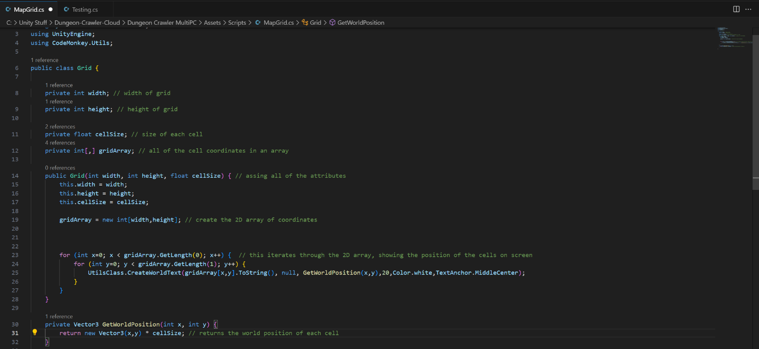white numbers on the screen represent the text to be outputted.

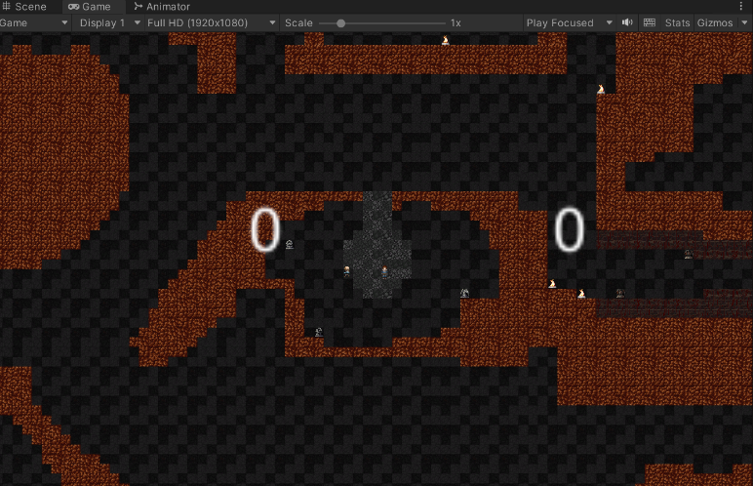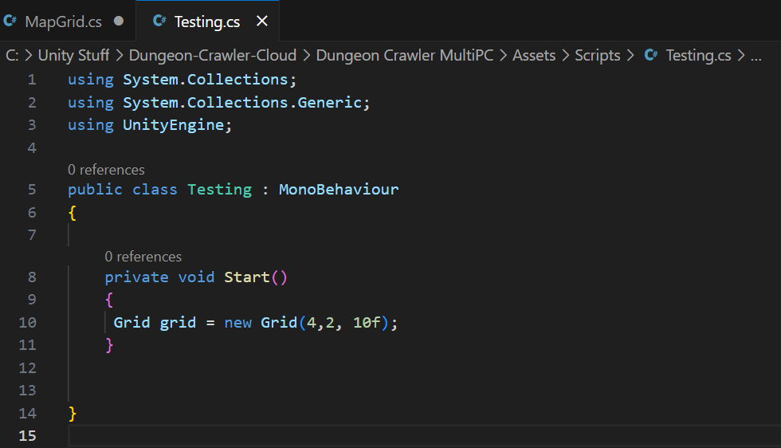

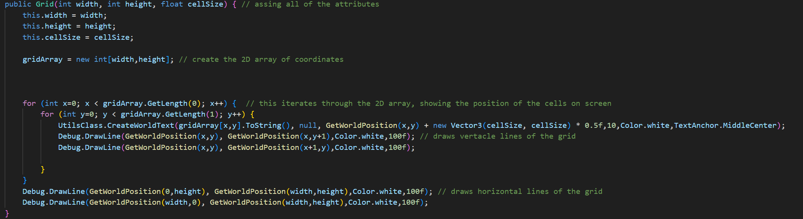Next I have developed the grid class to draw the grid specified on the game, so that I can debug it easier, so there are grid lines to demonstrate where the grid is; this will help when I map the grid around each tile on the map. I have also created functions to Set and Get the world position and the grid position respectively. All of the code is annotated to demonstrate where there functions are and how they work.

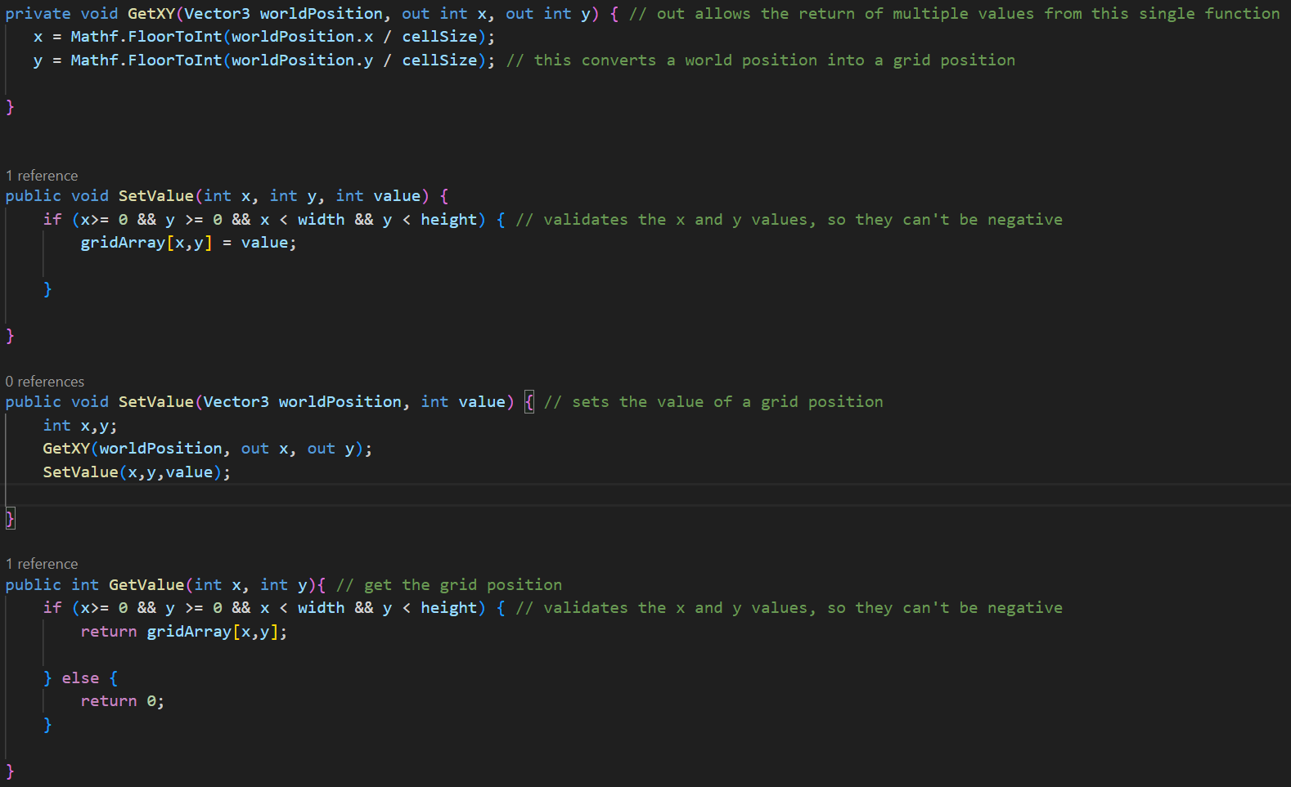

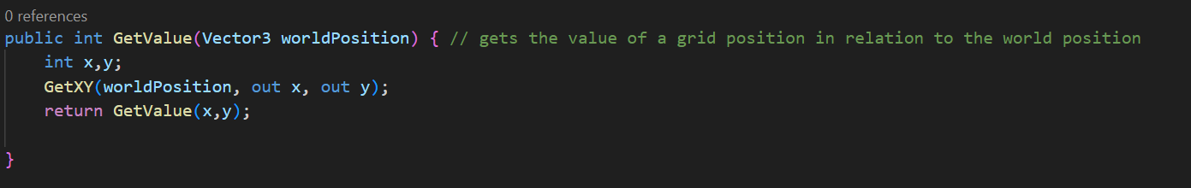

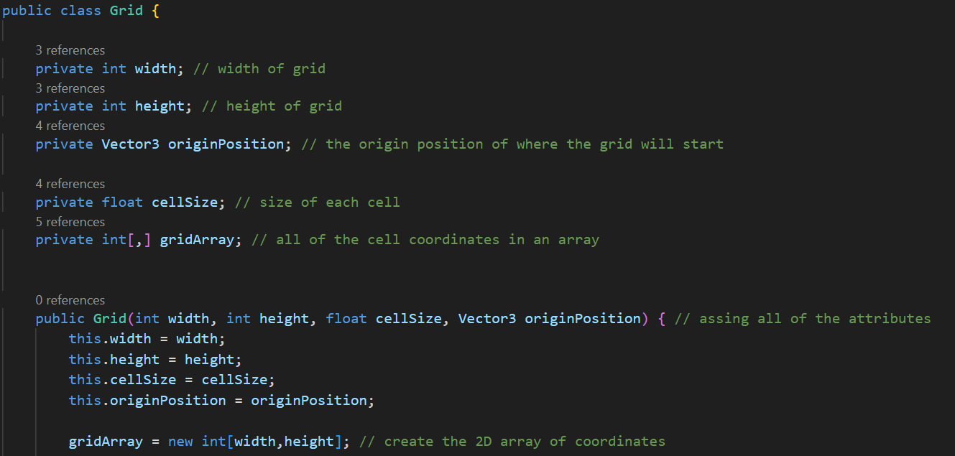Finally, I need to change the origin of the grid so that it starts at the bottom left of the tile map, and then I need to trial and error test the size of the grid so it is the correct size in relation to the tile map. These are the altered sections and what the grid looks like with the testing lines on:

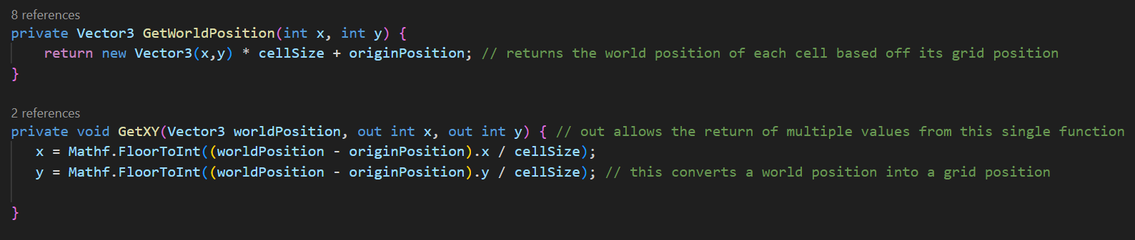

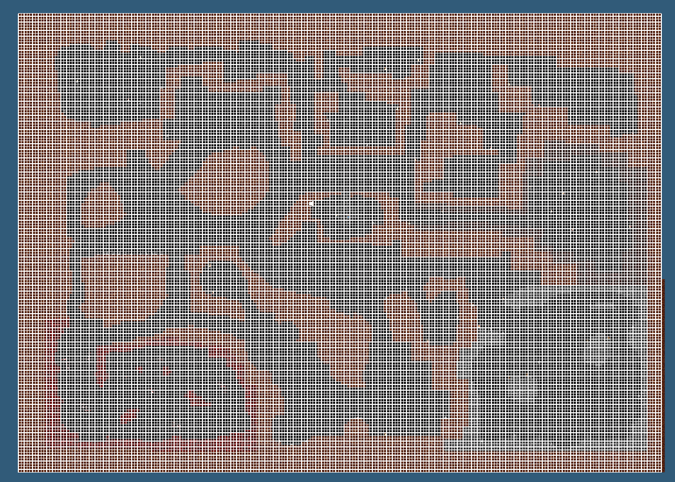

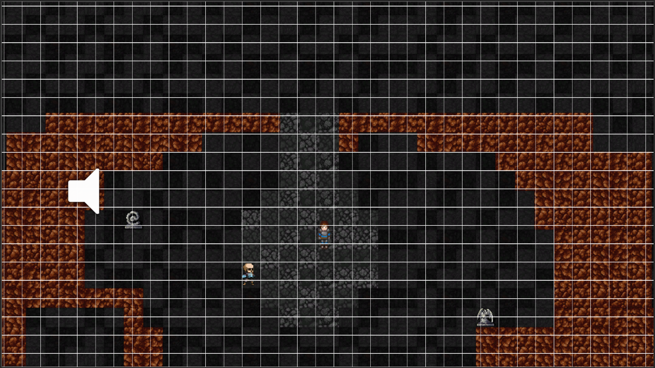

Path Finding

Now I have the grid, I can write the A* algorithm to work within my game – I will be importing the basis for the A* algorithm code as it is an industry standard code which would be very difficult to rewrite, however I will be amending it to work within my game, and with the player specifically, as well as collisions as the enemies will have to move around walls (used CodeMonkey unity utilities for the basis of the code). I have altered the parameters of the pathfinding and grid class to ensure that the grid fits to my map specifically; I have also altered the testing class to accommodate for the pathfinding algorithm, with debugging steps within it so I can test everything throughout.

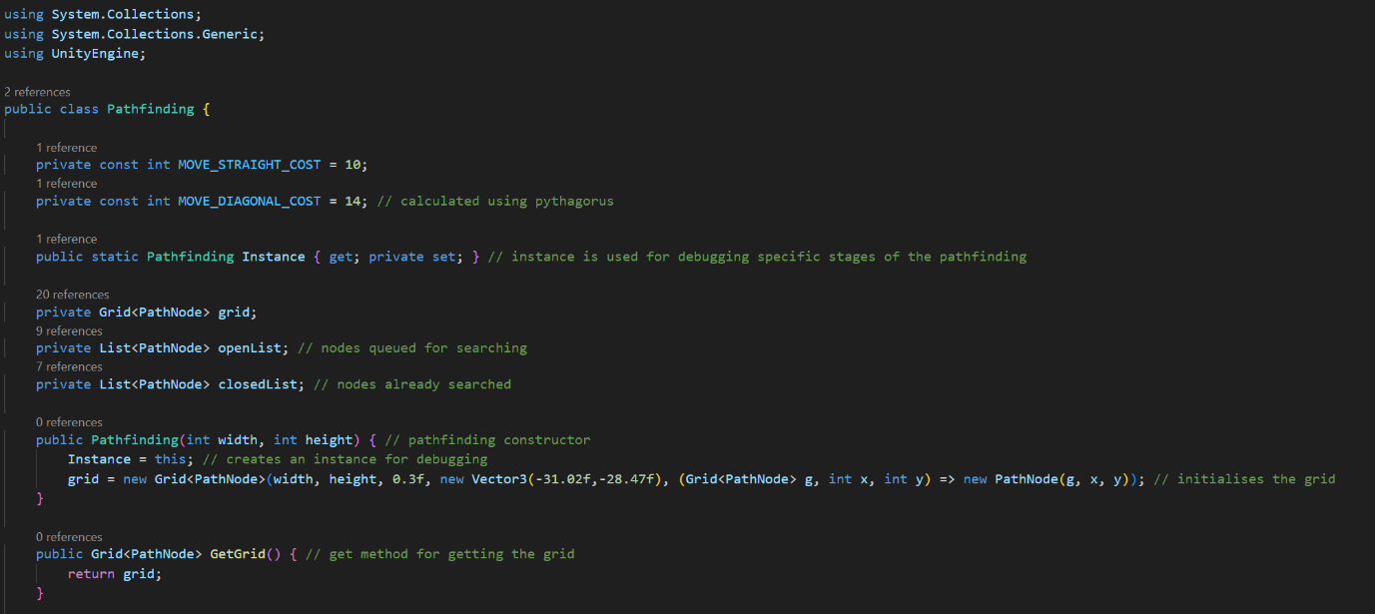

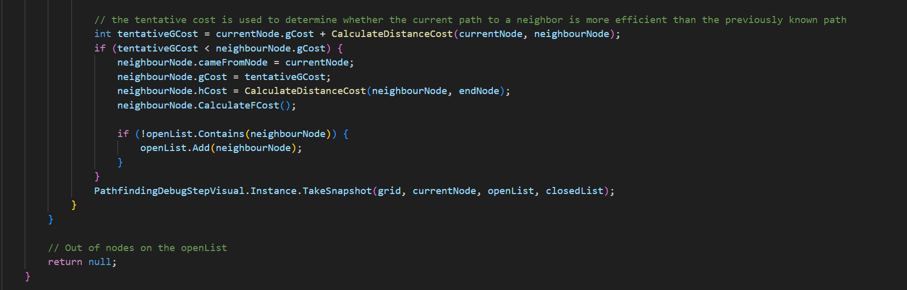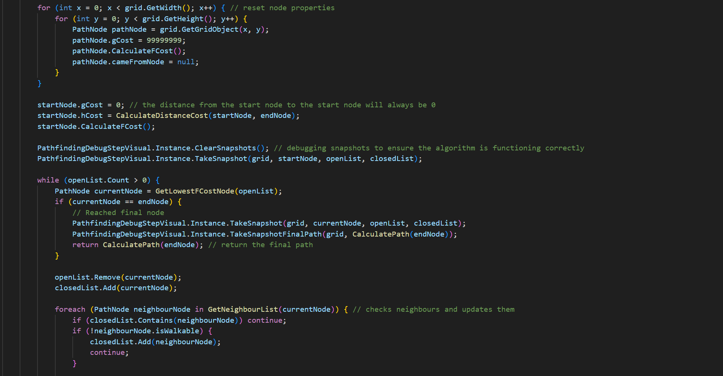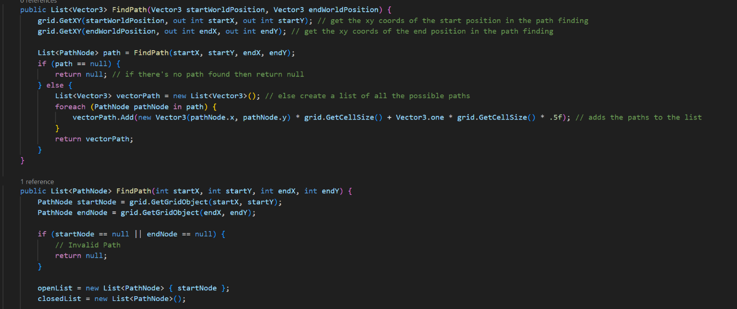

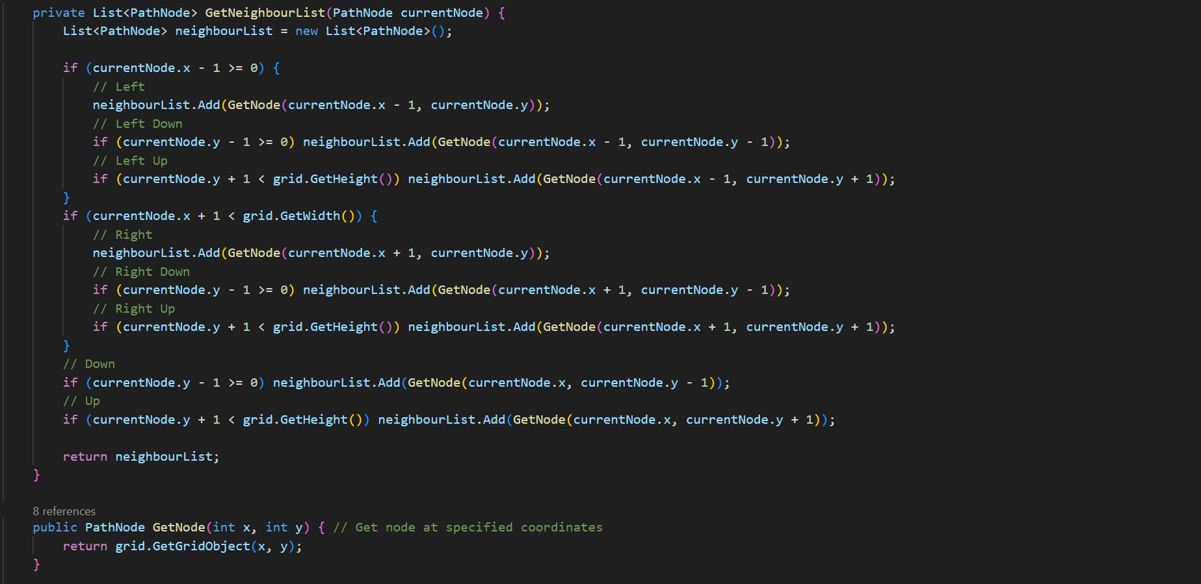

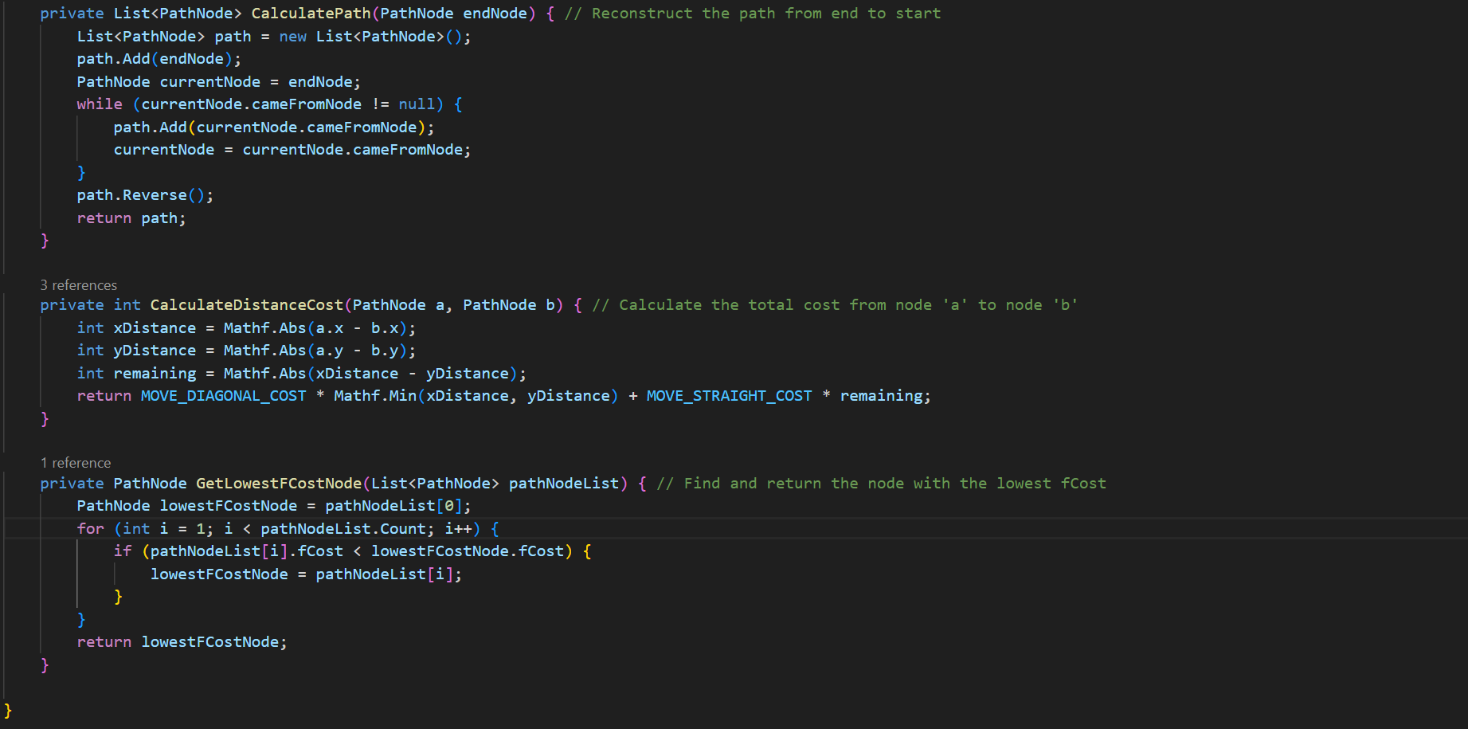

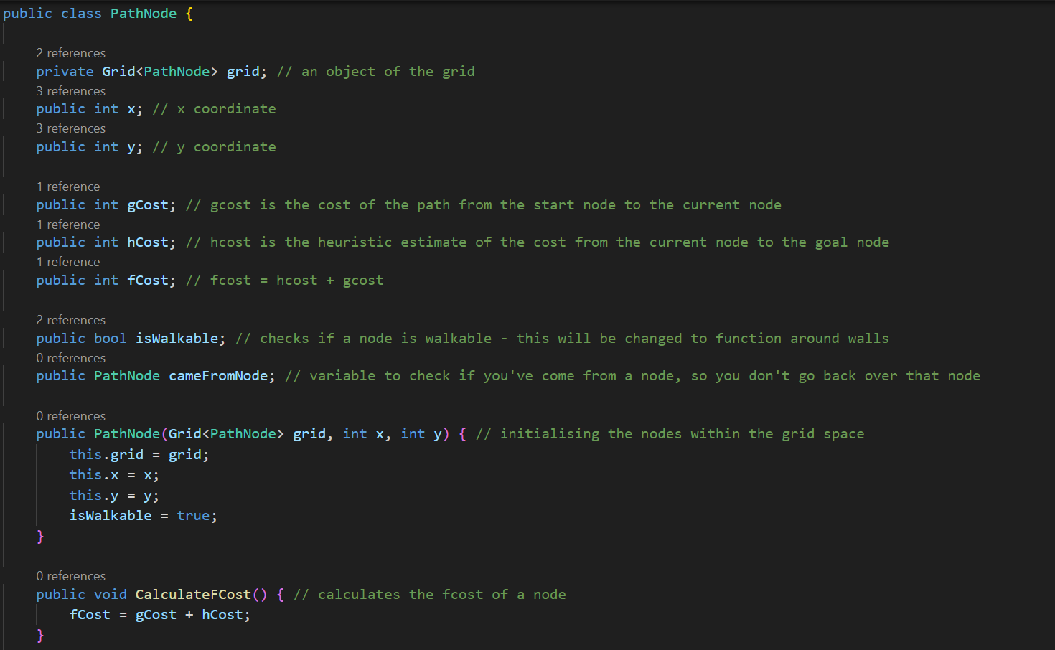

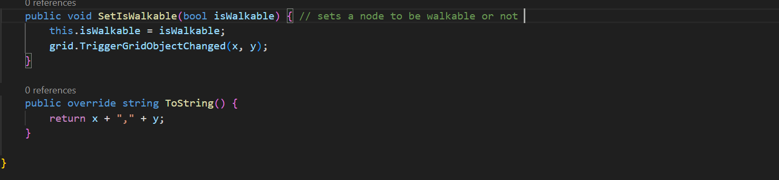

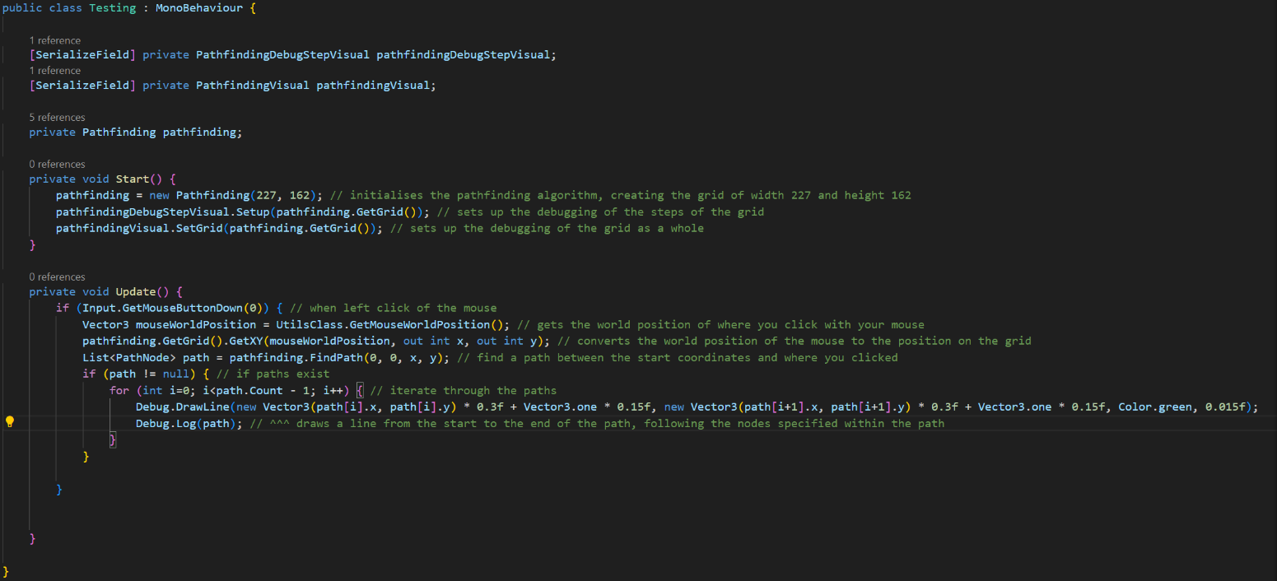

I will demonstrate some tests here to ensure that the actual pathfinding section of the algorithm does work, as if this doesn’t work then the next section (attaching this to the enemy movement) will not work.

Enemy Pathfinding Tests - FAILED

|  |  |  |  |
| --- | --- | --- | --- |
| What is the test and why test it? | Expected Outcome | Successful? | Improvements |
| Has the grid initialised correctly – the grid is essential for the A* algorithm to function | The grid should be visually shown on the map when “gizmos” is turned on, in line with the tiles on the map | Yes – it is as close to mapping the exact tiles as possible, ever so slightly off but still functional | Technically could keep adjusting the size of the grid but it would be too time consuming and unnecessary |
| Path is calculated from 0,0 (the bottom node of the grid) to the node where the player clicks | A green line should show from the start to the end of the path, showing the calculated route through each node | Yes – however performance and speed of the algorithm greatly decreases the further the distance is from the start node | I need to improve performance with the large grid size, it is causing freezes when it’s calculating too much. |

Next, I need to make it so that: the start position is where the enemy is; the end position is where the player is; the enemy follows the path specified, and also that it only does so when it is within a certain range of the player (not only does this mean that enemies can’t “find” the player from anywhere, it will also reduce the calculations that the algorithm has to do, as it can become very performance heavy if too many paths can be calculated). However each of these problems need to be decomposed into their own problem, as they are quite complex to solve as a whole.

I wrote an enemy script which takes into account the players location, the enemies location, and uses the A* Pathfinding algorithm to calculate a path between the two (if the player is within the specified detection range), and then the enemy is made to follow it. This also required a new method in the Pathfinding script to update the path to the player, so that the enemy will accurately follow the path consistently (the update frequency is controlled by a variable I made) as shown:

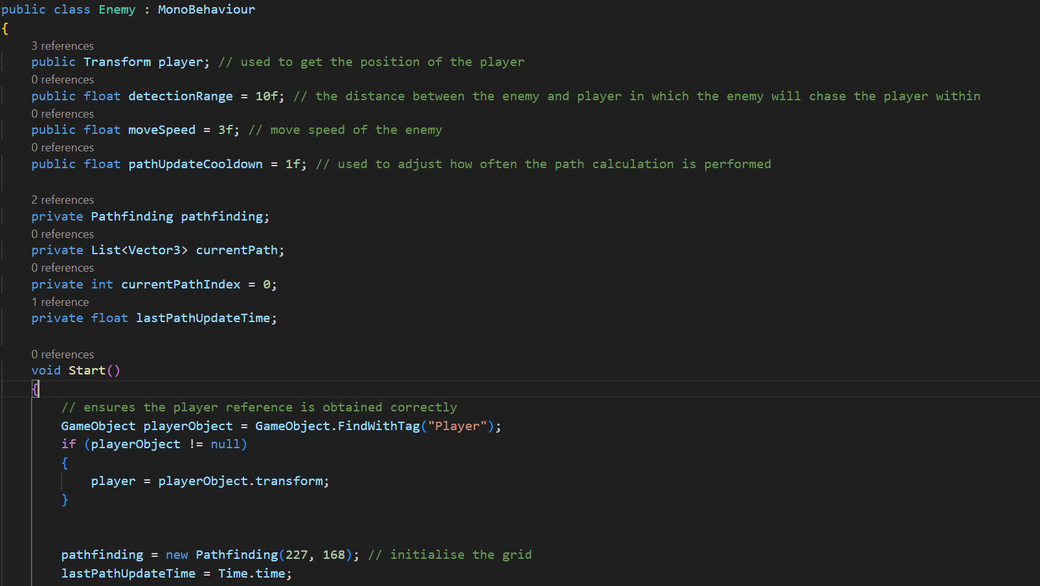

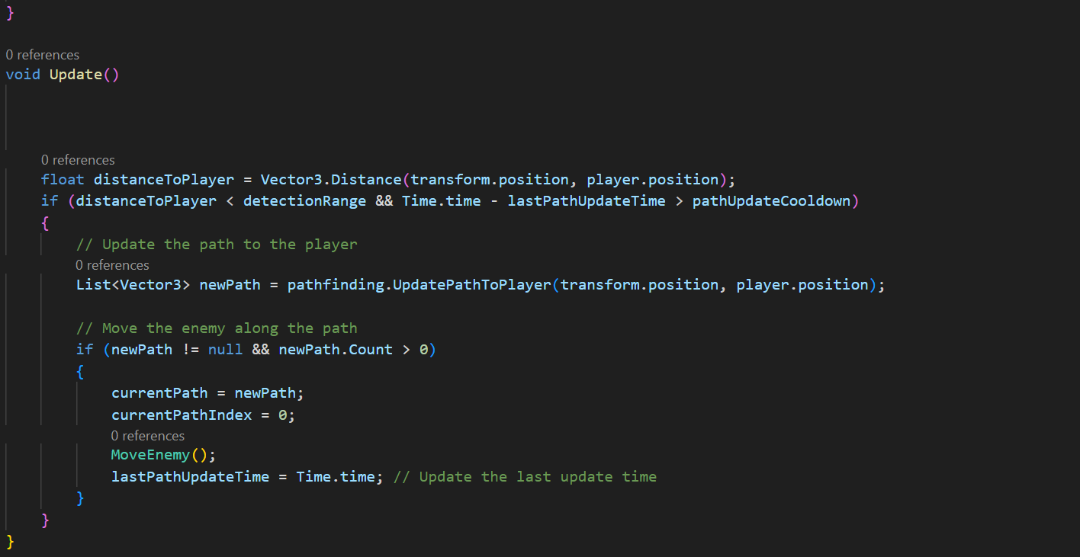

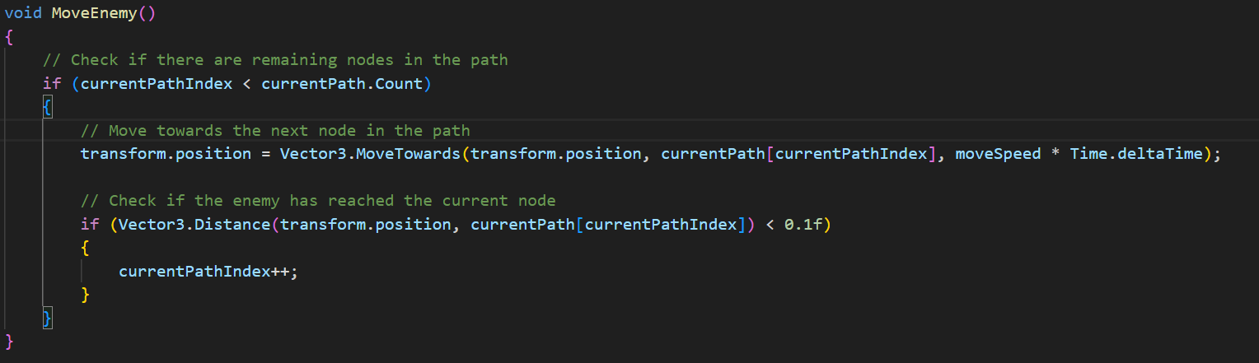

Then this is the new method in the Pathfinding class:

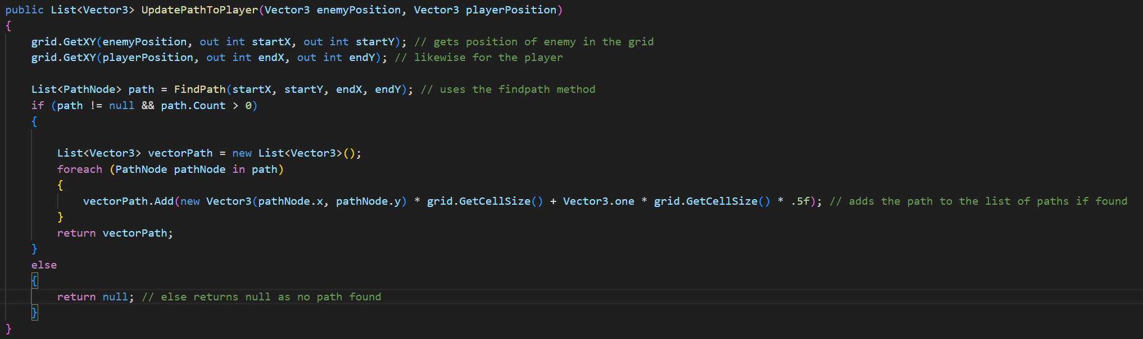

However upon testing this is what I found out:

|  |  |  |  |
| --- | --- | --- | --- |
| What is the test and why test it? | Expected Outcome | Successful? | Improvements |
| The enemy uses the pathfinding algorithm to move towards the player while within the detection range | The enemy keeps moving towards the player, along the optimal path | No – the game freezes every time the pathfinding algorithm is used, I can tell that is the exact problem, as the enemy is moving just about, but it freezes for a while every single time a path is found | I need to optimise the path finding algorithm, as it functions but is very inefficient in the way I have implemented it |

As it currently doesn’t work as intended due to poor implementation and optimisation, I have an idea to dynamically initialise the grid – that being the grid will be initialised in relation to the position of the enemy. It will have to be initialised to the bottom left of the enemy, and then expand outwards up and right, so I will be able to reduce the amount of nodes in the grid greatly, meaning performance should also improve significantly. As long as I can get that to function, I will then make it so the enemy moves around all the walls in it’s path, but that will rely on this section functioning first.

So, the way I have achieved this is altering the constructor for the PathFinding class to initialise the grid using more sensible parameters, allowing me to better control the position of the grid.

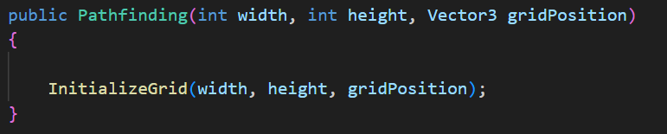

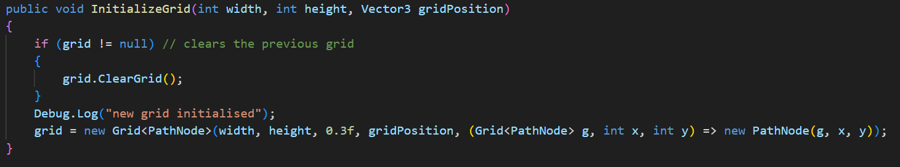

I have also added a clear grid method, that clears the previous grid so there won’t be hundreds of grids being initialised, to prevent errors.

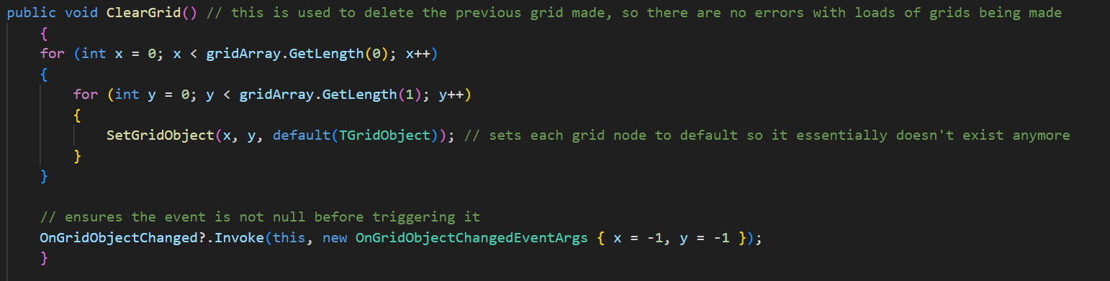

I also altered the way in which the enemy and player positions were being passed into the new grid initialisation and path finding, as I was not taking into account the actual grid position, I was just using the transform function, which just returns the position of objects in the game space, not my created grid.

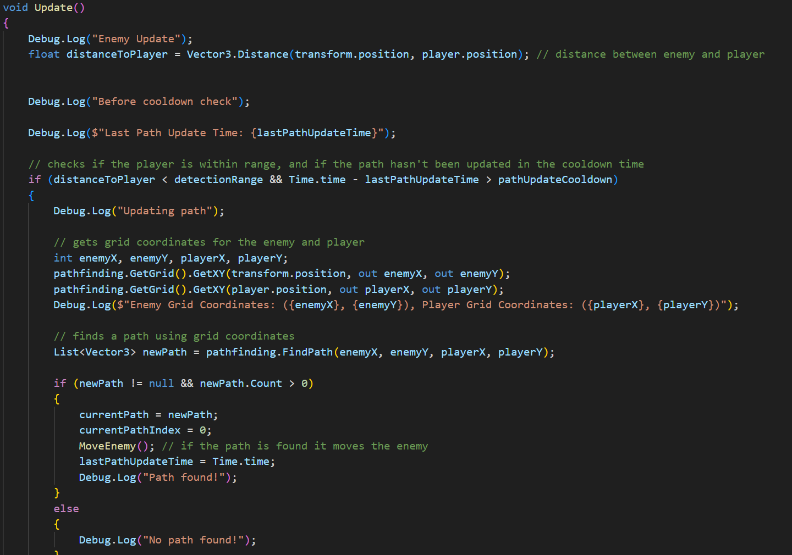

I have further created 2 new methods within the Enemy class that correctly calculate where the new grid will be made in relation to the position of the enemy.

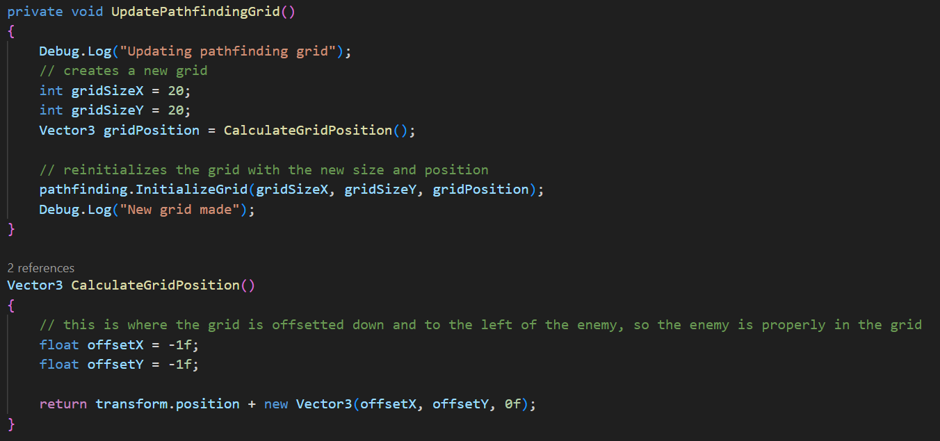

|  |  |  |  |
| --- | --- | --- | --- |
| What is the test and why test it? | Expected Outcome | Successful? | Improvements |
| A new grid is correctly initialised every 5 seconds, as long as the player is within the detection distance | The debugging logs will tell me when a new grid is created | Yes – the size of the grids has been altered to ensure optimum performance and functionality also | Can alter the frequency of the grids being made, as well as the size |
| The enemy uses the pathfinding algorithm to move towards the player while within the detection range | The enemy keeps moving towards the player, along the optimal path | Yes – the enemy follows a new optimum path towards the player every 5 second | I could reduce the delay between finding new paths to improve the accuracy of the enemies movement in relation to the movement of the player (however this would reduce performance) |

### Phase 4 Review

This was probably the most difficult part of my game to create, and required a lot of debugging due to serious problems faced with the implementation of the A* algorithm, however using the dynamic grid method and other small fixes, I was able to implement an enemy, with A* pathfinding capabilities; the enemy has a rigidbody and collisions, so it will collide with the player, walls and any objects I add colliders to. This has now built the main foundations of the game, next I will be adding stats to both the player and enemy, as well as combat (as that’s how the stats will be utilised).

## **Phase 5 – Stats and Combat**

In this phase I will be adding the stats to both the player and the enemy, these stats will be: health (both), armour (just player), mana (just player) and the damage stat will relate to combat (both). Then I will add the combat alongside this, as the stats directly link to combat.

### Enemy Attack + Health stats

Firstly I will make it so the enemy damages the player when coming in contact with them, this will need the health stats for both the player and enemy to be created, as well as the enemy attacking. To encapsulate these methods and attributes I will add an EnemyCombat script and a PlayerCombat script, to alter the stats and add the methods for the combat on both ends of the combat.

So initially I have made both of those scripts, set the health of both the player and enemy respectively; I have made it so when the enemy comes in contact with the player, the player takes damage. As shown:

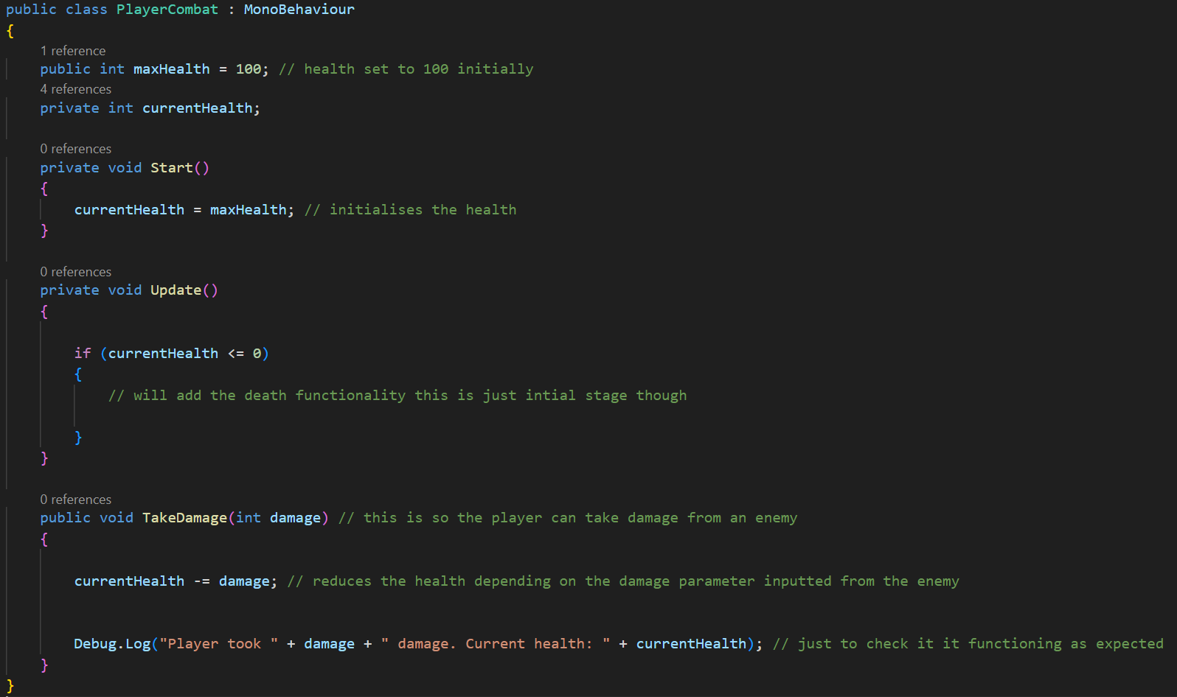

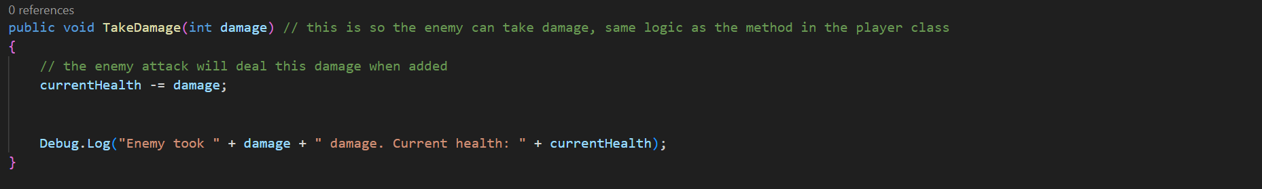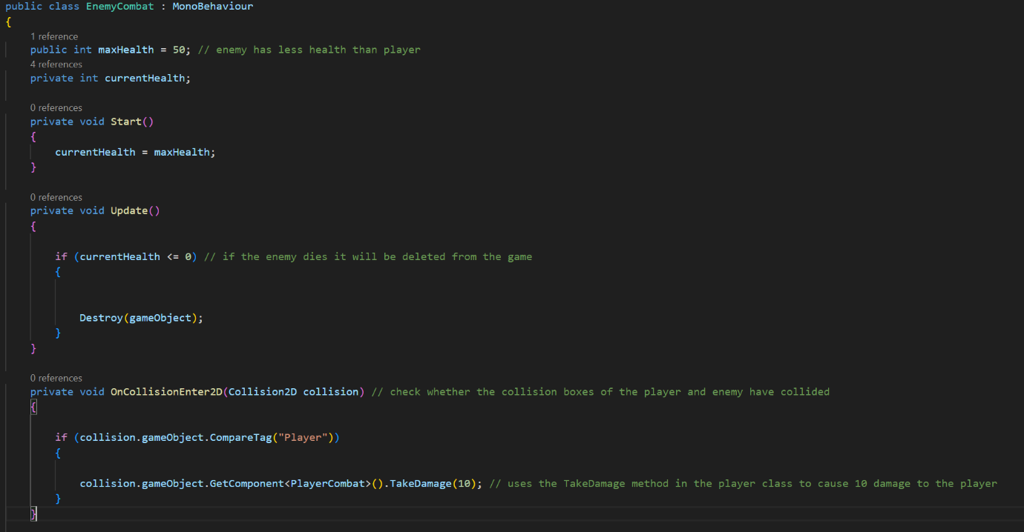

Next I want to add health bars for both the player and enemy, so that you can see the status of the health of both at all times; this is so that the player can plan how they will approach enemies. I will fix the play stats in the top left of the screen, and the enemy health above the enemies head, as shown in my usability features.

I have achieved this via the use of canvases and sliders: the canvas provides the game area to place the slider in, and the slider is interactable so that I can alter the appearance of it to reflect the health of the player and enemy respectively. So for the player, the slider is locked the actual screen, in the top left, so it never moves, and it is updated everytime the player takes damage:

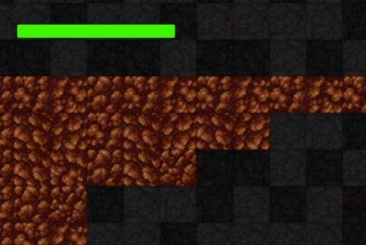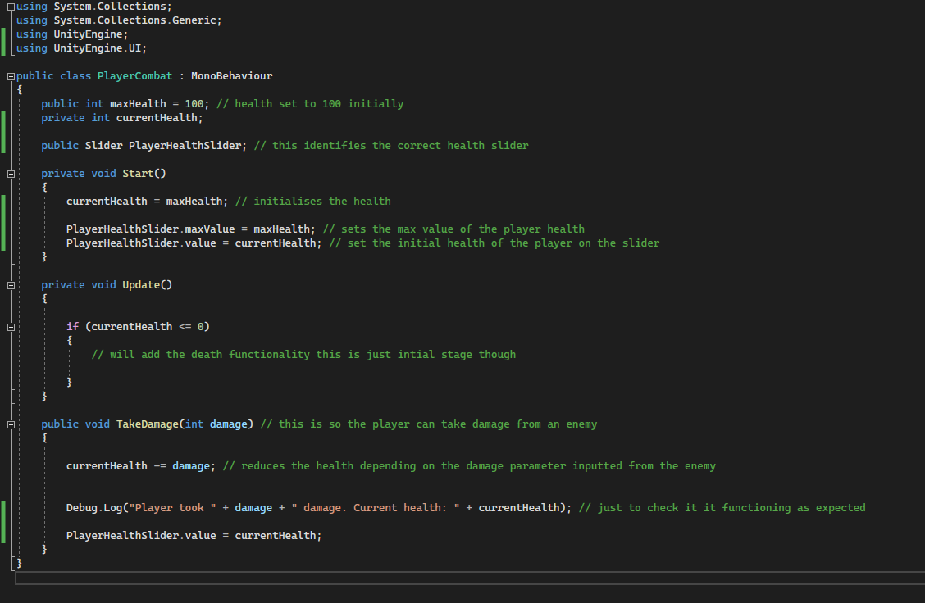

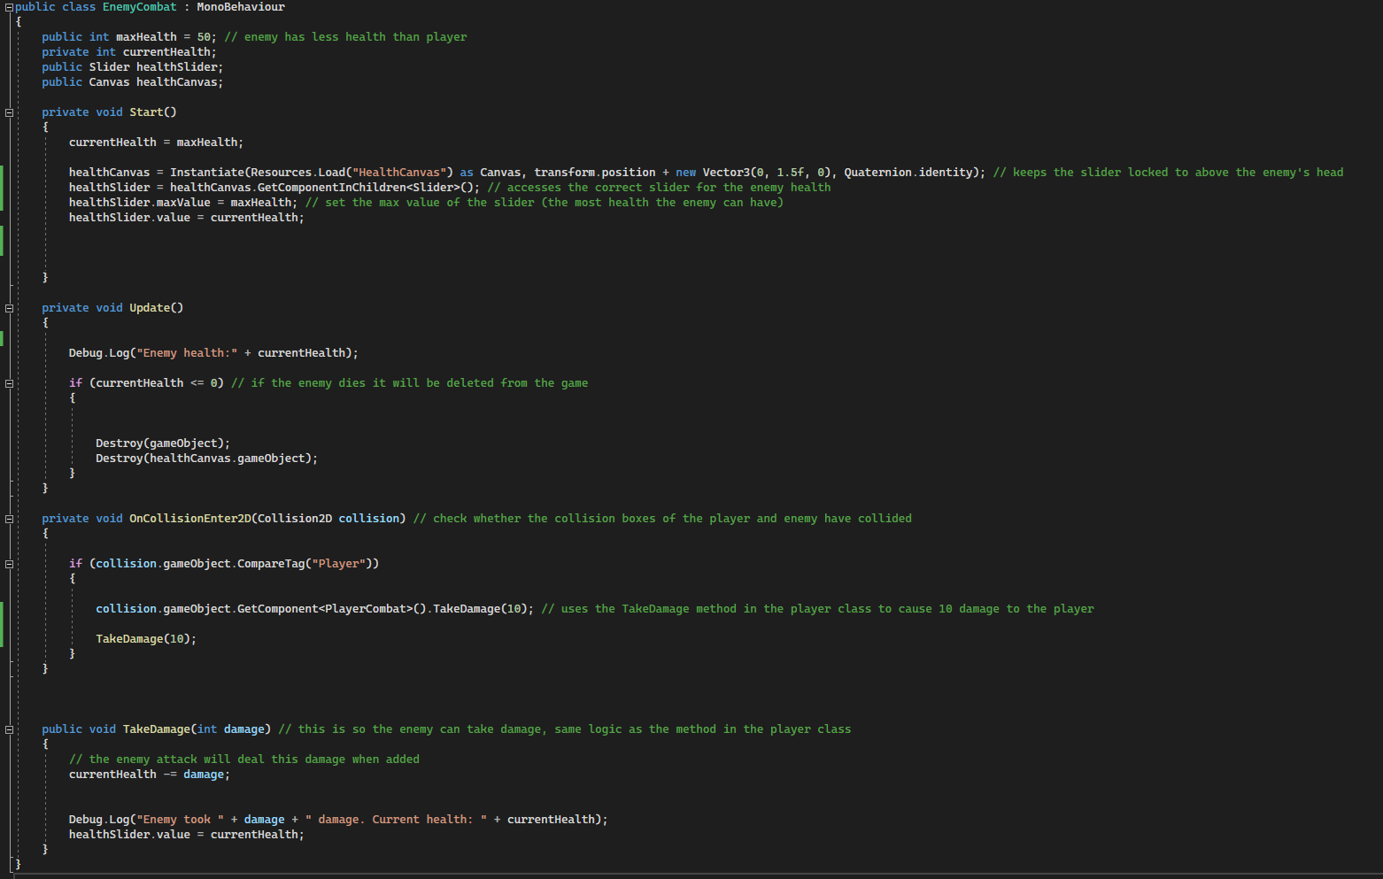

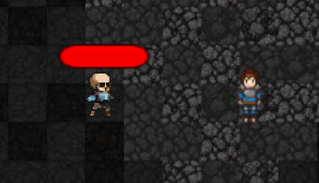

Next I will add the armour stat to the player, which will essentially act as a second health bar, I will also need it to be visually displayed on the screen in the top left, under the health bar.

The functionality of this will work as so: the enemy will damage the players armour first (if there is armour); if the player then runs out of armour, the health will be damaged directly; if the armour goes to 0 but there’s still damage left, then the remaining damage will be done on the health of the player. I will also create the new armour slider for the player, as shown:

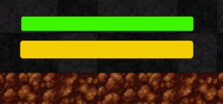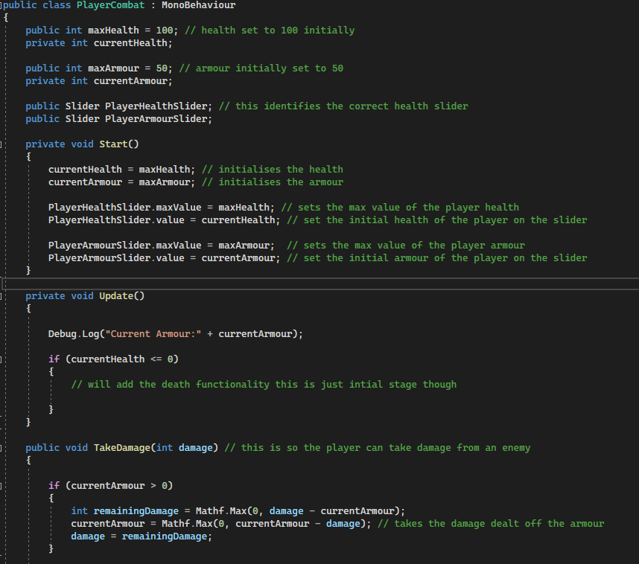

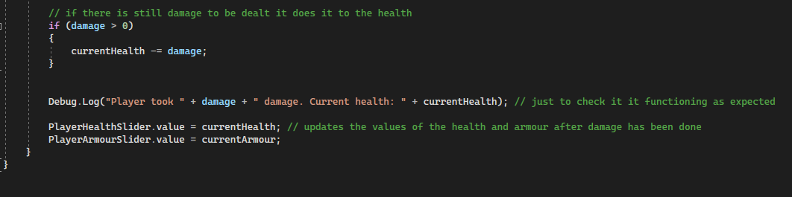

|  |  |  |  |
| --- | --- | --- | --- |
| What is the test and why test it? | Expected Outcome | Successful? | Improvements |
| Check the enemy damages the player when they come into contact | Debug log will show the player’s health falling by 10 damage points each time the enemy bumps into the player | Yes | The damage amount can be altered depending on the type of enemy later |
| Check the player armour functions as a second health bar, the armour is damaged first before the health and then once the armour runs out the health is damaged | Armour is damaged first, then health | Yes | No |
| Health and Armour of the player are displayed in the top left of the screen, and reflect the health and armour attributes of the player | Health and armour bars change when damage is done | Yes | No |
| Enemy health is displayed as a health bar above their head and reflects their health attribute | Enemy health bar reflects the current health of enemy | Yes | No |

Health and Armour Test (Including Sliders)

**(Shows the player health and armour bars, before any damage is done)**

**(Shows the player health and armour bars, after any damage is done)**

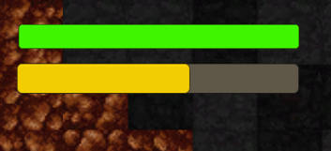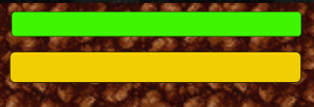

**(Shows enemy health after any damage is done)**

**(Shows enemy health before any damage is done)**

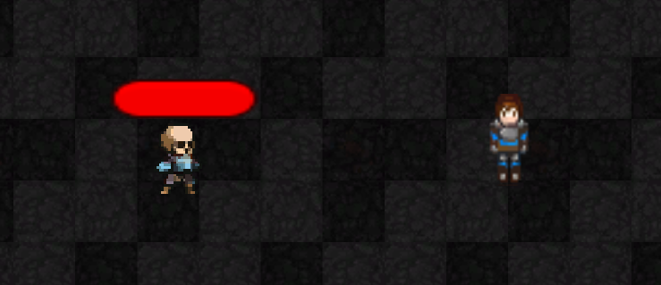

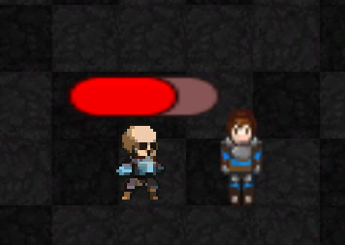

### Player Attack

Next I want the player to be able to attack the enemy (I made the enemy take damage from colliding with the player previously to test the health bars, that has now been removed) with a weapon, so that it will damage the enemy. The function to take damage is already in the enemy combat script so I will just need to create the weapon, and have it appear and swing when the player clicks a button; it will also need a delay so that the player cannot spam click the attack button.

I have made it also so that the sword swings in the direction of the players mouse and where they click on the screen, this means that the player can attack in any direction, regardless of the position or where the player character is facing (so they can fight multiple enemies surrounding them from any direction). I used the animator to add a state of attack that is triggered when the player clicks, so that the sword swings in a nearly 180 degree fashion, and the attack speed is set to be quick and effective. Here are the new additions for this to work:

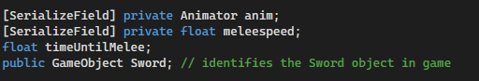

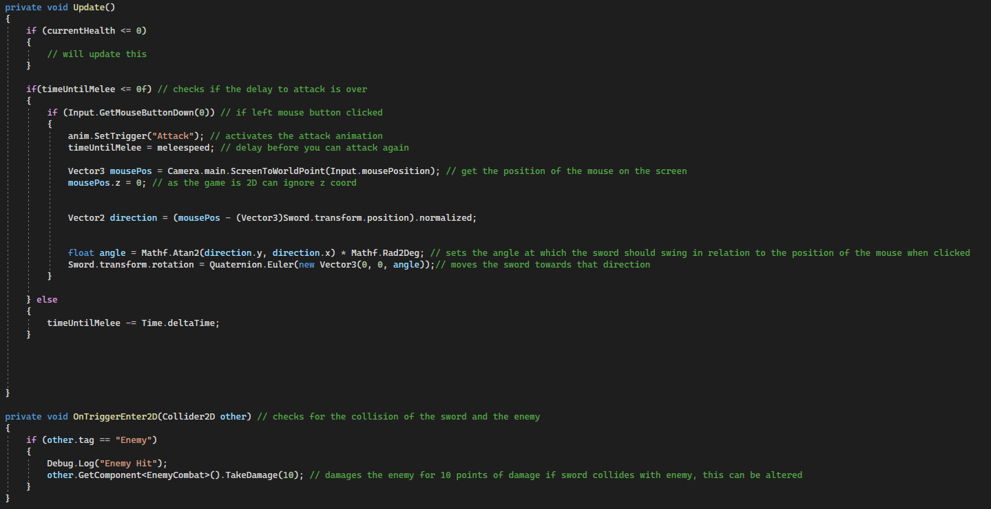

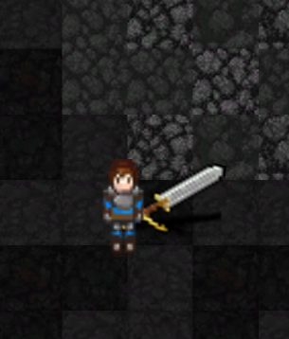

Player Attack Tests

|  |  |  |  |
| --- | --- | --- | --- |
| What is the test and why test it? | Expected Outcome | Successful? | Improvements |
| Does the sword swing when the player clicks LMB | Sword swings | Yes | No |
| Does the sword swing in the direction of where the mouse is on screen | Sword swing directions changes depending on position of mouse | Yes | No |
| When the sword hits the enemy, does the enemy take damage | Enemy health bar decreases when the sword hits them | Yes | Could change the box collider to more accurately map the shape of the sword (use capsule collider instead) |

**(Shows the damage the enemy took after being hit with a sword from the player)**



### Phase 5 Review

I have achieved everything I set out to in this phase: I have successfully created all the stats for the player (health and armour) and enemy (health) as well as the combat system, so that the player can kill the enemy; the player death will be added later. If time constraints allow, I will revisit the combat to add a special attack (magic attack) and also a dodge.

## **Phase 6 - Items**

In this phase I will set out to create interactable items in the game; this will be items such as potions to boost stats, armour to increase armour and gold to collect (possibly also different weapons if I can change the functionality involving “equipping” different weapons). I want the player to be able to pick up these items and consume them instantly.

### Armour Items

Firstly I want pieces of armour scattered around the map that the player can pickup to increase their max armour stat, as well as increasing their current armour stat.

So for the functionalility of it, I have added an armour sprite in game, inside of an empty object called “ArmourPickup”; then I have added a box collider to the object around the armour sprite so that I can detect when the player walks over the armour, so that it can be “picked up”. I have then created a script called “ArmourpPickup” that detects when the collision of the player and armour happens, and then triggers the change in armour stats. I also had to make sure the 2D box collider was set to “Is Trigger” so that you can walk over the items, rather than bump into them.

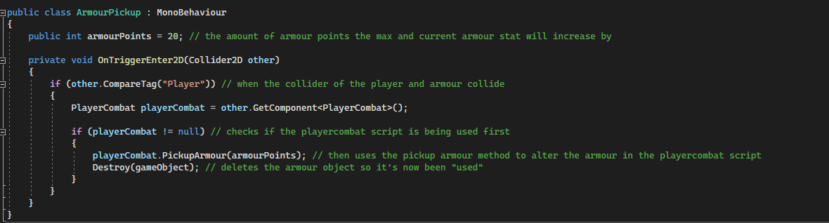

Then the collision detection function has been altered within the playerCombat script and a new ArmourPickup method has been added:

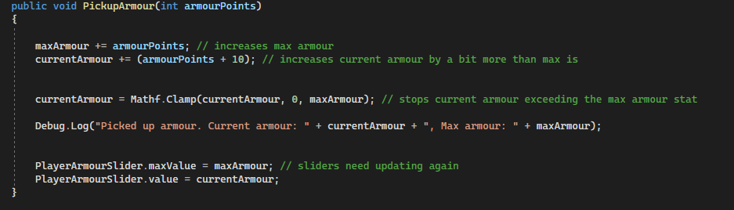

### Potions

Next I want to add different potions that have effects on the players stats, so for now I will create potions that will: boost health and boost damage.

The code for it is very similar to the armour pickup as it is following the same logic: upon the player colliding with the item, they pickup the item and the effects of the item happen; for the health potion the max health increases and the current health restores partly.

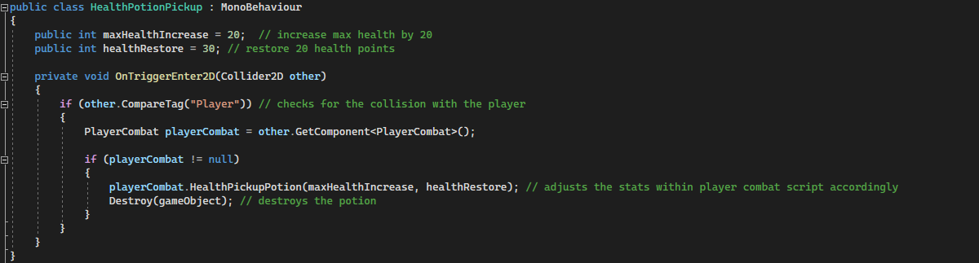

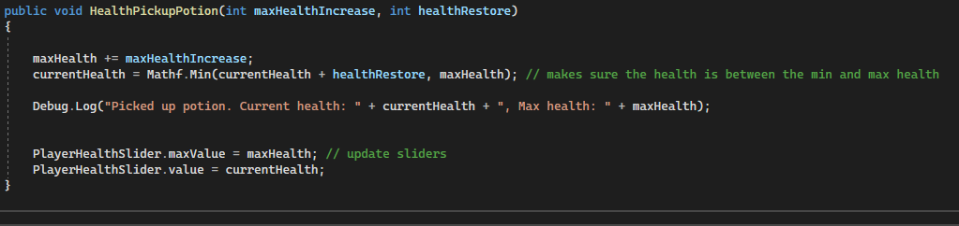

The next potion I want to do is the boost damage potion, so the damage that the player does to the enemy will increase, however at the moment the damage is a set amount (10 damage), so I will need to create a new variable to hold the current damage output of the player; then I also want the damage increase to only be temporary as the potion “runs out” (done in lots of games, normally potions only have a timed effect), so I will also need to add a time delay to reset the damage after it is completed.

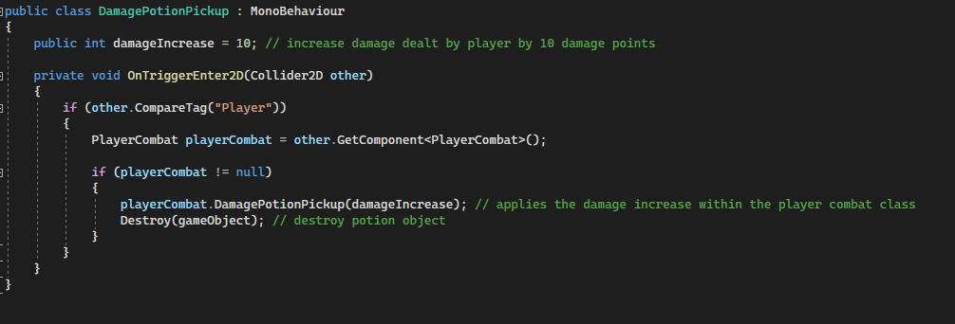

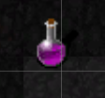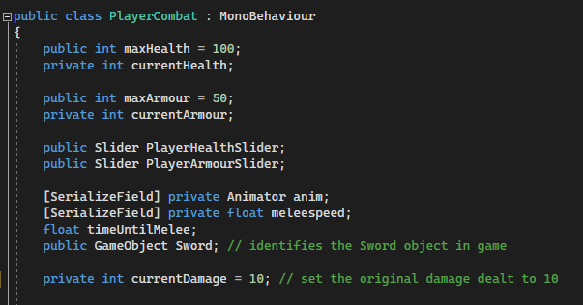

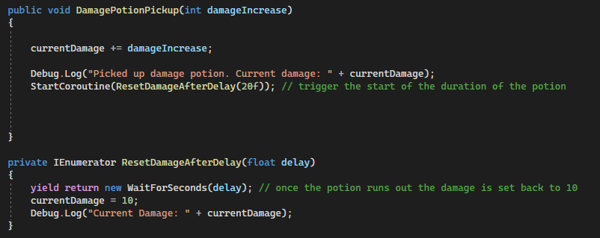

Damage Potion Test - FAILED

|  |  |  |  |
| --- | --- | --- | --- |
| What is the test and why test it? | Expected Outcome | Successful? | Improvements |
| Checks that when the player runs over the damage potion, the damage potion object is destroyed and the damage the player deals increases for the set amount of time, then reverts back to its original damage | Player does more damage to enemies during the effect of the damage potion, then damage reverts back to normal after the effects run out | No – the damage done is not changed at all when the potion is picked up | Need to take actions to fix this error, as shown ahead. |

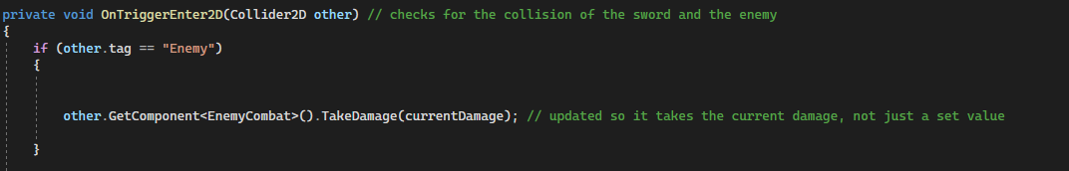To fix this problem, I realise that within the OnTriggerEnter2D function the damage was just set to 10, and not the actual currentDamage variable, so I changed that to fix the error.

### Gold

Finally, I will add gold to the game that can be collected, this can be used as a measure of progress for the player, and I can add further implementation where the gold could be used to buy something (e.g. potion). This will also come with a gold counter on screen so the player knows how much gold they have collected.

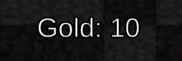



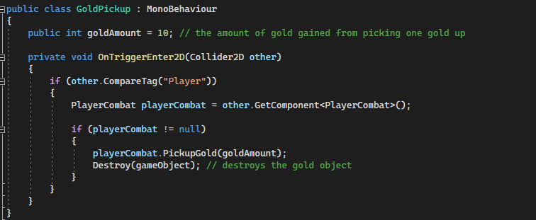

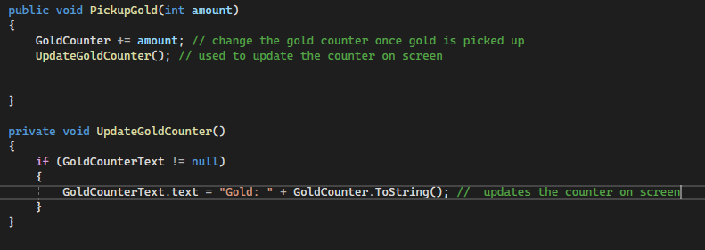

Items Tests

|  |  |  |  |
| --- | --- | --- | --- |
| What is the test and why test it? | Expected Outcome | Successful? | Improvements |
| Checks that when the player runs over the armour, the armour object is destroyed, max and current armour increases | Restores some armour (if armour is damaged) and increases max armour | Yes | Yes – this applies to all items: could add different variations of items, so stronger/weaker versions of each item (like a stronger health potion that increases health more than a standard health potion). |
| Checks that when the player runs over the health potion, the health potion object is destroyed, max and current health increases | Restores some health (if health is damaged) and increases max health | Yes | No |
| Checks that when the player runs over the damage potion, the damage potion object is destroyed and the damage the player deals increases for the set amount of time, then reverts back to its original damage | Player does more damage to enemies during the effect of the damage potion, then damage reverts back to normal after the effects run out | Yes | No |
| Checks that when the player runs over the gold, the gold object is destroyed and the gold counter increases | The on screen gold counter increases by 10 with each piece of gold picked up | Yes | No |

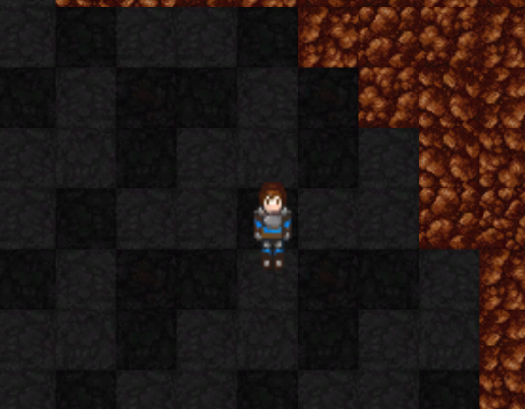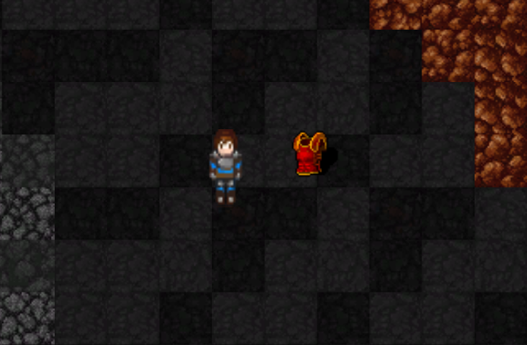

**(Before walking over the item)**

**(After walking over the item)**

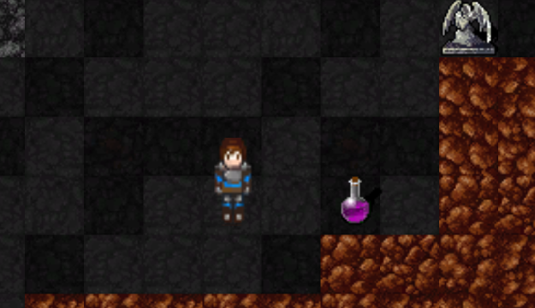

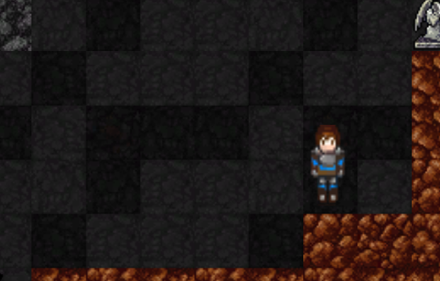

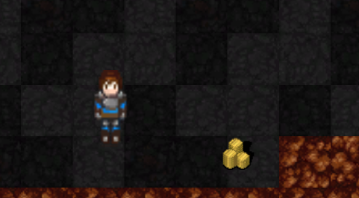

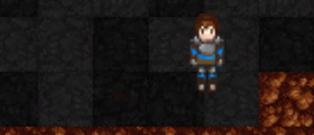

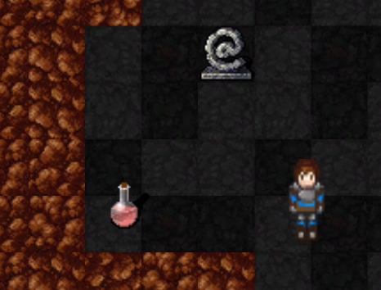

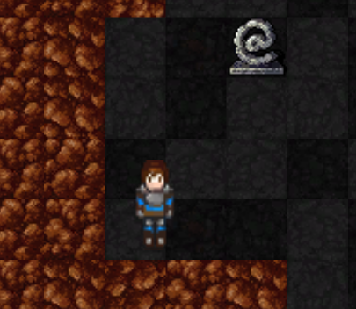

### Phase 6 Review

In this phase I set out to create all the interactable items within the game, and have done so successfully: I have created potions, armour and gold, all of which the player can pickup by moving over them, and they all affect the players stats in their own respective ways. Before the next phase I will copy more of these items and scatter them amongst the map so that the player has loads of items to find and collect throughout the game.

## **Phase 7 – Death Loop**

In this phase I want to tie it all together and finally add the death loop that is at the heart of all rogue-like games, where when you die, you restart at the start again, to play straight away and everything resets.

So I have added a new canvas for the death screen to be on, and then I’ve added the text for death and 2 buttons: one to revive yourself and start from the start again, and one to quit the game. I have also created a death controller script which will control the input of the buttons, so for the revive button, it reloads the scene upon the button being clicked, and for the quit button it quits the game. The canvas is deactivated initially and then activated once the player dies, so that the death screen is only present when the player dies (also the player object is deleted). So ive added to function call within the update function in the playercombat class (that checks whether the player’s health has fallen to 0 or below):



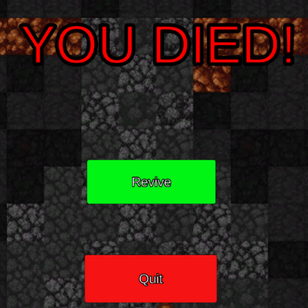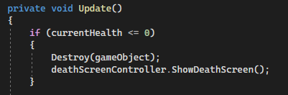

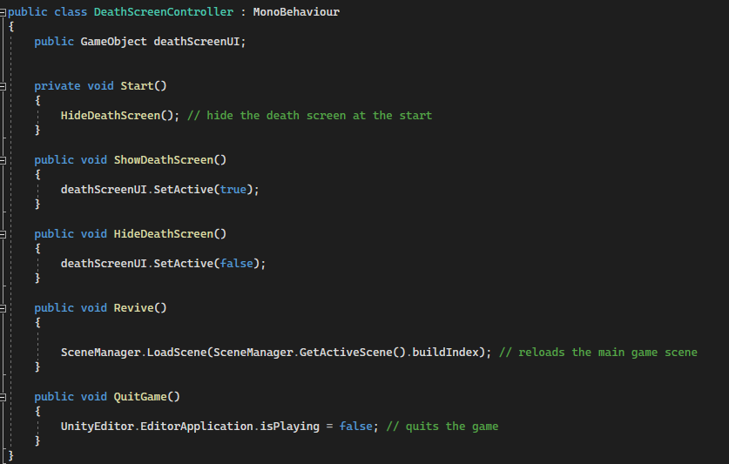

Death Loop Tests

**(The death screen showed when the player dies)**



|  |  |  |  |
| --- | --- | --- | --- |
| What is the test and why test it? | Expected Outcome | Successful? | Improvements |
| Does the player object get deleted upon player death – player needs to die otherwise the game won’t have the rogue-like functionality | When the player health falls to 0 the player dies and is deleted on screen | Yes | No |
| Does the death screen appear upon player death | The “YOU ARE DEAD!” deaths screen appears upon death | Yes | No |
| Does the “Revive” button put the player back to the start of the game | The scene is reset when the revive button is clicked, resetting all objects and stats | Yes | No |
| Does the “Quit” button make the player leave the game | The game is exited when the quit button is clicked | Yes | No |

### Phase 7 Review

In this phase I set out to create the death loop – the main core mechanic of a rogue like game, where you return to the start each time you day, almost immediately after dying. My implementation of it gives the player the option to quit or revive and start again to give the player more choice, however it still functions in a similar fashion.

## **Phase 8 – Enemy Levels + Win Condition**

As described in the design, I want to add enemies of different difficulty levels that are all children of the main base enemy class. These enemies will be progressively faster, have more health and do more damage to add to the difficulty of the overall game. I have created specific rooms on the map that have a different appearance, in which I will add the different levels of enemies, and then the rest of the map will be filled with the base enemies. I also want to add the winning condition so the player can beat the game, this will happen when you kill all the enemies on the map.

### Enemy Levels

To do this I will create a prefab for each level of enemy, and then use that prefab to create multiple instances of that level of enemy in each room. Each of these instances will have different stats compared to the base enemy. I will also add a different sprite to each of the different levels so you can identify the different types of enemies easily.

I have added a new public damage variable to the enemy combat script, so that I can change the damage in the inspector; I’ve then passed the damage into the on collision so that it deals the damage specific to that enemy, so now I can change the speed, damage and health all in the inspector.

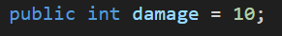

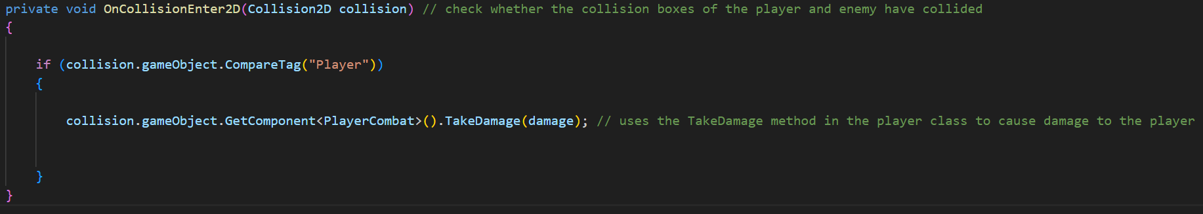

I then need to create the different prefabs for the different levels of enemies; as there are 3 special rooms on the map, I will create 3 new enemy prefabs, of different difficulty. As shown:

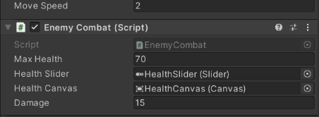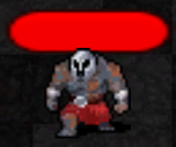

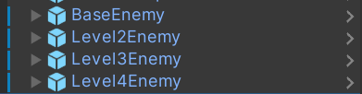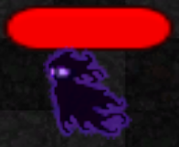

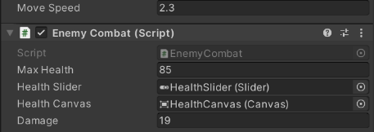

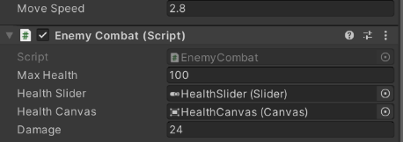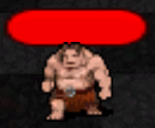

### Win Condition

For the win condition to function, I will add a variable that tracks how many enemies have been killed by the player, and then once the amount of enemies on the map equals the amount of enemies killed, the player will win the game and be presented with a win screen.

I have done this by adding a the Kills variable, that is updated everytime an enemy dies, through a function in the player combat script; the enemycombat script had to be altered slightly too. I have then created a win screen, very similar to the death screen but displays “YOU WON!” and a quit button.

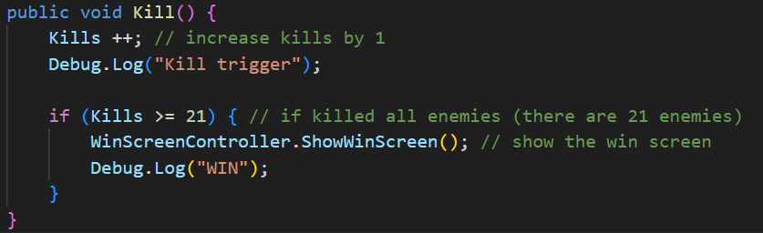

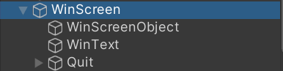

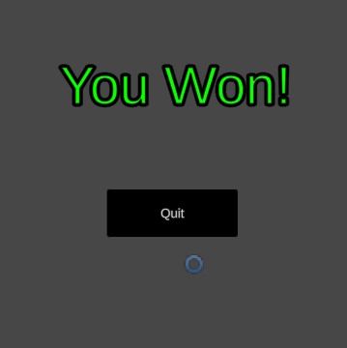

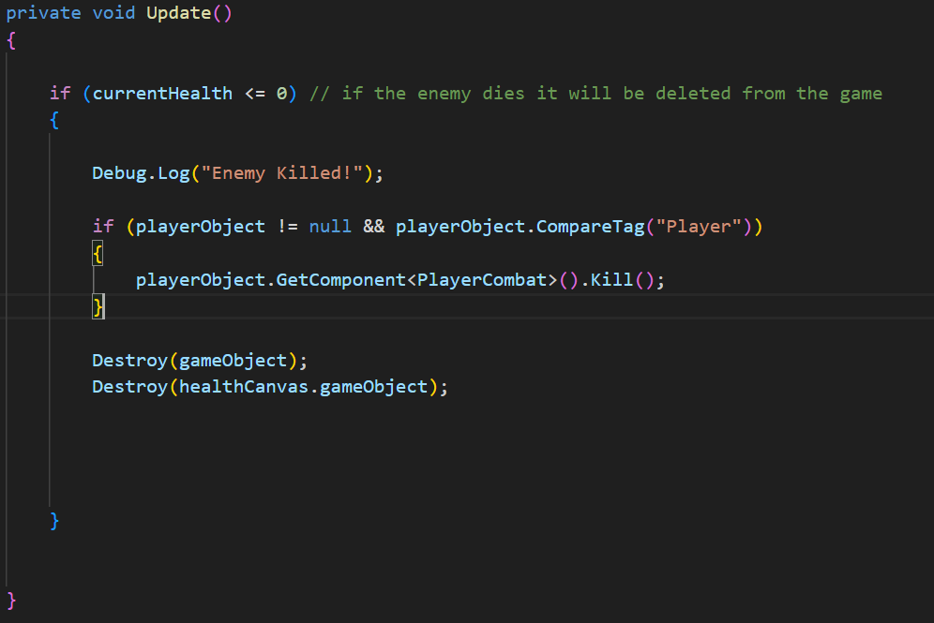

|  |  |  |  |
| --- | --- | --- | --- |
| What is the test and why test it? | Expected Outcome | Successful? | Improvements |
| Do the different type of enemies have different stats that have an in game effect | The higher level the enemy, the more damage they deal, the more health they have, and the quicker they are | Yes | Yes – could add more types, or give them different types of attacks |
| Does the kill count increase every time an enemy is killed | The kill counter will increase by 1 each time an enemy is killed | Yes | No |
| Does the win screen show when the player kills all enemies on the map | “YOU WON!” will show with a quit button upon killing all enemies | Yes | No |

Enemy Level and Win Condition Tests

**(Win Screen)**

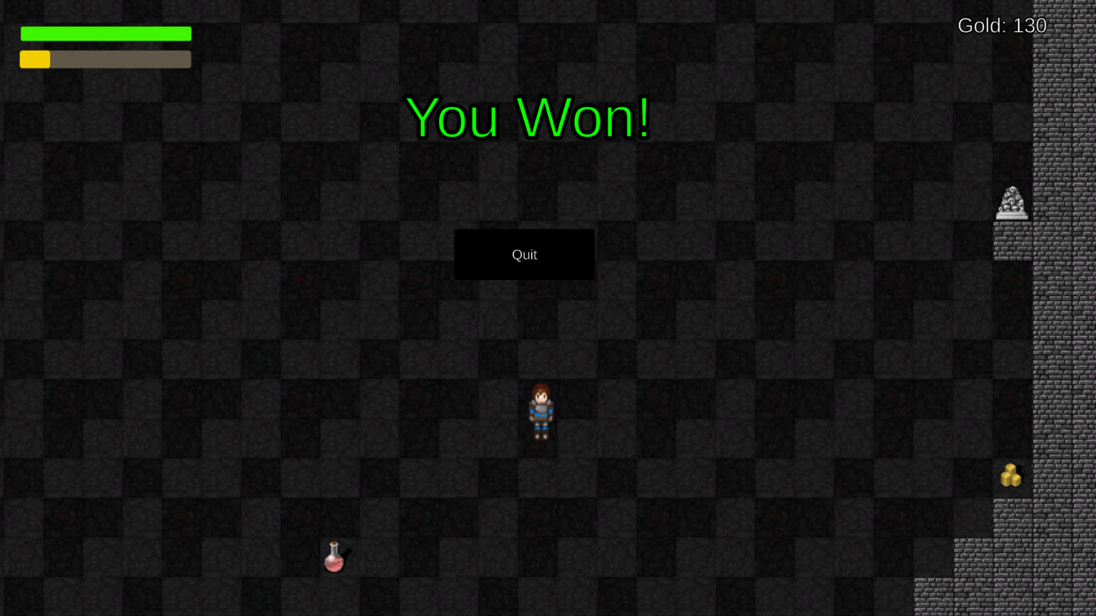

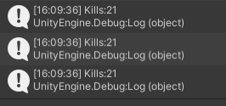

**(Shows that once the kills has reached 21, the win screen is shown)**

### Phase 8 Review

In this phase I set out to create the different types of enemy, with increasing difficulty (quicker, more health, and deals more damage), in which I have implemented it exactly as planned. Furthermore, I intended to add the functionality of “winning” into the game, in which the player can beat the game by killing all enemies on the map, in the event of which the win screen will be shown to the player.

## **Phase 9 (Final Phase) – Combat Improvements (Dodge and Battle Music)**

In the final phase of the development I want to just add some fine adjustments that will improve the player experience, these will be: adding a dodge for the player to use during combat, and also (as mentioned in the design) I want to add combat music that engages once the player is near an enemy, and then stops once “out of combat”.

### Dodge Mechanic

For this I want to create a dodge mechanic, in which the player dodges in a certain direction, normally to avoid an enemy, or/and it can be used as a dash towards an enemy also; it will have a cooldown so the player cannot spam dodges to balance it. It will function by getting the mouse position (similar to the sword swing) and then dash in that direction; I have done this all in the player movement script as it is a player movement mechanic. As shown:

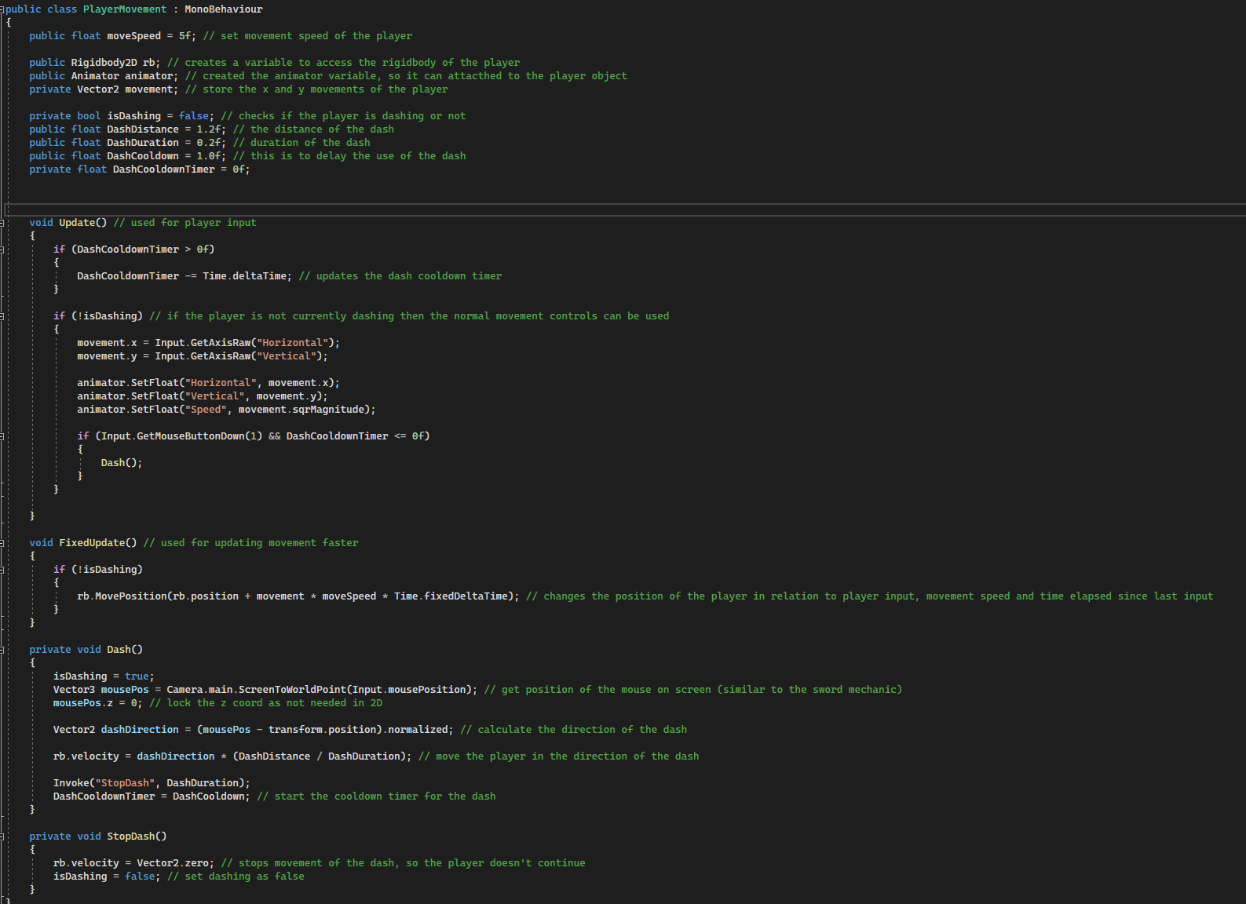

### Battle Music

Finally, I want to add battle music that engages once the player is close to an enemy, and then disengages when the player is not near an enemy, this will add a sense of intensity to the battles within the game.

To do this I will create a new MusicController script, in which the logic described above will be implemented; as I already have the background music object (BackgroundMusic) that’s one component sorted, and I will create a new music object called BattleMusic that will have the battle music assigned to it. Then it will just need to check whether the enemy is within the detection range, and alter which music is playing accordingly.

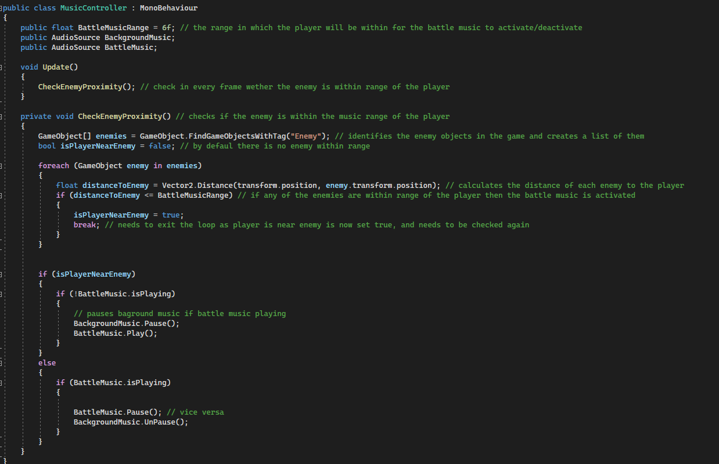

Dodge Mechanic and Battle Music Tests

|  |  |  |  |
| --- | --- | --- | --- |
| What is the test and why test it? | Expected Outcome | Successful? | Improvements |
| Does the player dash in the direction of the position of the mouse on screen | When the right mouse button is clicked, the player dashes towards the specified location | Yes | No – the duration and distance of dash can be altered to make it more balanced though |
| Does the dash cooldown stop the player from dashing again immediately after dashing | The player has to wait approximately one second before they can dash again after just dashing | Yes | No – cooldown can be adjusted as needed |
| Does the battle music start and the background music stop when an enemy is within the detection range of the player | When the enemy is within range, the music changes from background music, to battle music | Yes | Yes – I could add a fade between the changing of music, as it is quite a sudden switch |

### Phase 9 Review

In the final phase, I set out to tidy up some of the combat, to add some improvements to the player experience, via a dodge/dash mechanic to add more skill to combat, and some battle music to make battles more immersive. Both have been implemented successfully and it brings the game together at the end of development perfectly; it feels like a fully fledged game, with fun features and a good overall experience.

# **Evaluation**

## **Summary of Progress**

The game I have produced at the end of my development is not the fully completed envisioned game, but it has all the core functions of the idea, and is still (in my opinion) very fun to play. I met all the points of the essential criteria, just not all the points of the success criteria, however I will show where and how I would’ve implemented the features that are missing.

## **Tests Description**

I will be doing all of the post-development testing now, which will have a grade of completion next to it to show the extent of which each feature is implemented into the game, as follows:

* Fully Implemented (**F**) – the feature specified is fully implemented and functioning in the game, as described in the design.
* Partially Implemented (**PF**) – parts of the feature(s) is implemented into the game, with only some of the functionality of it working.
* Not Implemented (**NF**) – this feature was not implemented in the game at all.

The significant points of redacted implementations in my game were:

* The second/magical attack functionality of the player, so the player only has one type of attack.
* The item shop was not added, the gold function was but the item shop was not, so essentially the gold is just for show.
* The bosses were not added at all, so there were no enemies with special attacks or extreme difficulty.
* The objectives feature was not implemented at all, would take too much time to implement.

## **Post Development Tests for function and robustness**

|  |  |  |  |
| --- | --- | --- | --- |
| **Test Item** | **Input** | **Expected Outcome** | **Actual Outcome** |
| Player Movement | WASD keys, or arrow keys | The player on screen should move up (W), left (A), down (S) and right (D) with the respective key press; if there is a wall in the way then the player shouldn’t be able to move into it also.  Also if player holds 2 keys down – e.g. W and D – then the player should move diagonally. | The player can move in any direction they wish using WASD or arrow keys; that includes up, down, left and right, as well as all the possible diagonals. This is also accompanied by animations in 4 directions to make the movement more smooth. |
| Collisions (Player, world, enemies,items) | Any collision that could take place – e.g. player walking into wall | Any game object has a collision, others objects cannot walk through them. | All the sprites (visible things on the map) have correct collisions: the player collides with walls and enemies for example; nothing can move through walls or other colliders. |
| Enemy Death | Enemy health is 0 | When an enemy is killed (when their health is 0) the enemy object must be deleted so the enemy doesn’t exist in the game anymore. | When the enemy reaches 0 health they are deleted from the game, as they “die”, and they cannot be interacted with after that, as they are completely deleted from the game. |
| Enemy Movement | Enemy is within a certain distance of the player | Enemies should follow the player when within range. | The enemy follows the path specified by my modified A* algorithm, that utilises a dynamic grid implementation, so that the enemy movement is as quick and accurate as possible when tracking the player; it only does this when within the range of the player, which I set to be a medium range. |
| Player Death | Player health falls to 0 | When the player dies a death screen must be displayed, and the game will be effectively reset after that. | A death screen is displayed when the player dies, and the player object is deleted when the player dies, so they cannot move around while “dead”. The player is presented with the option to revive (start over) or quit the game. |
| Item Pickup | Player collider collides with the item collider | When player walks over an item they pick it up and equip (for weapons) or use it (for consumables). | When the player runs over an item, they pickup it up (and the item is deleted) and then the effects of the item happen successfully (e.g. health potion boosts current and max health). I dispersed many types of potions evenly across the map to make certain rooms more rewarding than others (rooms with harder enemies have more loot in them). |
| Player Attack | When the player presses left mouse button the player should use their standard attack | Player presses LMB and swings their weapon, upon collision of the enemy it will damage and knock-back them. | The player has a basic attack, in which they swing a sword in the direction of where the mouse is on screen when they click it, and this damages the enemies who collide with the sword; the sword also has a cooldown so the player can’t spam attacks. |
| Music | When the player gets close to enemies it will change from background music to “battle” music | When the player comes into a certain vicinity of an enemy the music should switch from the standard background music to the battle music, it should also switch back after all enemies within that vicinity are dead, or if the player escapes that vicinity. | The music is dynamic, where there is normal background music playing, and then when an enemy comes within range of the player, combat music is played instead. |
| Main Menu | * Player clicks START button * Player clicks OPTIONS button * Player clicks QUIT button * When game is run the controls should be displayed on the main menu | * When START button is clicked the main game should launch, and so the scene should switch from MainMenu to MainGame. * When OPTIONS button is clicked the options menu should be displayed. * When QUIT button is clicked the game should be exited and stop running. * The controls of the game should be displayed on the main menu. | The player can use all the buttons mentioned: Start button enters the game (switches to main game scene); the options button opens the options screen where the player can alter the volume; the quit button allows the player to quit the game. Also the game controls are shown at the start of the game on the left side of the screen. |
| Pause Menu | * Player clicks RESUME button * Player clicks OPTIONS button * Player clicks QUIT button * Game controls are displayed | * When RESUME button is clicked the game is unpaused and the resume menu is hidden. * When OPTIONS button is clicked the options menu should be displayed. * When QUIT button is clicked the game should be exited and stop running. * The controls of the game should be displayed while the pause menu is open. | The pause menu was not implemented, so there is no evidence of it. |

## **Essential Features Tests**

I will test each of the essential features to prove that I have completed all of them, fully implemented and functioning as expected.

|  |  |  |  |
| --- | --- | --- | --- |
| **Feature** | **Implementation Level** | **Comments** | **Improvements** |
| Player Movement | **F** | The player movement works in every direction, and the animations for the movement is in 4 directions; it takes either WASD or arrows keys for player movement and works perfectly, with a specified speed that is just about faster than the strongest enemies. | I could add 8 directional movement animations, to make the movement appear more natural on screen. |
| Combat System | **PF** | The player can attack the enemy with a sword, and the enemy damages the player by bumping into them; the player also has a dodge to avoid enemies attacks, or even to lunge towards enemies. | I didn’t have time to add the special attack so I could add that, which would be a magical attack; the enemies could’ve had their own weapons. |
| HUD | **F** | The HUD displays all the stats of the player (Health, Armour and Gold) ;the stats of the enemies are shown on screen, exactly as shown in the usability design. | The HUD could have mana on it also if the player had a magical attack; I could have shown the damage the player currently was dealing; show the player and enemy taking damage, e.g. they turn red for a second when they get hit. |
| Stats (Player and enemy stats) | **F** | The stats of both the enemy and the play are correctly changed upon damage being taken (for both), and when items are picked up (for the player). | As said before, mana could’ve been added, but only if a magic attack was added. |
| Replayable/Cyclical Structure | **F** | The game gives the player an option (upon death) to either revive (so start from the start again) or quit the game completely; it keeps the rogue-like structure intact as the player is sent back to the start upon death. | The only thing I could change is that upon death the player is immediately sent back to the start, without an option. |
| Enemy AI | **F** | The enemy AI is the movement script for the enemy, in which I implemented the A* algorithm, that functions exactly as expected – I further altered it the add a “dynamic grid system” as I called it to improve the performance of the algorithm. | I could find different ways to improve the performance of the algorithm but I thought it was perfect for the scale of the game. |
| Weapons | **PF** | There was one weapon (the sword) that functions perfectly, with a hitbox that maps around the sprite of the weapon where the contact should be, and it does damage the enemies. | I could add more weapons, with different hitboxes, damage and effects to add to the diversity of the game, but time constraints were strict. |

## **Success Criteria Tests**

I will now show the points of my success criteria that I implemented fully, partially, or not at all, and how I could’ve improved each of those points, or if they weren’t implemented, how they could then be implemented into the game in the future.

|  |  |  |  |
| --- | --- | --- | --- |
| **Feature** | **Implementation Level** | **Comments** | **Improvements** |
| Sprites | **F** | Sprites are essentially the skins of all the objects that you can visually see on screen, and I successfully used a diverse range of sprites on my many objects (even different sprites for the different types of enemies). | I could add more variety of sprites for the base enemy, and I could make all the other sprites (other than the player) more dynamic, that being animated sprites, such as enemies facing the direction they move; an effect displayed when the player picks up a potion. |
| Tile Map | **F** | The tile map is essentially the whole map that the player moves around in; I tried to make it as diverse and fun to explore as possible, and it all functions correctly, composed of different layers for: walls, floors and objects. The player is perfectly contained within the map and cannot get outside of it. | There is enormous potential for expanding the map, adding more rooms, and even puzzles or mazes to add diversity to the player experience. |
| HUD | **PF** | The HUD is almost exactly as shown within the usability features, as it shows the player health, armour and gold, as well as the enemies’ health (above their heads). However I did not have a mana bar to display mana, as I do not have a special attack requiring mana in the game. | Assuming I implemented the special attack, I could add a mana bar to the HUD, so the player could know when they could use their ability attack (when they have enough mana), which would be a useful and extensive addition to the game. |
| Player Movement | **F** | The player movement is perfect for the scale of game, and it functions as intended, as the player can move in any direction they wish to, with animations for the movement to add immersion into the game, and a smoother movement experience – the player can choose between using WASD and arrow keys for movement as they please also. Furthermore I added a player dodge/dash function, that allows the player to dash in the direction of where their mouse is, to add a level of skill to combat. | The only improvement would be to animate the dash and I could also have added more animations for small degrees of movements, as at the moment there are only 4 different movement states, whereas I could do 8-directional movement animations, which would make the movement look even smoother. |
| Player Stats | **PF** | The player stats are almost all added, but the stats that are added work as intended – only missing the mana stat as stated before. The armour stat is damaged before the health stat (if they have enough armour), so combat flows smoothly. The player does die when their health reaches zero, and all the potions and items correctly affect the stats of the player. | The mana stat, as stated before, relies on the implementation of an ability attack, which could both be made at a later date – this would then be displayed on screen with a mana bar. |
| Player Combat | **PF** | The player does have an attack with a sword, that has a swining animation and colliders and damages the enemy; I also made it balanced so that the sword has a swing cooldown; the player also has a dash (with a cooldown) that allows the player to dash away or even towards enemies, or to dodge out the way of enemy attacks. The only thing it’s missing is the special attack, which would’ve been something like a fire ball. | I could add the special attack in at a later date, consisting of some form of magic attack using mana (e.g. fireball, lightning blot etc.); this could aim to improve the overall combat experience by adding variety into the way in which you approach a battle and defeat enemies. |
| Enemy Combat | **PF** | The enemy has a very basic attack, in which upon colliding with the player, it damages the player, and it functions for its purpose. | I could add weapons or even ability attacks for enemies to use on the player, to make the combat more difficult for the player. |
| Enemies | **F** | The enemies do “track” down the player and “hunt” them, using the A* algorithm which I developed to work even more efficiently so that the enemies have clever pathfinding – to get to the player in the quickest and smartest way. | I could add animations to the enemies movements to make it more smooth, as well as better wall detections as they can get stuck on walls occasionally, this could be done using raycast to see if there is an object in the way. |
| Enemy Collisions | **F** | The enemies do collide with all the walls and the player with perfect accuracy, as I made sure its 2D boxcollider (its “hitbox”) was mapped in a sensible shape around its body (so that it wasn’t extending outside its body, but also not too far into its body). | It would be quite hard to improve on the collisions of the enemy, the only way would be to use a different shape of collider and map it perfectly around every pixel of the enemies’ bodies. |
| Enemy Stats | **F** | The enemy health is shown above the player in a health bar, as intended; there is a variety of enemies with different health, damage and speed stats that the player can encounter; the player can damage the enemies’ health by attacking them, and they die once their health falls to 0. | An improvement I could do is to add a larger variety of enemies, and I could add more stats, such as giving them their own armour bar and/or mana for a special attack if I gave them a special attack (e.g. for bosses) |
| Area Difficulty | **PF** | There are specific rooms with stronger and weaker enemies in, that add challenge to the game for the player – these enemies all use the base enemy class as a blueprint for their stats and behaviour, with altered stats however (depending on their difficulty). The only thing is there was only 3 levels of enemies and they don’t spawn mid game, they are positioned before the game runs. | I could add the “spawning” system that would make the enemies spawn in as the player got closer, as specified to save processor resources; I could easily add more areas with increasingly difficult enemies within them. |
| Loot (Weapons and items) | **PF** | I have a weapon that functions perfectly as intended, with a swing, a cooldown, and damages enemies within its range, however I don’t have a variety of weapons at all. Potions are implemented with a damage and health potion, as well as armour that you can pick up (and gold), all with effects that correctly affect the players stats. | I could add more weapons, with different damage stats, swing cooldowns and sprites. These weapons could then be found and picked up across the map, or even dropped when a special enemy is killed; this would add an incentive to explore the whole map, to improve your combat abilities. |
| Pause Menu | **NF** | Unfortunately I didn’t have time to implement a pause menu to halt the game, however all the other menus are in the game, and settings can be changed at the start of the game. | I could add the pause menu, using the same format at the start menu, as it would have the same options, with the “START” button being replaced with a “RESUME” button, to resume the game, rather than restart it; I would build it in the same format as shown in the usability features. |

## **Usability Features Testing**

|  |  |  |  |
| --- | --- | --- | --- |
| **Feature** | **Implementation Level** | **Evidence** | **Improvements/**  **Comments** |
| Main Menu | **F** |  | The main menu has all the components shown in the usability features, and they all function as intended, so there is no more needed to be added to it. |
| Options Menu | **F** |  | The options menu is displayed exactly as shown in the usability features, and allows the player to change the volume of the game. |
| Main Game HUD | **PF** |  | The main game HUD is missing the mana bar, which could be added if I added the special attack to the player, and therefore the player’s mana would be shown in real time on the HUD. Also the gold counter is quite plain, with no gold coin next to it – this could be improved to be more visually appealing (change the colour of the text to yellow and add a coin next to it), however it is still informative in showing the amount of gold the player has collected. |
| Pause Menu | **NF** | No Evidence as not done | The pause menu was not implemented due to time constraints, however I would’ve used the start menu scene as a blue print for the pause menu, as they would be very similar (just resume instead of a start button, and also showing the game in the background); I would’ve done it on a canvas, as I could easily turn on and off the canvas to be displayed when the player pressed the escape key. This could be added in a later patch for the game, as the game still works perfectly at the end of my development. |

## **Maintenance issues and Limitations of the solution**

|  |  |  |
| --- | --- | --- |
| **Limitation/Maintenance Issue** | **Impact on the project** | **How to deal with limitation** |
| Time | Time was a big limiting factor of developing my game, as there are loads of different features I wanted to implement (item shop, pause menu, special attack etc.) but I lacked the time to do so, especially with revision and other such activities to do; this meant I could not develop my game to its full potential, however I was able to develop a fully functioning game, with all the intended essential features. | I could’ve managed my time better and spent more time on the project earlier on, so that I had more time to actually develop the game and code it; this could’ve been achieved by allocating time slots each week to work on the development, and setting achievement goals so that I could gage if I was on schedule or not, and then seeing if I could add more features in that time frame. |
| Experience | I came into this project with no experience of Unity and very minimal knowledge of C#, this severely slowed down the development of the project as I had to learn both C# and how to use Unity as I worked through it; therefore this meant the project could’ve been so much more developed, with lots more features if I was more experienced in game production in Unity. | I could’ve practiced using Unity and C# before I started the project, however it was difficult to predict what I’d be coding in, or what I was going to use as the game framework – as I even considered using GoDot. Experience is developed overtime and I think if I were to continue the game development now, I would be able to develop a range of new features relatively quickly, so unfortunately it was an unavoidable obstacle. |
| Scale (Manpower required) | Game development, almost always, is not a one person job, so doing the whole game development as just me was quite difficult and unrealistic; it would’ve been a lot easier to have another person or a whole team working on it (as almost all games do) as I could allocate different tasks to different people, but for this development I had to do everything (which involved learning how to do everything on the fly). | For this project I could not avoid this, as it is supposed to be a solo development; therefore I think it was more down to experience again, if I had previous experience in game production I would’ve been able to develop all of the features I set out to make within the time frame, just by myself. |
| Expectations | My expectations of what I could develop within the time frame were slightly unrealistic, which meant the game is not fully developed to what I showed in the design (still functions and has ALL essential features however), so my expectations limited me in a mental sense, as it felt like I was not completed at the end of the development. | I could’ve managed expectations in relation to the scale and timeframe of the project, which most likely would’ve made me more productive as I would feel more accomplished at each stage of the development, therefore not limiting me at all; however this was difficult as I had no way to know the extent of which I could develop a game, and to what size the game would be. |